 [Facebook](https://www.facebook.com/pages/Australian-Disability-and-Development-Consortium-ADDC/924884487560967)     [Twitter](https://twitter.com/ADDCnews)                                      [Website](http://www.addc.org.au)  |  [Subscribe](mailto:info@addc.org.au?subject=Subscribe%20to%20ADDC%20newsletter&body=Please%20subscribe%20me%20to%20the%20ADDC%20newsletter.%0AName%3A%20%0AOrganisation%3A%20%0AEmail%3A%20)   |  [Email us](mailto:info@addc.org.au?subject=Newsletter%20feedback) │ [Donate](https://www.cbm.org.au/donate/addc/1508)

**Welcome to the November/December 2017 ADDC Bulletin**

With 2017 coming to close we thank you again for support of ADDC. It has been a productive end to the year for ADDC, electing our new Executive Committee who met face-to-face in early November, hosted a [concurrent session at this year’s ACFID conference](https://www.addc.org.au/addc-panel-at-the-acfid-conference/), launched our [new website](http://www.addc.org.au/) and [organised an event at Parliament House this week to mark 10 years of ADDC](https://www.addc.org.au/marking-10-years-of-addc-and-international-day-of-person-with-disability/).

I will be commencing maternity leave at on 8 December. We will welcome Lucy Hodson into the Executive Officer role starting on 16th January 2018. During this time contact ADDC via [info@addc.org.au](mailto:info@addc.org.au).

As always your contributions are welcome to continue to make the ADDC Bulletins a valuable resource providing updates and information on new research, conferences and events, employment and funding opportunities and resources for disability inclusive practice. Send all contributions to [info@addc.org.au](mailto:info@addc.org.au?subject=ADDC%20Bulletin%20Response) to be featured in the bulletin and on ADDC website.

Thanks again for your ongoing support of ADDC and seasons greeting!

**Kerryn Clarke**

**ADDC Executive Officer**

[info@addc.org.au](mailto:info@addc.org.au)

[Follow ADDC on Twitter](https://twitter.com/ADDCnews)

Follow ADDC on Twitter

**CONTENTS**

News and Updates  
Conferences and Events  
Employment and Funding Opportunities  
M&E and DisabilityNew Resources  
Newsletters from Other Organisations

**Disclaimer**

The ADDC Bulletin is a compilation of other organisations’ articles and material. While every effort is made to validate content ADDC does not endorse all opinions and views contacted within the Bulletin.

## NEWS and UPDATES

### ****International Day of People with Disability 2017****

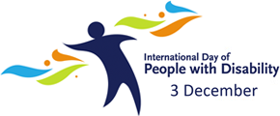

International Day of People with Disabilities (IDPD) was celebrated on 3 December. It’s an important day to raise awareness and promote action around the rights of people with disability and their full inclusion in society. See the [Include Us](https://www.youtube.com/watch?v=o_XCVeGAz-w) video produced by CBM Australia to mark the day.

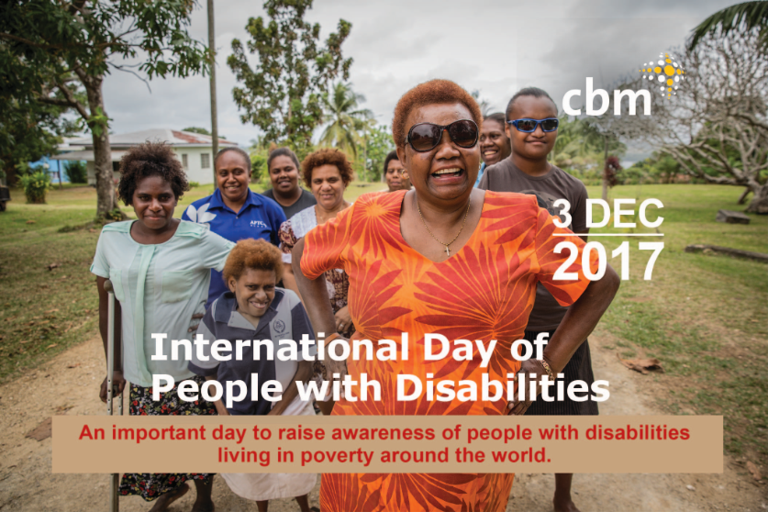

### ADDC Parliamentary Event for IDPD, 6th December

# This year we marked [10 years of ADDC and the International Day of People with Disability](https://www.addc.org.au/marking-10-years-of-addc-and-international-day-of-person-with-disability/) with an event at Parliament house in Canberra. Parliamentarians and representatives of the Australia disability and aid and development sectors gathered for breakfast to celebrate. The event focused on celebrating a decade of remarkable advancements in disability-inclusive development and called on the Australian Government to continue their leadership globally to ensure all people with disabilities can benefit from aid investments.

# The Minister for International Development and the Pacific, Senator the Hon Fierravanti-Wells and Australia’s former Minister for International Development, Bob McMullan both spoke highlighting Australia’s achievements.

# C:\Users\KCLARKE\Desktop\Photo Maulani.jpg

# They were followed by Mrs Maulani Rotinsulu (presenting above), a leading Indonesian disability rights advocate and chairperson of the Indonesian Association of Women with Disabilities who spoke of the need to ensure all our efforts remember and include women and girls with disabilities.

# Other speakers included Senator Claire Moore, and new Senator Jordon Steele-John who spoke as a person with disability. Mr Paul Deany, who was a founding member of ADDC as well as a current Executive Committee member also shared his involvement with the Consortium over the past decade and the many achievements that have been reached.

# Read a [full report of the parliamentary event on our new website](https://www.addc.org.au/marking-10-years-of-addc-and-international-day-of-person-with-disability/)

### ADDC Panel at the ACFID Conference

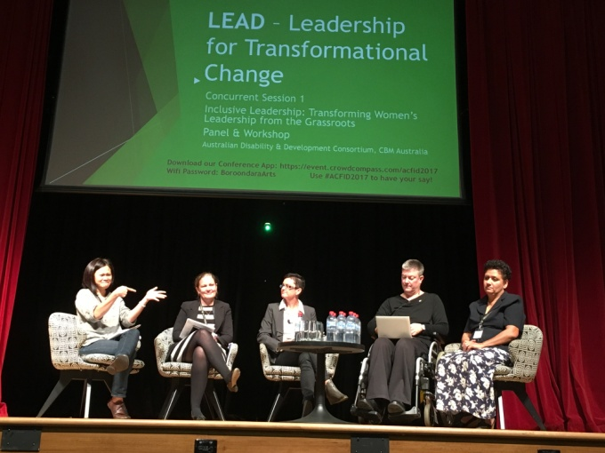

*Left: Eka signing in American Sign Language her presentation on the transformation impacts of including people with disabilities as leaders of their community. Eka Lui, Rachel Rawlings, Kirsty Thomas, Christina Ryan, and Cathy Nasarua (left to right) formed the ADDC panel at the ACFID Conference, Melbourne, 2nd November 2017. (Image: ADDC)*

An inspiring group of women spoke on a panel at the ADDC-hosted concurrent session at this year’s ACFID Conference in Melbourne on 2nd November 2017. Under the theme of transformational leadership, the panel explored the intersections between development programming and overcoming barriers for people with disability to reach a diversity of leadership roles locally, nationally and internationally. The panel also discussed new strategies to support women with disabilities to reach leadership roles through inclusive development and mainstream programming.

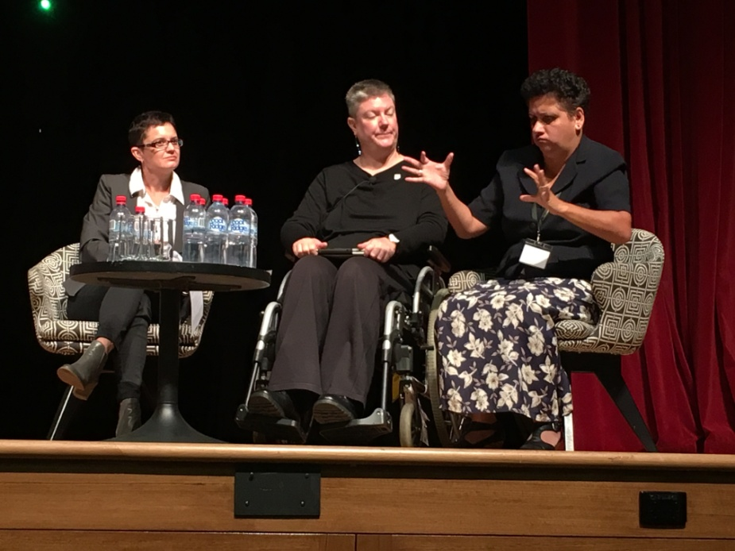

*Left: Cathy Nasarua signing in Auslan and Fiji home-sign her presentation at the ADDC session at the ACFID Conference, Melbourne, 2nd November 2017.(Image; ADDC)*

Cathy Nasarua, a Board Member of the Fiji Deaf Association shared her experiences as a woman with hearing impairment growing up in Fiji with no national sign language and the challenges she and others have to overcome to reach leadership roles with their communities, nationally and regionally. Eka Liu, from Indonesia challenged the audience to consider the positive and diverse impact people with disabilities can have within their communities as change agents when they reach leadership roles. Christina Ryan, the founder of the Disability Leadership Institute, provided an Australian perspective on strategies to support more women with disabilities into a diversity of leadership roles, including how to adapt the normative culture of leadership and recognising diversity within the disability population. Rachel Rawlings, from Australian Government’s Department of Foreign Affairs Gender Division, shared strategies within the Australia aid program supporting women with disabilities to become leaders and importance of continuing such work.

Thank you Eka, Christina, Cathy and Rachel for your invaluable contributions on the panel and Kirsty Thomas from CBM Australia for chairing the session.

# Read a [full report of the parliamentary event on our new website](https://www.addc.org.au/addc-panel-at-the-acfid-conference/).

### ADDC New Website is LIVE!

Very exciting news... our new website is LIVE!

[www.addc.org.au](http://www.addc.org.au)

The site is going to be grown and added to over the coming months, including the resource section following the strategic planning conversations next year.

Enjoy the new site!

### Three multinationals join UN global network on disability inclusion

Three multinational enterprises – Capgemini, Legrand and the Savola Group – became the latest members of a United Nations global network that promotes equal opportunities for persons with disabilities in the workplace.

“People with disabilities constitute some 15 per cent of the world’s population,” pointed out Guy Ryder, Director-General of the UN International Labour Organization (ILO), at the annual meeting in Geneva of the [Global Business and Disability Network](http://www.businessanddisability.org/index.php/en/).

“In striving to achieve full and equal rights and participation in society for all women and men with disabilities, we are pleased to [forge and strengthen](http://www.ilo.org/global/about-the-ilo/newsroom/news/WCMS_584676/lang--en/index.htm) such as the Global Business and Disability Network,” he added.

The Network serves as a platform for companies for peer-to-peer support on disability inclusion policies and practices, with the goal to promote the recruitment and retention of people with disabilities in the private sector, including in developing countries.

Participants at the meeting discussed the business case of digital accessibility and how to become more accessible for employees and clients with disabilities. Moreover, the meeting showcased good business practices on advertising that is inclusive and contributes to a positive image of persons with disabilities.

The meeting, among other things, also highlighted ways to prepare companies for the future of work by addressing their internal skills gaps through tapping into the professional potential of people with disabilities.

Representatives from Capgemini, Legrand and the Savola Group, together with other disability champions among the business community, also shared their success stories and challenges in putting principles of the Network into practice.

*Source: UN*

### IDDC Photo competition: Together for inclusion:

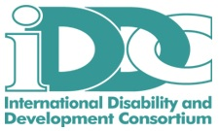

The International Disability and Development Consortium (IDDC) organises a photo contest under the framework of the European Disability and Development Week, which celebrates the International Day of the Rights of Persons with Disabilities.

All too often, persons with disabilities are discriminated environmentally, economically, and socially; however, IDDC hopes to address this gap by promoting inclusion of all people through the events taking place during this week, including this photo contest.

**The objective of the photo contest is to change attitudes barriers towards persons with disabilities.** Historically, persons with disabilities have been perceived as subjects instead as active agents. The photo contest aims to highlight inclusive responses to the challenges faced by persons with disabilities in a positive perspective, following a human rights based approach and the [UNCRPD](https://www.un.org/development/desa/disabilities/convention-on-the-rights-of-persons-with-disabilities/convention-on-the-rights-of-persons-with-disabilities-2.html). Photos submitted to this contest should reflect the idea of inclusion in a positive light. All submitted photos must be originals taken by the submitting photographer. The photographer submitting the picture should also write a brief statement as to why s/he believes this photograph reflects EDDW’s motto “Together for Inclusion.”

**How to participate**

* The Photo Contest is open to anyone who wishes to participate, both organisations and individuals.
* All photos should show disability and development in a positive light.
* Photos should be sent to eddw@iddcconsortium.net with the subject “EDDW17 Photo contest - Your name” by December 10th.
* The Contest will begin on **1st November** and end on **10th December**.

More information, including specific instructions for the photos, as well as how to submit them, are available on the [IDDC website](https://iddcconsortium.net/news/launch-eddw17-photo-contest).

### Financing for Development

**Inter-Agency Task Force (IATF) on Financing for Development**

The 2018[Financing for Development (FfD)](http://www.un.org/esa/ffd/index.html) process for the implementation of the[Sustainable Development Goals (SDGs)](https://sustainabledevelopment.un.org/sdgs) has begun. On 27 October, the Inter-Agency Task Force (IATF) on Financing for Development held a meeting at the UN in New York to discuss its report for 2018. The IATF report will contribute to the financing for development process. As the only civil society presenter, IDA and the International Disability and Development Consortium (IDDC) advocated for the inclusion and participation of civil society and in particular of persons with disabilities in the upcoming report. [Click here to read the presentation.](http://www.internationaldisabilityalliance.org/sites/default/files/iatf_statement_-_27_october.docx) [More information available here.](http://blog.cbm.org/financing-for-development-and-the-sdgs/)

### More efforts urged for inclusion of persons with disabilities in Africa

Policymakers and experts attending an international meeting on persons with disabilities on Tuesday 14 November called for more efforts to include persons with disabilities in Africa’s major development agendas.

Participants at the conference, organized by the Rehabilitation International (RI) organization at the UN Economic Commission for Africa, will evaluate opportunities, challenges and the way forward with regards to persons with disabilities on the African continent and beyond.

RI President Zhang Haidi said in her opening remarks that though the international community has registered remarkable achievements with regards to the inclusion of persons with disabilities, much needs to be done for a better inclusion and rehabilitation platform.

“Though we have made considerable progress in advancing disability affairs worldwide, there are still many persons with disabilities living in poverty,” she said. “It should be the goal and mission of every one of us to help improve their living conditions and create a favorable environment for their equal, inclusive and sustainable development,” Zhang said.

Noting that there are close to 118 million people in Africa under the category of disabilities, Demelash Bekele, RI deputy vice president for Africa region, said challenges such as accessibility of services, lack of assistive devices, poor inclusive education, and access to health services are preventing African persons with disabilities from being included through development agendas.

The conference is organized by Rehabilitation International in partnership with China Disabled Persons Foundation.

RI is a global organization and network striving to empower persons with disabilities and provide sustainable solutions to achieving a more inclusive society.

*(Source: Xinhua, GAATES)*

### Ghanaians with Disabilities Assured of Accessibility to Courts

The Ghanian Chief Justice, Sophia Akuffo, has assured persons with disabilities that all efforts are put in place under her leadership to ensure that  all the courts in the country are accessible to  them  to access justice.

The Chief Justice gave the assurance when she paid a two-day working visit to the Upper East Region to assess the situation and condition of the Judiciary Service and to see how to improve upon the service. She was responding to some staff of the Judiciary Service who shared their experiences on how they carried persons with disabilities to climb stairs to access justice. “It is part of my topmost priorities to ensure that persons with disabilities are able to observe proceedings in the courts and to access justice without any hindrance”, she stressed.

The Chief Justice acknowledged the difficulties persons with disabilities had to go through to access justice at the courts and promised to resolve the problem. She said she would see to address gender imbalances in the Judiciary and appealed to parents to ensure that they give priority to their daughters’ education so as to help break the gender imbalances in all spheres of society.

She said women in the country could play critical roles in justice delivery just like the men when they were given the necessary education and encouragement.

The Judiciary Secretary, Justice Alex Opoku Acheampong, who was with the Chief Justice on the visit to the region, assured the workers that his outfit would facilitate to ensure that their demands including; the request for interpreters, rent allowances, identification cards and the repair of broken machines at the court rooms were met.

*(Source: GNA, GAATES)*

### Iranian parliament discussing bill on rights of persons with disabilities

Iranian parliament, Majlis, is hammering out a bill on rights of persons with disabilities, Tasnim news agency reported.  
  
The bill is being discussed and will soon become a law before the International Day of People with Disability on December 3, said an official with Iran’s Welfare Organization.

Hossein Nahvinejad further pointed out that the adoption of the bill can play a significant role in creating job opportunities and providing people with disabilities with pension.

According to Anoushirvan Mohseni- Bandpey, head of the welfare organization, Majlis has allocated a budget to the tune of 9 trillion rials (nearly $225 million) to generate job opportunities for people with disabilities.

The organization has also agreed to give low-interest loans of 150 million rials (nearly $3,750 USD) to employers who will recruit and train people with disabilities, Mohseni-Bandpey said.

*(Source: tehrantimes, GAATES)*

### Defeating a dire diagnosis – Supercoach’s epic victory featuring AFL PNG and celebrating International Day of Persons with Disabilities

“Supercoach” Jonathan Ila has shaken off a dire diagnosis to lead his nation on the world stage and become both an Australian Football icon in PNG and a celebrated champion of success despite Multiple Sclerosis.

Jonathan Ila sure doesn’t look like a man having perhaps the greatest moment of his life.

He has layer after layer of thick clothing on, a beanie pulled down over his ears and the freezing winds tear at the bilim hanging around his neck. His steely glare is occasionally broken by an exasperated toss of the head. The truth is, there is nowhere in the world this man would rather be.

[Read the full article here.](http://bit.ly/2nivt5D)

### Footy feat heightens Hala's hunger to help featuring AFL Fiji

After proving to the world her disability is no barrier to achieving on the international stage, a profoundly deaf Fijian AFL star has switched her focus to ensuring everyone enjoys the same opportunities.

It is fulltime in the Australian Rules Football International between Papua New Guinea and Fiji, and Halamehi "Hala" Tuilomania is shaking hands. Her opponent generously congratulates Hala on a good game. The young Fijian smiles and using gesticulations reserved for the sign language illiterate, explains that she can't understand what is being said because she is deaf. Her opponent looks genuinely shocked, pauses briefly and then smiles broadly and throws her arms around Hala.

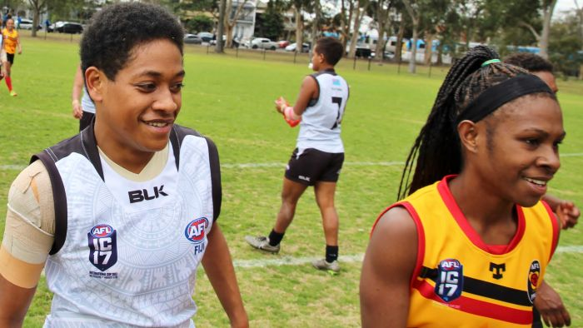

Victorious – Hala at fulltime in the match against PNG. *ABC: Aaron Kearny*

[Read the full story here.](http://www.australiaplus.com/international/style-and-wellbeing/footy-feat-heightens-halas-hunger-to-help/9100142)

### Meet the volunteer supporting Vanuatu’s pioneering para-athletes featuring VASANOC and Van2017

As Vanuatu assembles its first para-athletics team to compete on home soil in the upcoming Pacific Mini Games, an Australian volunteer has been instrumental in supporting the athletes on their journey and changing attitudes about disability in the Pacific nation. In Port Vila’s late afternoon light, two pioneers are preparing to change the face of sport in Vanuatu. Ellie Enock and Morris Kerry are training to compete in the upcoming Pacific Mini Games which will be hosted in Vanuatu next month. This will be the first time the Mini Games has included para-sports (athletics and table tennis).

[Read the full article here.](http://www.australiaplus.com/international/style-and-wellbeing/meet-the-volunteer-supporting-vanuatus-pioneering/9145440)

### Fiji commits to improve accessibility of sidewalks

The Ministry of Local Government is serious about making footpaths in municipalities around the country accessible for persons with disabilities.

Minister for Local Government, Housing, Infrastructure, Transport and Environment Parveen Kumar said he had been advised by the Labasa/Savusavu special administrator Vijay Chand that they were rebuilding the footpaths in Labasa Town.

Mr Kumar said people claiming that there were not enough accessible facilities for those living with disabilities in Fiji were not true. “There are some areas we need more work on and this is where we need to focus more,” he said. “We want to work with the disabled people associations and people with disabilities to provide them with the best accessibilities and facilities.”

Meanwhile, speaking during the International Day for People with Disabilities this year, Minister for Women, Children and Poverty Alleviation Mereseini Vuniwaqa said Government had provided funds to the Fiji Roads Authority to ensure that new roads and footpaths were accessible and provided easy access.

Mrs Vuniwaqa also assured people with disabilities that bus fare subsidy for persons with disabilities would continue. She said in addition, $120,000 had been allocated to promote participation of persons with disabilities in sporting activities. She said the Government had allocated money to renovate government offices to suit the needs of persons with disabilities.

*(Source: Fiji Times, GAATES)*

### Uganda Sign Language App Launched

The Uganda National association of the Deaf (UNAD) have launched a mobile application to ease communication for people who are deaf or hard of hearing.

The Shs400 million App – dubbed UGsign Mobile – was developed in partnership with SPIDER, a Swedish programme for ICT in developing regions, to make learning of sign language accessible via digital platforms.

People with hearing disabilities make up close to 3.4% of Uganda’s population and are one of the most excluded minority groups in the country. A recent survey by UNAD estimates that 87% of people who are deaf have no access to social services and this has been as a result of communication barriers that limit them from accessing education, health, legal and public services among others.

*(Source: GAATES)*

### Children with disabilities are being left behind, says World Bank/GPE report

Children with disabilities are being left behind by global efforts to improve education opportunities for all, as gaps between children with and without disabilities have increased dramatically in developing countries, according to new research from the World Bank and the Global Partnership for Education (GPE) released ahead of the International Day of Persons with Disabilities.

The study, [Disability Gaps in Educational Attainment and Literacy](http://documents.worldbank.org/curated/en/396291511988894028/Disability-gaps-in-educational-attainment-and-literacy), found that primary school completion for children with disabilities in 19 developing countries* is just 48 percent, and as many as three in ten children with disabilities have never been in school. The study, based on analysis of census data, also found that literacy rates and secondary school completion lag considerably behind: Only six in ten children with disabilities can read and write, and only a third complete secondary school.

The Sustainable Development Goals (SDGs) call for inclusive and equitable quality education, with the aim of ensuring equal access to all levels of education for the vulnerable, including children with disabilities. The SDGs call for building and upgrading education facilities that are child, disability and gender sensitive, and also provide safe, inclusive and effective learning environments.

As part of its efforts to promote inclusive education and ensure that all children have the chance to succeed in life, the World Bank is working to design and implement inclusive education strategies, finance projects, and provide advisory support, in countries including China, India, Malawi, Moldova, Tunisia, and Vietnam.

The Global Partnership for Education also provides developing countries with funding and guidance to develop and implement robust education sector plans that include strategies to close the gap between access, participation and learning, to ensure that children with disabilities can go to school and learn.

*(Source: World Bank)*

### High-Level Political Forum (9-18 July 2018) – seeking your input

The 2018 High-level Political Forum (HLPF) for Agenda 2030 will be held from Monday, 9 July, to Wednesday, 18 July 2018 in New York. The theme is **"Transformation towards sustainable and resilient societies."** The set of Sustainable Development Goals to be reviewed in depth will be: Goals 6, 7, 11, 12, 15 and 17.

**Official submission on behalf of the Stakeholder Group of Persons with Disabilities to the 2018 HLPF**

Annually persons with disabilities are asked to make an official submission to the United Nations addressing the annual theme of the HLPF. For 2018, we expect that the submission will be six pages and due some time in April. Please note that the UN defines the length and date of the submission. The submission will be published on the UN website and also widely disseminated to Member States and UN Agencies.

In line with the 2018 HLPF theme, we are asking for inputs over **sustainable and resilient societies and the inclusion and leadership of persons with disabilities**; we are calling for any research, papers, and/or information addressing this theme. We will compile all material received and subsequently share an outline for further discussion. You will be able to contribute and share on a continual basis via these bulletins.

*Please send your inputs with the subject line:****Submission 2018 HLPF****to Orsolya Bartha*[*obartha@ida-secretariat.org*](mailto:obartha@ida-secretariat.org)*and Elizabeth Lockwood*[*elizabeth.lockwood@cbm.org*](mailto:elizabeth.lockwood@cbm.org)

## ****CONFERENCES**** ****and EVENTS****

### DFAT Disability Inclusion Webinar (20 Dec 2017, 2.00pm-3.00pm)

In this webinar DFAT presenters will focus on disability-inclusive development which is a priority for Australia's international engagement.

They will discuss the Development for All 2015-2020: Strategy for strengthening disability-inclusive development in Australia's aid program, and give examples of how it is being applied within Australia's Aid program to promote improved quality of life of people with disabilities in developing countries, and recent developments that Australia has been leading on. This webinar will be of interest to member organisations who are reviewing their compliance under 2.4 of the Code of Conduct.  
  
This webinar is targeted at ACFID member organisations who receive funding under the Australian NGO Cooperation Program (ANCP).

[Registration information is available on the ACFID website](https://registrations.acfid.asn.au/imis15/Public/EventDetail?EventKey=171121DISA&_ga=2.225086364.788135170.1512433677-955830063.1432167912)

### ISAAC Conference 2018 (21-26 July, 2018)

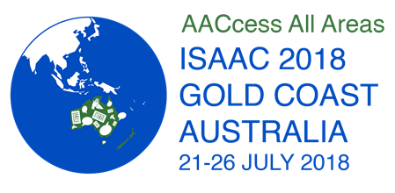

ISAAC is excited to announce the 18th Biennial Conference of the **International Society for Augmentative and Alternative Communication**, ISAAC 2018, will be held at the Gold Coast Convention and Exhibition Centre in Gold Coast, Queensland, Australia, on July 21-26, 2018.

JOIN US for AAC events and perspectives, the latest in research and clinical innovations, workshops, seminars, exhibits, social events, entertainment – everything you have come to expect from an ISAAC conference, and more!

Mark your calendar today, and save the date for **ISAAC 2018 in Australia**!

For more information, visit us at [www.isaac-online.org](http://www.isaac-online.org/) and follow #ISAAC2018 on Twitter.

**EMPLOYMENT and** **FUNDING OPPORTUNITIES**

**Employment Opportunities on our new website**

Keep a watch on the [Get Involved](https://www.addc.org.au/get-involved/) section of our new website for postings of job opportunities, consultancies and other funding opportunities in the sector

# Occupational Therapist

# AVI, South Africa

# Assignment duration; 12 months

# Advertisement Code; 10539490

# Application Deadline; 21 Dec 2017

# Work with staff to strengthen the work of Sparrow Schools Educational Trust, making a positive difference for children and youth with barriers to learning.

# Live in Johannesburg and immerse yourself in a different culture.

# Share your OT skills and approaches to your profession.

# For enquiries, contact Kylie Regester on [KRegester@avi.org.au](mailto:KRegester@avi.org.au) or [+61 3 9279 1745](tel:+61-3-9279-1745). All applications must be submitted online.

# [Application information and the full job description is available for download on the AVI website](https://www.australianvolunteers.com/opportunities/10539490/).

### Toyota Mobility Foundation launches $4 million challenge to expand mobility for people with lower-limb paralysis

The Toyota Mobility Foundation, in partnership with Nesta’s Challenge Prize Centre, has launched a $4 million dollar global challenge to change the lives of people with lower-limb paralysis, culminating in the unveiling of the winners in Tokyo in 2020.  
  
The Mobility Unlimited Challenge aims to harness creative thinking from across the world to accelerate innovation and encourage collaboration with users to find winning devices to transform the world for people with lower-limb paralysis. The Challenge will reward the development of personal mobility devices incorporating intelligent systems.

The mobility solutions of the future could include anything from exoskeletons, to artificial intelligence and machine learning, from cloud computing to batteries.

Around the world, millions of people have lower-limb paralysis (the most common causes being strokes, spinal cord injury and multiple sclerosis). Innovation in “smarter” mobility technology has the potential to create personal devices that are better integrated with the user’s body and the environment. But the application of this groundbreaking technology is slow due to disincentives such as small and fragmented markets, regulatory burdens, and reimbursement complexities from healthcare systems and insurers.

A panel of expert judges will pick five finalists who will each receive $500,000 to take their concepts from an intelligent insight to a prototype. The Challenge winner will receive

$1,000,000 to make the device available to users- with the winning concept unveiled in Tokyo in 2020.

The Mobility Unlimited Challenge aims to attract and support smaller innovators who might otherwise struggle to break into the assistive technology market. The Discovery Awards will provide seed funding of $50,000 for 10 groups with promising concepts, but who might otherwise lack the resources to enter the Challenge. Interested innovators can apply online at [mobilityunlimited.org](http://mobilityunlimited.org/).

### 21st ASEF Summer University 27 January – 10 February 2018,

Australia & New Zealand, **applications close 10 December.**

The Asia-Europe Foundation (ASEF) has recently published an Open Call for Application to the 21st ASEF Summer University (ASEFSU21) on “Youth with Disabilities: Shaping Inclusive ASEM Societies”. The project will take place between 27 January and 10 February 2018 in Melbourne (Australia) and Christchurch (New Zealand).

[Read more about the program and how to apply here.](http://asef.org/index.php/projects/themes/education/4122-21st-asef-summer-university-asefsu21)

## ****M&E and**** ****DISABILITY****

### Questionnaire: Empowerment of Women who are Blind or Partially Sighted

World Blind Union Members are requested to share this survey with blind and partially sighted women and encourage them to complete and return it to the WBU Women’s Committee to aid in determining the reason for a low number of women leaders.

Please return the completed questionnaire by **31 January 2018 to the WBU Office at** [info@wbu.ngo](mailto:info@wbu.ngo)

The survey is available for download on the [ADDC website](http://www.addc.org.au/content/resources/questionnaire-empowerment-of-women-who-are-blind-or-partially-sighted/1721/)

## ****NEW**** ****RESOURCES****

### Supporting the Poorest and Most Vulnerable in CLTS Programmes (Learning Paper)

This paper provides practical suggestions and examples on how to identify and include the poorest and most vulnerable (including people with disabilities) within CLTS programs.

[See the paper here.](http://www.communityledtotalsanitation.org/resource/supporting-poorest-and-most-vulnerable-clts-programmes-learning-paper)

### Bhutan launches KAP study on children with disabilities

The Education Ministry in collaboration with UNICEF Bhutan launched the first-ever [Knowledge, Attitudes, and Practices (KAP) study on children with disabilities](http://www.unicefbhutan.org.bt/wp-content/uploads/2017/11/FullDocument.pdf) in Thimphu, on Saturday.

The study provides an insight into attitudes of Bhutanese people towards children with disabilities. According to education officials, the survey was carried out in nine districts where responses were asked based on sex, age, and education status among others. “One of the key findings under the Knowledge on disability is very limited. And educated people are more aware of disability issue and their attitude towards children with disability is more positive than those who are uneducated,” said Tshering Lhamo, Deputy Chief Programme Officer of Education Ministry. “Under practices, it was discovered that access to services for children with disability is poor, mainly in rural areas.”

[UNICEF Bhutan](http://www.unicefbhutan.org.bt/) hopes the study will be instrumental in making policies and programmes to address the needs of one of the most marginalised groups and help identify priorities on social inclusion of children with special needs. The KAP study is also expected to guide relevant stakeholders in improving and reforming policies to support disabled children.“There are number of recommendations and UNICEF is fully committed to work with various partners to help families, to help institutions and to also improve the knowledge because if people have the right knowledge, already the effort has been made in order to improve the lives,” said Rudolf Schwenk, Representative of UNICEF Bhutan. “This will lead to much more inclusive society,” she added. *(Source:* [*BBS*](http://www.bbs.bt/news/?p=83863)*,GAATES)*

### New UNAIDS report ‘Disability and HIV’

*“Persistent discrimination against and exclusion of people with disabilities, in particular women and girls with disabilities, increases their vulnerability, including their risk of HIV infection."*

This report from the Joint United Nations Programme on HIV and AIDS (UNAIDS) highlights existing key evidence on the relationship between disability and HIV. It discusses the concrete steps needed for a person-centred, disability-inclusive HIV response that allows for increased participation of people with disabilities and integrates rehabilitation within the continuum of HIV care.

The report is available for download from the [UNAIDS website](http://www.unaids.org/sites/default/files/media_asset/JC2905_disability-and-HIV_en.pdf).

### New report from PLAN International: ‘Let Me Decide and Thrive’

Girls with disabilities are kept in the dark about their sexual and reproductive health and often don’t know how to protect themselves against abuse, pregnancy and disease. This report highlights the perfect storm of discrimination faced by girls with disabilities, which leaves many of them totally unaware of their rights.

While the discriminatory hurdles posed by gender, youth or disability alone can be great, this reportreveals that when all three come together they intensify the negative effects of exclusion. As a consequence, girls and young women with disabilities face significant obstacles to the full realisation of their rights, including their sexual and reproductive health and rights (SRHR).

The [*Let Me Decide and Thrive*](https://plan-international.org/publications/let-me-decide-thrive-srhr-disability)Research Report explores diverse existing materials on this subject and adds a first-hand vantage point gleaned from its in-depth qualitative research in three countries, Cambodia, Paraguay and Zambia. The research was commissioned by Plan International and conducted by the International Solutions Group as part of an ongoing collaboration between Plan International and the UN Special Rapporteur on the Rights of Persons with Disabilities, Ms. Catalina Devandas Aguilar, to promote and protect the SRHR of girls and young women with disabilities.

The report provides an overview of regional and international legal frameworks and trends, country-specific case studies, as well as concrete recommendations.

The report is available for download from the [PLAN International website](https://plan-international.org/publications/let-me-decide-thrive-srhr-disability)

### Jeremy the Dud: The Short Film That Flips Disability on its Head

Jeremy the Dud is a comedy set in a world where everyone has a disability, and those that don't are treated with the same prejudice, stigma and condescending attitudes people with disabilities face in our own society. Presented by GenU and produced by Robot Army.

20 minutes of your time, very well spent! [See the film here.](https://www.youtube.com/watch?v=qFcFpWzIQNk)

### World Blind Union – Asia Pacific has a new website

The [website of World Blind Union – Asia Pacific](http://wbuap.org/index/) has just been updated.

Through this website you can keep up to date with the work World Blind Union – Asia Pacific are doing to promote the interests of blind and vision impaired people in this region. You can:

* browse through our latest news and website updates right here on this page;
* read about [their work](http://wbuap.org/index/work) in more detail;
* find out more about [who they are](http://wbuap.org/index/about-us) and the [countries](http://wbuap.org/index/members) that make up our region;
* read issues of the [East Wind](http://wbuap.org/index/archives/category/publications/east-wind) newsletter; and
* subscribe to receive [updates](http://wbuap.org/index/subscribe) from this website direct to your inbox or use the [RSS feed](http://wbuap.org/index/feed).

WBU-AP have tried hard to make this website work well for you whether you are blind, have low vision or are fully sighted, and whether you are using a computer, smart phone or other device. You can read more [about this website](http://wbuap.org/index/about-this-website), its accessibility features and how you can get the most from it.

## ****NEWSLETTERS**** ****from OTHER ORGANISATIONS****

### United States International Council on Disabilities (USICD) Newsletter, Oct/Nov 2017-11-21

**In this issue:**

* Fourth USICD Gala on December 5th 2017!
* US and Ireland Independent Living Peer Project in June 2018
* Using Amazon Smile to Support USICD #GivingTuesday
* Global Disability Rights Leader Maria Veronica Reina Passes Away
* International Holman Prize Award Competition Soon Open for Applications from Blind Adventurers and Creators
* Inclusion International will hold its 17th annual World Congress from May 30 to June 2nd, 2018
* The next World Down Syndrome Congress will be held in Scotland, July 24-27, 2018
* Vice President of Argentina emphasizes country's commitment to Convention on the Rights of Persons with Disabilities (CRPD)
* Hanoi People's Committee builds website providing information on accessibility for people with disabilities in Vietnam
* New Handbook on Observing and Promoting the Electoral Participation of Persons with Disabilities released by Organization for Security and Co-operation in Europe (OSCE)
* European Disability Forum highlights barriers that deny the right to vote to many Europeans with disabilities

[To access the newsletter go to the USICD website](http://campaign.r20.constantcontact.com/render?m=1102973772183&ca=e21a7d0e-1737-4475-84c4-0c2514700297)

### ****DRD - Newsletter October 2017****

Disability Research and Capacity Development (DRD) was established in 2005 in Vietnam. DRD works alongside the community to create support models that promote the rights of people living with disabilities.

Some of the highlights in the Oct 2017 newsletter are:

* Improved access to education for students with disabilities
* DRD’s notion is that not going alone, but must cooperate with other partners, especially government agencies.
* “How to make workers with disabilities feel inte-grated in their work-place” at SCHENKER Company.
* Kids do physical therapy on Mid-autumn fest too!
* How accessible is Saigon for people with disabilities?

[Download the full newsletter](http://www.drdvietnam.org/images/baiviet/An%20Pham/2017.10.Newsletter.pdf).

**ADDC**is an Australian, international network focusing attention, expertise and action on disability issues in developing countries; building on a human rights platform for disability advocacy.

To join ADDC or just receive our bulletins and information please contact [info@addc.org.au](mailto:info@addc.org.au?subject=Newsletter%20feedback).

**ADDC Executive Officer  
Kerryn Clarke**  
+61 3 8843 4519

[info@addc.org.au](mailto:info@addc.org.au?subject=ADDC%20Newsletter%20Feedback)  
[www.addc.org.au](http://www.addc.org.au)