 [Facebook](https://www.facebook.com/pages/Australian-Disability-and-Development-Consortium-ADDC/924884487560967)     [Twitter](https://twitter.com/ADDCnews)                                      [Website](http://www.addc.org.au)  |  [Subscribe](mailto:info@addc.org.au?subject=Subscribe%20to%20ADDC%20newsletter&body=Please%20subscribe%20me%20to%20the%20ADDC%20newsletter.%0AName%3A%20%0AOrganisation%3A%20%0AEmail%3A%20)   |  [Email us](mailto:info@addc.org.au?subject=Newsletter%20feedback) │ [Donate](https://www.cbm.org.au/donate/addc/1508)

**Welcome to the October 2017 ADDC Bulletin**

The purpose of this Bulletin is to provide information on Disability Inclusive Development across organisations working to improve the quality of life for people with disabilities both here in Australia and across the world.

Generic disability and domestic information will be included in our Bulletins when possible as part of our commitment to disability advocacy and strengthening partnerships: however our focus remains on disability and development issues.

Your contributions are welcome to make these Bulletins a valuable resource providing Updates and Information on Conferences or Events, Employment and Funding Opportunities and Resources for Disability Inclusive Practice.

Please do not hesitate to send updates, news or resource documents to [info@addc.org.au](mailto:info@addc.org.au?subject=ADDC%20Bulletin%20Response) so they can feature in this bulletin or on ADDC website.

[Follow ADDC on Twitter](https://twitter.com/ADDCnews)

Follow ADDC on Twitter

**CONTENTS**

News and Updates  
Conferences and Events  
Employment and Funding Opportunities  
M&E and DisabilityEmployment and DisabilityNew Resources  
Newsletters from Other Organisations

**Disclaimer**

The ADDC Bulletin is a compilation of other organisations’ articles and material. While every effort is made to validate content ADDC does not endorse all opinions and views contacted within the Bulletin.

## **NEWS and** **UPDATES**

### **International Day of People with Disability 2017**

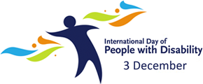

International Day of People with Disabilities (IDPD), celebrated on 3 December each year, is fast approaching! It’s an important day to raise awareness and promote action around the rights of people with disability and their full inclusion in society.

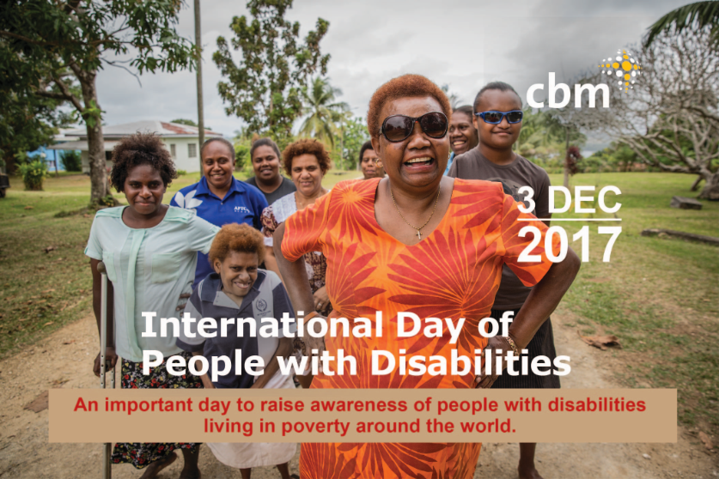

Each year CBM Australia produces an IDPD Communications Kit to help you and your organisation raise awareness and promote the day. The Kit includes a range of resources such as: images, infographics and suggested social media posts, as well as a new video from Vanuatu which highlights the unique experience of women and girls with disabilities living in poverty.

For more information or to receive the IDPD Communications Kit, please contact Elle Spring: [espring@cbm.org.au](mailto:espring@cbm.org.au)

### High-level Intergovernmental Meeting on the Midpoint Review of the Asia-Pacific Decade of Persons with Disabilities, 2013-2022

***Beijing, China***

United Nations [ESCAP](http://www.unescap.org/events/high-level-intergovernmental-meeting-midpoint-review-asian-and-pacific-decade-persons), in cooperation with the China Disabled Persons’ Federation (CDPF), is organizing the High-level Intergovernmental Meeting on the Midpoint Review of the Asian and Pacific Decade of Persons with Disabilities, 2013-2022, in Beijing from 27 November to 1 December 2017.

Objectives of the Meeting are:

* To undertake a midpoint review of the progress made, including gaps and challenges, in the implementation of the Asian and Pacific Decade of Persons with Disabilities, 2013-2022, and the Incheon Strategy to “Make the Right Real” for Persons with Disabilities in Asia and the Pacific;
* To discuss the future policy direction for building disability-inclusive societies in Asia and the Pacific, bearing in mind the synergies between the Incheon Strategy and the 2030 Agenda for Sustainable Development as well as the Convention on the Rights of Persons with Disabilities;
* To consider and adopt an outcome document to accelerate the implementation of the Incheon Strategy for the remainder of the Decade.

The Meeting is taking place at a critical juncture when ESCAP member States and associate members are striving to build more inclusive societies at a time of global economic uncertainties and rising inequality, and the 2030 Agenda for Sustainable Development provides a unique opportunity to “leave no one behind” in development, and to support disability-inclusive development across Asia and the Pacific.

[Read more here](http://globalaccessibilitynews.com/2017/09/30/high-level-intergovernmental-meeting-on-the-midpoint-review-of-the-ap-decade-of-persons-with-disabilities-2013-2022/)

***(Source: GAATES, ESCAP)***

### UN Women’s Strategic Plan 2018-2021

UN Women’s new Strategic Plan will contribute to women with disabilities reaching decision-making positions; gender responsive national and local plans, strategies, policies and budgets, including support to disability programming; and more and better quality and disaggregated data and statistics, including for those in vulnerable situations.

UN Women will continue to strengthen its relationship with women’s organizations and networks, including disability organizations. The Strategic Plan has four inter-connected outcomes: women lead, participate in and benefit equally from governance systems; have income security, decent work and economic autonomy; live free from violence; and contribute to building sustainable peace and resilience, and benefit equally from crisis prevention and humanitarian action.

For more information, go to visit the [UN Women website](http://www.unwomen.org/en/executive-board/documents/second-regular-session-2017).

*(Source:GAATES)*

### Why We Need Specific Funding for the Rights of Women with Disabilities

‘In the years following the adoption of the UN Convention on the Rights of Persons with Disabilities (CRPD), international disability rights advocacy was mostly focused on getting on the human rights agenda. It was about getting into the room, becoming visible in places where persons with disabilities had been invisible, and participating in policy development. These were important targets and there was an important focus on uniting people with disabilities across impairments, but less attention was paid to the multiple identities people with disabilities hold.

Today, with the Sustainable Development Goals, *leaving no one behind* is not only a reference to marginalized communities such as persons with disabilities, but the need for the disability rights *community* to better include marginalized persons with disabilities.

Women with disabilities are a stark example of the marginalization some sub-groups face within the disability community itself. It’s exciting to hear how many governments are talking about the need for inclusion of women with disabilities. And we also need to keep challenging ourselves.’

*Taken from a presentation made by Catherine Hyde Townsend, Sr. Program Officer, Wellspring Advisors and DRF / DRAF Board Co-Chair at the 10th session of the Conference of States Parties to the CRPD, “Supporting Inclusive Movements: Funding the Rights of Women with Disabilities,” June 14, 2017.* [Read the original article from Disability Rights Fund here](http://disabilityrightsfund.org/2017/07/24/why-we-need-specific-funding-for-the-rights-of-women-with-disabilities/)

### Vietnam to improve the quality of life for persons with disabilities

The National Committee on Empowerment of Persons with Disabilities has agreed to support funding for the building and improvement of provincial service centers for people with disabilities in 77 provinces, to provide them with thorough access to government welfare.

The life improvement for people with disabilities, according to the Government policy, aims to support them by providing public transportation and other facilities, investigating companies that do not hire people with disabilities, adding more pay channels in the E-Payment system, improving health care, and allowing them to choose either universal health care or social insurance.

The National Committee for Empowerment of Persons with Disabilities has agreed with the draft of the fifth Life Improvement for People with Disabilities plan (2017-2021), with the vision “people with disabilities can truly access the facilities and can live happily in society,” and it has assigned the Department for Empowerment of Persons with Disabilities to proceed accordingly.  
According to the Empowerment of Persons with Disabilities Act, B.E. 2550 (2007), and its amendment (Vol. 2) B.E. 2556 (2013), it prohibits discriminatory actions that result in the loss of benefits or rights of persons with disabilities on the grounds of their disabilities.

The employment policy is that public and private organizations are required to hire person with disabilities at the ratio of one persons with disabilities to 100 regular employees. However, employers who do not comply with the employment of persons with disabilities ratio must make a payment to the Fund for Empowerment of Persons with Disabilities.

At the urging of the Government, many public sector agencies tend to hire more people with disabilities to work in their organizations; for instance, the Ministry of Public Health plans to hire more than 1,200 people with disabilities to work in its health service centers around the country in the next fiscal year. The ministry has so far employed 513 people with disabilities to work in health organizations in 47 provinces.

*(Source: vov, GAATES)*

### Persons with disabilities emphasize need to involve in DRR programs

*Philippines*

In its effort towards disaster risk reduction, persons with disabilities expressed the need to involve themselves in disability-inclusive disaster risk reduction programs. The secretary general of the World Blind Union Asia-Pacific, Teddy Kahil, commented that persons with disabilities are greatly affected during disaster. “I, as a blind person, can move quickly in times of disaster, but the only problem is I don’t know which direction to go,” he said. “If we want to make an inclusive disaster risk reduction management programs, we have to be involved in the decision making process.”

Abner Manlapaz, the president of Life Haven, recalled an experience wherein he and other persons with disabilities emphasize need to involve in DRR programs were having a meeting at a hotel in Manila when they were approached by the hotel manager to excuse them from the earthquake drill but they insisted on joining. Manlapaz said that it took a lot of time for the hotel staff to carry them to the evacuation area at the ground floor. “In times of real disaster, evacuations must be done as soon as possible,” he said.

In addition, Manlapaz said there is also a need to improve facilities to make it accessible to persons with disabilities emphasize need to involve in DRR programs. In institutionalizing disability inclusion in disaster risk reduction management in the Philippines, a three-day national conference on disability-inclusive disaster risk reduction and management with the theme of “Inclusion starts with I” was held. The conference was initiated by the different persons with disabilities who emphasized the need to be involved in DRR programs groups and local government units.

*(Source: cebudailynews, GAATES)*

### Mental Health Bill Undermines Disability Rights in Mexico

Mexico’s Congressional Mental Health and Drug Commission is considering a national mental health bill that proposes to improve mental health services for all in Mexico but would seriously jeopardize the rights of people with disabilities, Human Rights Watch said today.

In a [letter](http://www.hrw.org/news/2017/10/16/letter-chair-mental-health-and-drug-commission-mexico) sent on October 16, 2017, to the Commission on Health and Drugs in the Chamber of Deputies, Human Rights Watch urged the commission to reject the bill in its current form. The commission should revise the bill to reflect a human rights-oriented framework, based on consultations with organizations representing people with disabilities and disability rights experts. The final bill should ensure the right to mental health for all in Mexico on an equal basis, without resort to forced treatment, and be consistent with Mexico’s laudable international commitments to the rights of persons with disabilities.

“The bill before the commission unfortunately reflects a discredited approach to mental health, focusing on forced medical treatment instead of on the consent, autonomy, and rights of those in need of mental health services,” said Carlos Ríos Espinosa, senior researcher and advocate for disability rights at Human Rights Watch. “The bill is inconsistent with Mexico’s human rights obligations, in particular the right to consent to or refuse treatment, which is an integral aspect of the right to health.”

Mexico was an early champion of the United Nations Convention on the Rights of Persons with Disabilities (CRPD), signing the treaty when it was first opened and becoming a full party to the CRPD in 2007. The Mexican government has the opportunity with this new law to incorporate the standards of the CRPD into domestic law and protect the rights of persons with disabilities. It should follow the example of other countries and international organizations, such as the World Health Organization, that are developing new mental health policies that respect the rights of people with disabilities and emphasize people’s right to choose and to govern their own lives.

[Read more.](https://www.hrw.org/news/2017/10/17/mexico-mental-health-bill-undermines-disability-rights)

*(Source: Human Rights Watch)*

### Google Maps is Getting Serious about Accessibility

Google wants to make it easier for people with wheelchairs to get around using Maps, so the search giant is asking its massive user base for some help.

Maps is launching a new initiative to encourage its [**Local Guides**](https://t.e2ma.net/click/6x8ly/ir7pfk/advk5i) community to update locations around the world with new, detailed information about accessibility. Maps users can answer five simple questions about a site, for example, "Is there a wheelchair-accessible entrance?", and the answers will be visible in the Map results afterwards.

Google is also launching a new YouTube series, [**Rolling On**](https://t.e2ma.net/click/6x8ly/ir7pfk/q5vk5i), to highlight accessibility issues for around the world. The first two episodes have already posted, giving the wider world a closer look at the challenges people using wheelchairs face as they navigate life in Chicago and Indonesia.

[**Read more about ‘Google Maps getting serious about accessibility’**](https://t.e2ma.net/click/6x8ly/ir7pfk/6xwk5i).

## **CONFERENCES** **and EVENTS**

### 23rd Conference of Asian Federation on Intellectual Disabilities (AFID), (18-24 November, 2017)

Theme: “Acceptance, Accessibility, Inclusion-A key towards Sustainable Development”.

The 23rd Conference of Asian Federation on Intellectual Disabilities (AFID) is going to be held from 18-24 November 2017 in Dhaka, Bangladesh. So we are delighted to call for submission of abstract for the 23rd Conference of AFID.

AFID is an International Association for the persons with Intellectual Disabilities in the Asia Pacific region to promote, coordinate and sponsor activities related to Intellectual Disabilities in Asia also to assist the formation of national organizations in any Asian country, and assist such national organizations to coordinate activities related to the Intellectual Disabilities.

[For more detailed information on the submission of abstract and conference registration please visit the Conference of Asian Federation on Intellectual Disabilities website](http://afid23.org/).

### ASEAN Disability Forum Conference, Manila (3-4 December 2017)

*Conference Theme: Partnering for Change, Inclusion the World*

The conference will be held in Manila on December 3-4, 2017. It will focus on the implementation of the Convention on the Rights of Persons with Disabilities (CRPD) and the ASEAN Decade of Persons with Disabilities 2011 - 2020 in conjunction with Agenda 2030.

[More information is available on the ADDC website](http://www.addc.org.au/events/asean-disability-forum-conference/199/)

### ISAAC Conference 2018 (21-26 July, 2018)

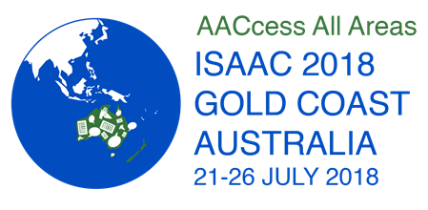

ISAAC is excited to announce the 18th Biennial Conference of the **International Society for Augmentative and Alternative Communication**, ISAAC 2018, will be held at the Gold Coast Convention and Exhibition Centre in Gold Coast, Queensland, Australia, on July 21-26, 2018.

JOIN US for AAC events and perspectives, the latest in research and clinical innovations, workshops, seminars, exhibits, social events, entertainment – everything you have come to expect from an ISAAC conference, and more!

Mark your calendar today, and save the date for **ISAAC 2018 in Australia**!

For more information, visit us at [www.isaac-online.org](http://www.isaac-online.org/) and follow #ISAAC2018 on Twitter.

## **EMPLOYMENT and** **FUNDING OPPORTUNITIES**

### ****Inclusive Education Technical Adviser, PNG, Save the Children****



**Rapidly Improving Standards in Elementary Program**

The Rapidly Improving Standards in Elementary consortia is led by Save the Children in Papua New Guinea, Summer Institute of Linguistics (SIL) Papua New Guinea Branch and Callan Services for Persons with Disabilities National Unit (CSNU). The Rapidly Improving Standards in Elementary aims to improve literacy and numeracy of elementary aged children in the East Sepik Province, Eastern Highlands Province and the Autonomous Region of Bougainville.

CSNU is currently seeking applications for the position of:

**Inclusive Education Technical Adviser**

For information on this position and how to apply go to the [ADDC website](http://www.addc.org.au/content/resources/inclusive-education-technical-adviser/1716/)

Applications are to be submitted by close of business by **16th November 2017**

### Disability Rights Fund Seeks Pacific Islands Grants Consultant

The Grants Consultant is an exciting new position, which will help support the grant making of the Disability Rights Fund and the Disability Rights Advocacy Fund in the Pacific Islands region (Cook Islands, Federated States of Micronesia, Fiji, Kiribati, Marshall Islands, Nauru, Niue, Palau, Papua New Guinea, Samoa, Solomon Islands, Tonga, Tuvalu, Vanuatu).

Position location: Pacific Islands.

For more about this position including the full job description, visit the [DRF website](http://disabilityrightsfund.org/about/opportunities/).

Applications must be received by November 30, 2017.

### 2018 Disability Rights Scholarship Program

The Disability Rights Scholarship Program provides yearlong awards for master’s degree study to disability rights advocates, lawyers, and educators to develop new legislation, jurisprudence, policy, research, and scholarship to harness the innovations and opportunities offered by the United Nations Convention on the Rights of Persons with Disabilities (CRPD).

With the knowledge and networks gained through the program, it is expected that fellows will deepen their understanding of international law and education, with a focus on disability rights, and gain the tools necessary to engage in a range of CRPD implementation strategies, such as: challenging rights violations in their home countries by drafting enforceable legislation consistent with the CRPD; utilizing enforcement mechanisms set forth in the Convention; taking forward disability rights litigation requesting CRPD-compliant remedies; engaging in disability rights advocacy; and developing law, education, or other academic curricula informed by the CRPD.

The scholarships are open to citizens and legal residents of China, Ghana, Malawi, Mozambique, Sudan, South Sudan, Tanzania, Uganda, Mexico, or Peru at the time of application.

Application deadline is 1 December, 2017.

[For more information about the program and application information go to the website](https://scholarshipprograms.submittable.com/submit/96217/2018-disability-rights-scholarship-program).

## **NEW** **RESOURCES**

### New UNICEF study shows children with disabilities often face stigma and discrimination

Six in ten people surveyed do not have enough information about children with disabilities, UNICEF said in a [study released](https://www.unicef.org/malaysia/resources.html). This is the first nationwide research to shed light on the perceptions, attitudes and practices towards childhood disability in Malaysia.

Findings from the research reveal that knowledge about disability is low and that children with disabilities, their parents, and family face real stigma and discrimination at home, in schools, and other environments in Malaysia. [Read more about this on GAATES](http://globalaccessibilitynews.com/2017/10/16/new-unicef-study-shows-children-with-disabilities-often-face-stigma-and-discrimination/)

[Download the full report in PDF from the UNICEF website](https://www.unicef.org/malaysia/Final_File_Childhood_Disability_in_Malaysia_Book_(Interactive_PDF).compressed_3_Oct_2017.pdf).

### New app to help people with vision disabilities navigate spaces, buildings

World Sight Day 2017 takes place this year on Thursday 12 October. It is a day which highlights issues affecting people who are blind and have low vision across the globe.

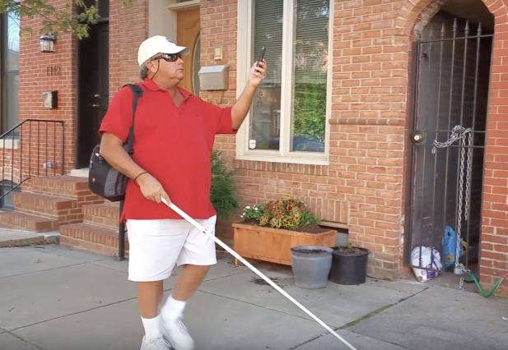

Three South African men are making an impact in an effort to improve the support of people with vision disabilities in the country. Siegfried Jegels, Richard Newman and Brandon van der Ventel developed a mobile app called ProxiSee. ProxiSee aims to help people who are blind and have low vision independently navigate their homes and other public spaces using beacon technology, they explain. “It helps people who are blind and have low vision navigate independently indoors by means of audible signals and gesture controls” said Siegfried Jegels, developer of ProxiSee. “The app pushes information using the Bluetooth signal. It uses the idea of magnetic steering.” said Brandon van der Ventel.

*(Source:GAATES)*

**ADDC**is an Australian, international network focusing attention, expertise and action on disability issues in developing countries; building on a human rights platform for disability advocacy.

To join ADDC or just receive our bulletins and information please contact [info@addc.org.au](mailto:info@addc.org.au?subject=Newsletter%20feedback).

**ADDC Executive Officer  
Kerryn Clarke**  
+61 3 8843 4519

[info@addc.org.au](mailto:info@addc.org.au?subject=ADDC%20Newsletter%20Feedback)  
[www.addc.org.au](http://www.addc.org.au)