Development for All 2015-2020 Strategic Framework, pg. 6

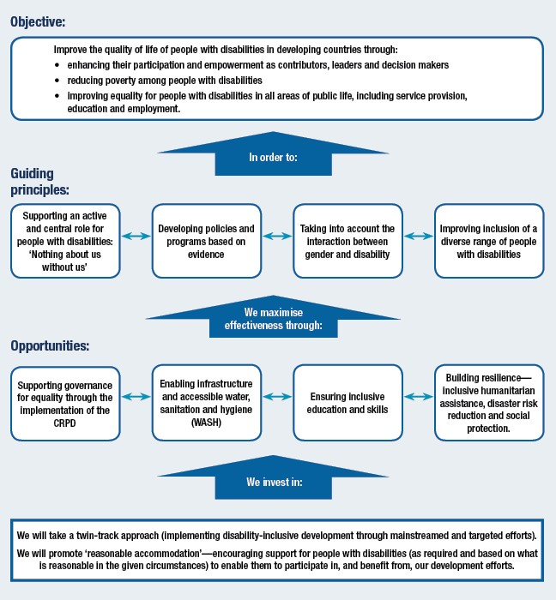

Image description of the Development for All 2015-2020 Strategic Framework:

The title written on the top of the page is “Strategic Framework” and it is found on page 8 of the word version of the Development for All Strategy 2015-2020. This framework underpins Development for All 2015–2020: Strategy for strengthening disability-inclusive development in Australia’s aid program and outlines how Australia will strengthen disability-inclusive development and, in turn, promote our national interests by contributing to sustainable economic growth and poverty reduction, in line with the overall purpose of the aid program.

The information flow in the diagram flows from the bottom to the top of the page.

On the bottom of the page is a box with the words “We will take a twin track approach (implementing disability-inclusive development through mainstreamed and targeted efforts). We will promote ‘reasonable accommodation’ – encouraging support for people with disabilities (as required and based on what is reasonable in the given circumstances) to enable them to participate in, and benefit from, our development efforts.

Above the box is an arrow pointing upwards with the following words “We invest in” written inside the arrow. Above the arrow are four boxes that state the opportunities for investment. From left to right the words in the first box say “Supporting governance for equality through the implementation of the CRPD”. The words in the second box say “Enabling infrastructure and accessible water, sanitation and hygiene (WASH). The words in the third box say “ensuring inclusive education and skills. The words in the fourth box say “Building resilience – inclusive humanitarian assistance, disaster risk reduction and social protection”. These four boxes are connected by two way arrows indicating that all stated opportunities are interconnected.

Above the four opportunity boxes is an arrow pointing upwards with the words “We maximise effectiveness through:” written inside the arrow. The arrow points up to four more boxes representing the guiding principles. These four boxes are interconnected by two-way arrows. From left to right the first box says “Supporting an active and central role for persons with disabilities: ‘Nothing about us without us’”. The second box says “Developing policies and programs based on evidence”. The third box says “Taking into account the interaction of gender and disability”. The fourth box says “Improving inclusion of a diverse range of people with disabilities”.

Above the guiding principles is a final arrow pointing upwards with the words “in order to:” written inside. This arrow leads to one box that states the objective. Inside the box is written “Improve the quality of life of people with disabilities in developing countries through:
- enhancing their participation and empowerment as contributors, leaders and decision makers
- reducing poverty among people with disabilities
- improving equality for people with disabilities in all areas of public life, including service provision education and employment.”

Above this box we return to the page title “Strategic Framework”

End of image description.

