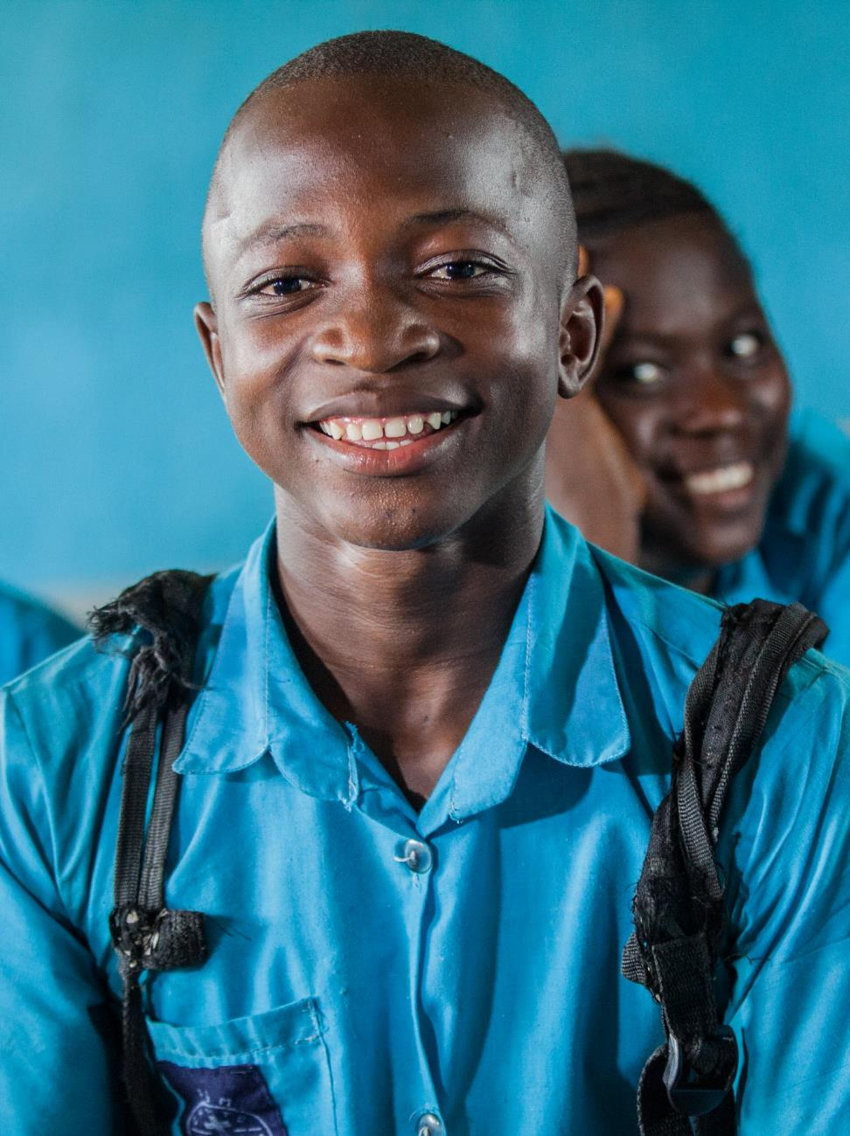**Practice note:** Collecting and using data on disability to inform inclusive development

**Plan International Australia  
CBM Australia-Nossal Institute Partnership for Disability Inclusive Development**

July 2015

This Practice Note was prepared by Asahel Bush (Plan International), Aleisha Carroll (CBM Australia) and Kathryn James (CBM Australia), drawing on inputs from other Plan, CBMA and Nossal Institute staff.

**About this Practice Note**

This document is the result of a collaboration between Plan International Australia and the CBM Australia-Nossal Institute Partnership for Disability Inclusive Development. It was prepared in the context of growing interest among international development agencies in disability inclusive practice, and the collection of evidence to underpin this. It draws on some of the experiences and learning arising from Plan’s work to strengthen disability inclusion within its development programs and the CBM-Nossal Partnership’s work to strengthen disability inclusion within the Australian development sector.

Rather than serving as a comprehensive manual or toolkit, it is hoped that this Practice Note will contribute to a conversation on how data on disability can be collected and used within programs to support both inclusive development practice and inclusive development outcomes. To this end, we would encourage any feedback on the contents of this practice note or suggestions for supporting resources which could be of use to international development agencies.

**Contact Us**

For further information, please contact us at:

Plan International Australia: [Deborah.Elkington@plan.org.au](mailto:Deborah.Elkington@plan.org.au)

CBM Australia: [idresources@cbm.org.au](mailto:idresources@cbm.org.au)

Nossal Institute for Global Health: [ni-info@unimelb.edu.au](mailto:ni-info@unimelb.edu.au)

**About Us**

**Plan International** is one of the oldest and largest children’s development organisations in the world, working with communities in more than 50 developing countries. By actively involving children, and working at a grassroots level with no religious or political affiliations, Plan unites and inspires people around the globe to transform the world for children.

**CBM Australia** is Australia's largest implementer of disability-specific and inclusive development activities worldwide. CBM International is an independent Christian development organisation, whose primary purpose is to improve the quality of life of the world's poorest people with disabilities and those at risk of disability, who live in the world's most disadvantaged societies.

**The Nossal Institute for Global Health** at the University of Melbourne brings together multi-disciplinary expertise to address global health challenges. The Nossal Institute’s work focuses on non-communicable diseases, health systems strengthening, education and learning, communicable diseases and inclusive development practice. It has a combined focus on development assistance, research and teaching.

**The CBM Australia-Nossal Institute Partnership for Disability Inclusive Development** strives to develop and strengthen capacity, policies and systems towards disability inclusive development practice and research.

Plan International Australia  
GPO Box 2818, Melbourne VIC 3001 Australia  
Tel: 13 75 26 Fax: +61 (0)3 9670 1130  
[www.plan.org.au](http://www.plan.org.au)

CBM Australia  
PO Box 348, Box Hill VIC 3128 Australia  
Tel: 1800 678 069 Fax: +61 (0)3 8843 4545  
[www.cbm.org.au](http://www.cbm.org.au)

Nossal Institute for Global Health  
Melbourne School of Population and Global Health  
The University of Melbourne, Vic. 3010 Australia  
Tel: +61 (0)3 8344 9299 Fax: +61 (0)3 9347 6872  
[ni.unimelb.edu.au](http://ni.unimelb.edu.au/)

Contents

Introduction 4

1. Background on disability inclusion 5

1.1. Why collect information about disability? 6

1.2. Defining disability 8

1.3. Disability inclusive development 10

2. Making data collection processes disability inclusive 13

3. Planning for data collection within a project or program 16

4. Methods and tools for collecting data to support disability inclusion 20

4.1. Disaggregating data by disability 23

4.2. Identifying people with disabilities 24

4.3. Data collection methods 30

4.4. Collecting data about children with disabilities 36

Key messages 42

Further resources 46

List of Acronyms

|  |  |
| --- | --- |
| ANCP | Australian NGO Cooperation Program |
| ADRA | Australian Development Research Award |
| CBR | Community-Based Rehabilitation |
| CEDAW | Convention on the Elimination of All Forms of Discrimination Against Women |
| CRPD | Convention on the Rights of Persons with Disabilities |
| DFAT | Department of Foreign Affairs and Trade (Australia) |
| DPO | Disabled People’s Organisation |
| FGD | Focus Group Discussion |
| INGO | International Non-Government Organisation |
| M&E | Monitoring and Evaluation |
| MSC | Most Significant Change |
| NGO | Non-Government Organisation |
| PLA | Participatory Learning and Action |
| PRAAC | Promoting Rights and Accountabilities in African Communities project |
| RAD | Rapid Assessment of Disability tool |
| SDGs | Sustainable Development Goals |
| UN | United Nations |
| UNICEF | United Nations Children’s Fund |
| WASH | Water, Sanitation and Hygiene |
| WHO | World Health Organization |

# Introduction

Over the past decade, there has been growing awareness within the Australian development community of the need for international development programs to be inclusive of people with disabilities. The United Nations Convention on the Rights of Persons with Disabilities(CRPD) states that international development programs should be inclusive of and accessible to people with disabilities. *Disability inclusive development* refers to the involvement of people with disabilities in all development processes and outcomes, to ensure equal realisation of their rights and effective inclusion. It involves overcoming inequalities and addressing barriers which hinder access and participation of people with disabilities in all aspects of human society.[1] Australian international non-government organisations (INGOs) have committed considerable resources to this process, and are increasingly seeking to implement practical approaches to make their programs disability inclusive.

With this focus on disability inclusive development comes a need to collect, analyse and respond to data relating to the experiences of people with disabilities in their communities and their inclusion in development programs. The Australian government has also demonstrated a commitment to strengthening data for disability inclusion within the Australian Aid program.[2] In many contexts, however, there has been little data collected and made available on the diverse situations and experiences of people with disabilities. There is also limited guidance available for development practitioners on how to collect and use meaningful data on disability within their projects.

To respond to this need, Plan International Australia and the CBM Australia-Nossal Institute Partnership for Disability Inclusive Development have developed this Practice Note. It draws on some of the experiences and learning arising from an ongoing collaboration between Plan and CBM-Nossal to strengthen disability inclusion within Plan’s development programs. The document aims to identify some principles, practices and approaches that can help to guide agencies and staff in effectively collecting and analysing data, and using this information for the purposes of strengthening disability inclusion within their programs. It may be particularly useful for program managers, monitoring and evaluation (M&E) advisors and other implementing staff.

The Practice Note sets out:

* a brief overview of disability inclusive development practice and the need for data to support this;
* some key issues and principles to consider when collecting disability inclusive data;
* how such information can be used to strengthen disability inclusion at all stages of the project and program cycle; and
* methods and tools that can be used to gather data with both adults and children with disabilities.

The focus of this Practice Note is on providing an overview of the collection and use of data for disability inclusion. For this purpose, ‘data’ is taken to include all sources of information available to help inform inclusive practice, including but not limited to evidence collected through formal qualitative and quantitative methods. The Practice Note does not address all disability inclusion actions necessary for an inclusive program, nor provide a detailed manual of tools for data collection. Further resources to promote and guide other aspects of disability inclusion are listed in the final section. It is intended that this Practice Note will provide some useful guidance about data collection as a component of disability inclusive practice, and will prompt consideration by agencies as to how this can be integrated into a comprehensive organisational and programmatic approach to disability inclusion.

# 1. Background on disability inclusion

Disability inclusion within development programs is both a process and an outcome. The process involves ensuring all people with disabilities participate fully; while the outcome is that the benefits of the program accrue to people with disabilities on an equal basis with others.

Strengthening disability inclusion requires data collection in order to understand and respond to the experiences and situation of people with disabilities. This encompasses both collection of specific data on disability – such as disability prevalence, impairment types, participation restrictions, or barriers to inclusion faced by people with disabilities – as well as broader information-gathering processes within programs, which need to be implemented in an inclusive way to ensure the voices of people with disabilities are heard.

Disability inclusive practice within development projects and programs can be understood as a process of continual improvement, involving an ongoing loop of learning and action (see *Figure 1*). This includes: collecting and analysing data, including data on disability, using inclusive methods; using this to learn and reflect about disability and the experiences of people with disabilities; planning inclusion strategies and approaches; and then implementing these while continuing to gather more data (and initiating a further loop of learning and action). While the focus of this Practice Note is on inclusive data collection and analysis (highlighted in *Figure 1*), there are multiple entry points into the loop, and it is important that inclusive data collection is part of broader efforts to strengthen inclusion in programs and organisations.

**Inclusive data   
collection & analysis**

Learning and reflection about   
disability

Inclusion strategies and approaches

Practice   
change

Figure 1: Learning and action loop to strengthen disability inclusion

## 1.1. Why collect information about disability?

Collecting and using information about disability and the experiences of people with disabilities is important because:

* It is estimated that 15 percent of the world’s population (approximately 1 billion people) are living with a disability, and that 80 percent of these people live in developing countries. It is estimated that 22 percent of people in the poorest communities in low income countries have a disability.[3] Therefore people with disabilities are likely to be present in any community that a development program is working in.
* Women, men, girls and boys with disabilities are often among the poorest and most marginalised in any community. They often have not been included in development processes or benefited from development activities on an equal basis with others, due to the barriers they face.[4] Planning and design for disability inclusive development requires intentionally collecting information from and about people with disabilities.
* Addressing barriers to the inclusion of people with disabilities requires understanding the experiences of people with disabilities at the local level. Without this understanding, development programs risk contributing to further isolation and stigmatisation of people with disabilities within communities, and implementing disability inclusion strategies and program activities which are ineffective.
* People with disabilities are a diverse group: each person’s experience of disability is moderated by many factors, such as their sex, age, type of impairment, level of education, cultural context, and so on. However many approaches to project planning and data collection tend to treat groups such as ‘children’, ‘adults’ or ‘people with disabilities’ as homogeneous. Effectively engaging with all community members requires disaggregated data to support learning about the complexity of disability and in particular the intersections of disability exclusion and gender-based inequalities.
* Exclusion from development has often been underpinned by a lack of reliable data about disability, including prevalence of disability. Where prevalence data does exist, typically the number of people with disabilities is underestimated even in official statistics and reports, which can make disability inclusion appear less of a priority.
* Data collection approaches need to take into consideration the fact that women, men, boys and girls with disabilities are often hidden or less visible within their communities and households, due to structures and systems that disempower people with disabilities.
* Having high-quality local information about disability supports international cooperation, including evidence-based policy engagement with governments.
* Collecting disaggregated data about disability is increasingly regarded as good development practice internationally, with some donors (such as the Australian Department of Foreign Affairs and Trade (DFAT) and the UK Department for International Development) requiring such data in program reporting.

* Understanding the local disability context and collecting disability-disaggregated monitoring data is required for equitable development as set out in the proposed Sustainable Development Goals (SDGs).[5]

Collecting data for disability inclusion is a core aspect of effective development practice. The following section provides an overview of concepts of *disability* and *disability inclusive development* to underpin this data collection.

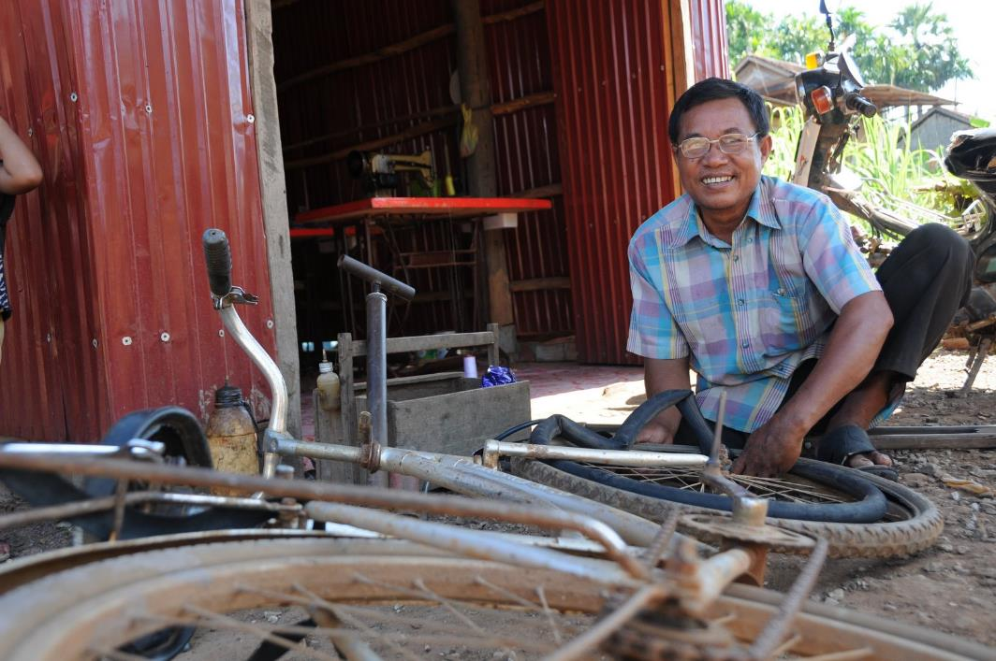

Photo caption: Hoeun at his family’s bicycle repair business and tailoring shop in Kampong Cham, Cambodia

## 1.2. Defining disability

The UN Convention on the Rights of Persons with Disabilities (CRPD), the guiding international framework in understanding and approaching disability, describes people with disabilities as encompassing[6]:

**those who have long-term physical, mental, intellectual or sensory impairments which in interaction with various barriers may hinder their full and effective participation in society on an equal basis with others.**

Of key importance to the conceptualisation of disability set out in the CRPD is the understanding that disability arises not from impairment (i.e. problems in body functions or structures) alone, but from the interaction between a person’s impairment and the barriers they face to full participation in their community on an equal basis with others. The CRPD also recognises that disability is an evolving concept: understandings of and responses to disability by societies have been different over time and across contexts.

Approaches to disability are important to consider when designing disability inclusion actions appropriate to the context. Historically, some approaches to disability have included:

* The **medical model**, which focuses on medical and rehabilitation treatment to “fix” a person’s impairment in order for that person to “fit in” to society. This approach centres decision-making power with health professionals, and can disempower people with disabilities.
* The **charity model**, which conceptualises people with disabilities as passive recipients of care and unable to contribute to society, often leading to their segregation from the wider community.
* The **social model**, which focuses on society as creating or failing to address barriers that act to disable those individuals who happen to have an impairment.
* The **rights-based approach**, which is encapsulated in the CRPD. This incorporates the social model and identifies disability as the interaction of a person’s impairment with barriers that they face in society, which results in a failure in fulfilment of their right to full participation in society on an equal basis with others.

A rights-based approach to disability inclusion requires international development agencies to address the barriers (in society, within programs and within their own organisations) which prevent people with disabilities from fully participating in and benefiting from development activities and realising their rights. *Table 1* outlines categories of barriers to inclusion which can serve to disable people with impairments, and examples of barriers under each category.

Table 1: Types of disabling barriers

|  |  |
| --- | --- |
| Type of Barrier | Examples |
| Attitudinal barriers | Negative attitudes about the capability of a person with impairments, such as from a family member, employer or NGO staff member |
| Physical/ environmental barriers | Barriers to access within the built environment, such as a health centre which does not have a ramp to allow access for wheelchair users |
| Institutional barriers | Discriminatory laws, policies and practices, such as educational policies that exclude children with impairments from mainstream schools |
| Communication barriers | Lack of information in accessible formats, such as classroom materials that are not available in Braille, or a lack of sign language interpreters |

## 1.3. Disability inclusive development

Equality and inclusion are core principles of effective development and are central to achieving a vision of a world where all individuals, groups and communities – including women, men, girls and boys with disabilities – are able to exercise their human rights fully and participate in society without discrimination. Article 32 of the CRPD sets out that international cooperation, including international development programs, should be inclusive of and accessible to people with disabilities – as they have a right to participate in, contribute to, and benefit from development on an equal basis with others.

Disability inclusive development, therefore, seeks to ensure that people with disabilities are fully included in their communities, in the process of development, and as beneficiaries of development programs. A brief summary of principles for disability inclusive practice is set out in *Box 1*, and some key concepts are outlined below– for more information on inclusive development and inclusive practice see the *Further Resources* section of this paper.

|  |
| --- |
| Box 1: Disability inclusive practice principles  The following principles can guide projects and agencies in disability inclusive practice, including within data collection.[7]   * **A rights-based approach:** emphasise the rights of people with disabilities (including under the CRPD and within many countries’ domestic laws) to access all life opportunities on an equal basis with others, and their role as active participants in their own development. * **Participation – “Nothing about us without us”:** ensure that programs targeting people with disabilities, or the communities in which they live, include people with disabilities as active participants throughout the program cycle as decision-makers, advisors, researchers, trainers, etc. Partnerships with DPOs or other representative groups of people with disabilities, where these exist, can support this participation. * **Strengths-based approach**: inclusive actions should seek to recognise the unique and important contributions that all people make to their communities, including people with disabilities. A strengths-based approach is important to challenging misconceptions about the capacities of people with disabilities and ensuring that communities and programs benefit from a full diversity of experiences and contributions. * **Intersectionality:** recognise that women, men, girls and boys with disabilities have a diversity of situations and perspectives; at any point in time they may also experience multiple, intersecting forms of exclusion based on disability, gender, age, ethnicity, HIV status, or membership of other marginalised groups, dependent on context. * **Reasonable accommodation**: make necessary and appropriate modifications and adjustments to ensure people with disabilities can exercise all human rights and fundamental freedoms on an equal basis with others. * **Universal accessibility:** apply “universal design” principles to guide the design ofproducts, environments, programs and services to be usable by all people, to the greatest extent possible, without the need for adaptationor specialised design.[8] * **Twin-track approach:** implement concurrent activities that include *disability-specific initiatives* specifically targeted at people with disabilities, as well as *disability mainstreaming* *initiatives* ensuring that all development programs are inclusive of people with disabilities. * **Tailor approaches to the context:** consider different meanings attached to disability and the experiences of people with disabilities in different contexts. * **Harm minimisation:** understand and apply a critical approach to development programs to avoid potentially harmful outcomes, for example by: avoiding perpetuating stigma around disability; being aware of community attitudes and potential repercussions from activities; following full informed consent procedures; and ensuring confidentiality is maintained for all data collected. * **Continual improvement:** acknowledge that disability inclusion is an ongoing journey – it takes time to implement inclusive practices, and requires continual reflection and improvement. |

### The twin-track approach

A useful way to conceptualise disability inclusive development is the *twin-track* approach. This describes two parallel and interacting approaches to disability inclusion, which are both required to support meaningful participation of people with disabilities in programs.

* *Disability-specific initiatives* are activities specifically targeted at people with disabilities, in order to increase their empowerment and participation (e.g. support for/linkages with DPOs; specific health interventions; provision of assistive devices).
* *Disability mainstreaming* *initiatives* are activities designed to ensure that all development programs, whatever their sectoral focus, include a disability perspective and are fully accessible to and inclusive of people with disabilities.[9]

A disability-specific approach does not necessarily require programs to run separate projects or activities targeting people with disabilities: it can involve coordinating their activities with other disability-specific programs, such as DPOs or rehabilitation services.

### Disabled People’s Organisations

The slogan of the disability movement is ‘Nothing about us without us’. This means that people with disabilities need to be represented in all activities and decision-making processes that affect them. Disabled People's Organisations (DPOs) are representative organisations run by and for people with disabilities. They provide a way for the voices of people with disabilities to be heard and their views and perspectives included, and are key partners in disability inclusive development and in gathering data.

DPOs differ from service providers and other disability-focused organisations, which may advocate for the rights or interests of people with disabilities but which typically do not have a membership and leadership made up solely or primarily of people with disabilities. The *further resources* section lists some links to sites that can help organisations locate DPOs in their program context.

### Intersectionality

A key issue for development actors is how to identify and respond to the diversity that exists among people with disabilities. Within the development sector, the use of the term ‘people with disabilities’ is often underpinned by the understanding that people with disabilities are not all the same. People with disabilities have different identities and impairments, and come from a variety of backgrounds.

Yet for many policymakers, people with disabilities remain an undifferentiated group. This results in the diversity that exists within the disability community going unrecognised, and also in development interventions failing to take into account the different needs of people with varying impairments. For example, WHO research highlights how people with psychosocial disabilities are often left out of development.[10] Similarly, women with disabilities are frequently not included in development activities, as agencies fail to combine a disability perspective with a gender perspective.[11]

Intersectional analysis recognises that all people live multiple and layered identities which are derived from social relations, history and the operation of structures of power. An intersectional approach acknowledges that human beings are members of more than one community or ‘category’, or have more than one identity at any given point in time (for example, being a person with disability, being male or female, or identifying as Indigenous). Rather than simply adding different combinations of identities, intersectional analysis is about understanding how these identities interact and converge to create discrimination or privilege in different contexts, and in turn impact on access to rights and opportunities for people with disabilities.[12]

# 2. Making data collection processes disability inclusive

Applying the principles of disability inclusive development practice to data collection not only requires collection of data on the specific situation of people with disabilities, but also inclusion of people with disabilities in all data collection processes that concern them. The participation of women, men, girls and boys with disabilities in designing, adapting and implementing data collection methods is therefore a key principle of disability inclusive practice.

Even if people with disabilities have not been participating to date or if a project has not yet developed disability inclusion strategies, involving people with disabilities in data collection and analysis can:

* help build their capacity to engage in community decision-making processes;
* provide positive role models and raise awareness about disability in the community;
* challenge negative stereotypes about capacity and encourage more people with disabilities to participate;
* serve as an entry point for broader disability inclusion strategies; and
* result in data collection that is more relevant, sensitive and of higher quality.

Some key actions and considerations which can be taken to make data collection processes more disability inclusive and help create an enabling environment for participation are set out below. See also *Box 2* for some reflections from one organisation on their actions to develop inclusive baseline data collection processes.

Not all of the actions suggested will be possible in every context, and some may require an ongoing investment of time, resources and support. However, there are always some steps which can be taken without large resource requirements at the organisational, program and project levels and which can provide a starting point for strengthening inclusion. There are also resources available which can support this work – see the *Further Resources* section.

### Involving people with disabilities as active participants

Wherever possible, people with disabilities and DPOs should be involved as active participants and decision-makers at every stage of the data collection process. This may require provision of training to participants and other support to build the capacity of DPOs. Creating project consultative or advisory committees (or other similar processes) with local people with disabilities and/or DPO representatives could be one mechanism to support this.

Local DPOs or individuals with disabilities can advise on appropriate approaches or may be able to participate as facilitators or interpreters. Many DPOs also run self-help groups which can be a valuable source of data when seeking the perspectives of people with disabilities. Discussions can involve people with disabilities themselves, and also other key stakeholders (rights holders, duty bearers, civil society and project staff) to learn more about the local disability context.

It is important to keep in mind that people with disabilities are not a homogeneous group and that some views of people with different types of impairment may not be represented in reference groups. Ensuring meaningful participation therefore requires consideration of how and when people with different perspectives are involved in the research process.

Provisions for the participation of people with disabilities and the use of inclusive data collection methods can be incorporated into research designs or terms of reference for evaluations, surveys or other processes that involve data collection.

### Adapting data collection methods and tools

Irrespective of the method selected to collect data, it is imperative that interviews/discussions are accessible by all participants and are inclusive. This means ensuring that appropriate communication methods are used, that locations for data collection are accessible, and that people with disabilities feel comfortable participating. This may involve adapting the format (for example by using written communication and also ensuring people speak clearly and slowly), ensuring a protocol for verbal consent to participation to be provided (not just written consent), or having flexibility to conduct separate interviews with people who find it difficult to participate in group discussions.

Holding separate group data collection processes for men, women, girls and boys with disabilities (as well as those without disabilities) can sometimes help draw out different opinions and experiences of disability which might not otherwise be mentioned in mixed groups. At the same time, it is important that any “whole of community” approaches include people with and without disabilities at the outset so as not to reinforce the notion of separateness or difference.

Caution is required where carers (including service providers) or family members are supporting participation of people with disabilities in data collection. People who require interpreters or other support in communication, for example those who are deaf or hard of hearing and those with communication difficulties related to intellectual or psychosocial impairments, may not be able to provide information freely or safely in the presence of family members.

Questions exploring participation should be considered sensitive information and treated as such: for example, analysis of participation requires exploring issues of power in decision-making between family and community members. The impact of drawing out such information on people with disabilities needs to be carefully considered and all attempts made to collect information in a safe environment, free from influence, and assessed for risk of repercussions to the participant from family members or community members. See *Section 4.4* for guidance pertaining to collecting information from and about children with disabilities.

### Raising awareness among program staff and other stakeholders

Addressing attitudes and assumptions about disability and raising awareness about disability inclusion and human rights among staff is an important first step towards creating an enabling environment for disability inclusive development. The ability of programs to collect data effectively and respectfully is dependent on staff having positive and sensitive attitudes and behaviours towards people with disabilities.

Being involved in inclusive activities is the best way to challenge misconceptions about disability – the involvement of people with disabilities in the design and delivery of awareness-raising or training activities is integral to this.

|  |
| --- |
| Box 2: Case Study: Disability inclusive data collection processes in a World Vision Zimbabwe WASH project  World Vision Australia and World Vision Zimbabwe, with the support of CBM Australia, have partnered with the Federation of Organisations of Disabled Persons in Zimbabwe (FODPZ) to support disability inclusion in their four-year Australian Aid-funded Civil Society WASH Fund 2 program being implemented in Bulawayo and Gwanda. Representatives from DPOs have participated in the baseline survey process, including reviewing data collection tools, providing disability awareness training to enumerators of the household survey, participating as enumerators of the survey and facilitators of focus groups, and writing assessment reports.  Some key reflections from the process have been:   * People with disabilities involved in the baseline survey reported that this was the first time they had been involved in a data collection process in communities, and that it was an important opportunity to learn about WASH as well as research activities. * Through facilitating the focus groups, representatives of DPOs were able to gain a better understanding of the needs of people with disabilities in the program target populations and felt better able to articulate their needs, further supporting participation in other aspects of the project. Information on DPOs was also provided to people identified as having functional difficulties, many of whom were not aware of local DPOs before. * The consultant facilitating the household survey phase reported that working alongside people with disabilities had raised awareness within the team of how to make reasonable accommodations (e.g. translation of baseline data collection tools into Braille, selection of meeting rooms informed by accessibility principles, using sensitive language to describe impairments). * The visibility of people with disabilities working with World Vision Zimbabwe was reported to improve the respect for their capabilities that those people felt they received from their families and wider community. One participant reflected on the impact of his involvement as a project enumerator on inclusion in his community: “They think I am an important man now, they value my opinion”, he said. |

# 3. Planning for data collection within a project or program

A commitment to disability inclusive practice requires keeping in mind *why* information is being collected – that is, to inform inclusive program activities and to contribute to a fair and equitable society – and ensuring that data collection activities are targeted towards these outcomes at each stage of the project or program cycle.

A recent study of the experiences of Australian INGOs of engagement on disability inclusion in their organisations found that often data is collected largely to comply with donor requirements, and there is not necessarily meaningful use of the information collected to guide practice.[13]

Before selecting data collection methods or approaches, it is therefore important for programs and projects to be clear about what they need to know to inform disability inclusive practice, recognising that this will vary at different stages of the project; and to include regular opportunities for learnings to be shared to inform project design and continual improvement.

Programs should collect data that will inform and allow for monitoring of inclusion at three levels: whether women, men, girls and boys with disabilities have *meaningful participation* in a project; whether they are equally *benefiting* from projects targeting them or their communities, compared to people without disabilities; and whether there are *changes in their communities and households* which support greater inclusion.

*Table 2* provides a set of guiding questions to assist planning for data collection at each stage of the project cycle. The *HOW* column also includes examples of data collection methods that could be used at each stage – these are further discussed in *Section 4*.

*Box 3* provides a case study on how a Plan International program in Zimbabwe approached the collection and use of information about disability throughout the project cycle.

### Learning, reflection and adaptation throughout the project cycle

While disability inclusion is often considered at the situation analysis and program design stage, it is easy to get caught up in implementing projects and forget to reflect and use data to inform and adapt the project as it progresses. Disability inclusion is an ongoing journey: each project cycle will involve several rounds of collecting data, learning, adapting/improving and taking action, and then repeating this process again to further strengthen disability inclusion and refine data collection approaches (see *Figure 1*).

Throughout a project, it is important for projects/programs to set aside time for reflection and sharing of learning across programs. If disability inclusion has been planned for and incorporated into project activities right from the start, reflection processes provide an opportunity to assess how project activities and outcomes have been working for women, men, girls and boys with disabilities and what changes could be made to strengthen their inclusion. If disability inclusion has not yet been a focus of a project, reflection processes can still provide an entry point to start collecting and using information about disability – even when project implementation has already started, it is not too late to start promoting and monitoring inclusion!

Examples of reflection or evaluative questions are set out in *Table 2* in the *WHAT* column.

### Developing monitoring and evaluation indicators of disability inclusive practice

Conducting evaluation surveys which allow disaggregation of data by disability is an effective way of measuring the outcome of development initiatives for people with disabilities compared to people without disabilities. However, as outlined earlier, disability inclusive practice is also a process which requires monitoring and evaluation.

As part of developing a theory of change during the planning phase of projects, organisations can identify which aspects (or ‘drivers’) of disability inclusive practice are relevant and within their capacity to influence, and then develop relevant tangible indicators and targets for inclusion in monitoring and evaluation frameworks.[14] For example, for the driver of ‘accessibility’, a health promotion project could monitor the number of community awareness-raising sessions that took place in physically accessible venues, and the availability of health promotion materials in accessible formats (e.g. large print, Braille or audio). For the driver of ‘participation’, the same project could also monitor the number of people with disabilities attending community awareness-raising activities and their experiences while participating, and the involvement of DPOs in developing health promotion messages.

### Integrating inclusive data collection into organisational processes

It is also important to consider how inclusive data collection is integrated within organisational approaches to effective programming: for example, ensuring that terms of reference for research or evaluation studies routinely include disability inclusion measures. There is a risk that new disability inclusion actions may be seen as ‘special’ and remain separate or outside organisational processes. Actions should be taken to mainstream disability inclusive data collection processes across program strategies, M&E frameworks and other organisational approaches.

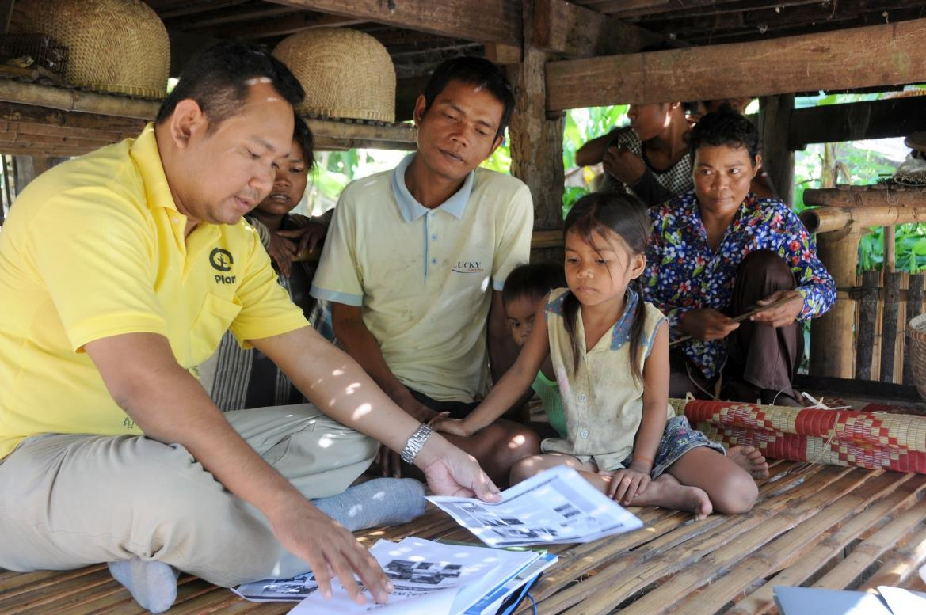

Photo Caption: Vin (centre) and Pheab (right) sharing their family’s experiences of living with disability, during a ‘life history’ storytelling activity with Plan Cambodia staff

|  |
| --- |
| Box 3: Case study: Disability inclusion in Plan’s PRAAC program in Zimbabwe  In Zimbabwe, Plan International’s Promoting Rights and Accountabilities in African Communities (PRAAC) program focuses on addressing gender-based violence particularly among marginalised women and young people. People with disabilities have been included among PRAAC’s target groups since the program began in 2011. The program’s approach to disability inclusion has been one of ‘embracing complexity’ and recognising that promoting inclusion is an ongoing journey of learning, reflecting and adapting. Some approaches along the way have been:  **Program design:** acknowledging relatively limited existing resources and services, as well as its own limited experience, the program consciously set out to find out more about the local contexts and situations of people with disabilities. This included mapping of Disabled People’s Organisations (DPOs) and disability-focused services in the target locations.  **Program start-up:** participatory learning and action (PLA) activities were held to engage communities and staff around local culture and resources and explore dynamics of power and social exclusion. Participatory household mapping data was used to identify people with disabilities in each village, and staff then conducted visits to talk to these people individually and encourage their participation. The process revealed various local perspectives about disability and significant experiences of social prejudice and exclusion – and this information was used to develop program inclusion strategies that were closely informed by each local context. Staff also sought out DPOs operating with a rights-based approach to disability and engaged them to design and co-facilitate training and community awareness-raising sessions and attend meetings with district officials.  **Implementation:** people with disabilities participated in a range of project activities, and over time have played a growing leadership role through co-facilitating awareness-raising sessions, serving as community volunteers and contributing to community action plans. Home visits enabled staff to engage with people with disabilities who were housebound or not confident to participate in community activities, and link them to local volunteers, leaders and service providers. Staff have also been able to build up evidence around the local situations of people with disabilities to advocate for policy changes and improved access to government services.  **Monitoring:** monitoring approaches have included collecting disaggregated data about who is accessing project activities, public services and community processes. Case studies and most significant change (MSC) stories have captured information about changes in attitudes and practices towards people with disabilities from various perspectives, and have proved a powerful means to hear the voices of people with disabilities. Community members with disabilities have also been active in MSC selection processes which have helped to find out what changes were most valued by different stakeholders.  **Reflection and learning:** regular reflection workshops have focused staff attention on how the program outcomes are working for people with disabilities – who *is* or *is not* benefiting, and why. The mid-term review included evaluative questions assessing the extent to which the project had impacted people with disabilities (compared to other groups) and supported them to claim rights and access services.  Plan’s experience through PRAAC suggests that focusing on the lived experiences of people with disabilities, their interactions with various social processes and structures, and community understandings of disability can provide a meaningful, detailed and locally relevant basis for inclusive action to complement conventional survey methods or predetermined indicators. It also highlights the need for regular reflection and continual improvement to find out what works in each context and track an ongoing journey towards disability inclusive practice.  PRAAC is funded through the Australia-Africa Community Engagement Scheme (AACES), a partnership between the Australian Department of Foreign Affairs and Trade, ten Australian NGOs and their partner organisations. |

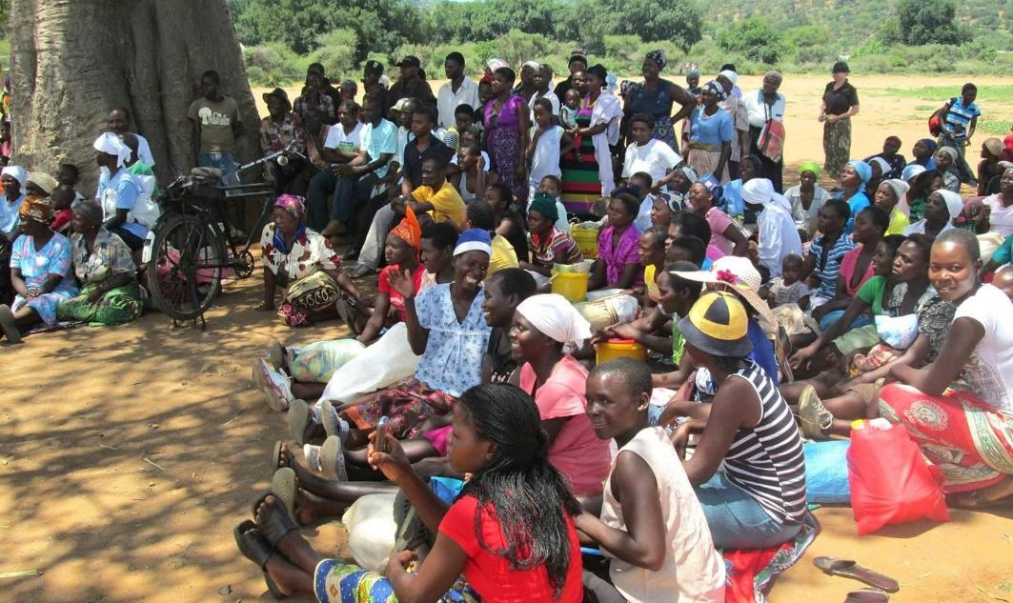

Photo caption: Community members gathered at a PRAAC rights awareness-raising session in Chipinge District, Zimbabwe

Table 2: Collecting and using information about disability throughout the project cycle

|  |  |  |  |  |  |
| --- | --- | --- | --- | --- | --- |
| Project cycle stage | WHY collect data about disability? | WHAT do we want to know? | WHERE can we find this information? | HOW to collect it? | WHO should be participating? |
| Situation analysis and project design | * + - To better understand the local situation/context     - To target programming where it will be most effective | * + - Who are the people with disabilities in our target communities?     - What are their opinions and experiences, and how do these differ among men, women, boys and girls?     - What are the local understandings and attitudes about disability?     - What disability organisations exist?     - What barriers prevent people with disabilities from accessing programs/services and participating fully in their communities? | * + - Data on the prevalence, types and causes of disability     - Qualitative information on people with disabilities’ own experiences     - Mapping of DPOs, services, laws, programs, etc     - Evidence and analysis of attitudinal, physical, communication and institutional barriers to inclusion | * + - Participatory Learning and Action (PLA) tools     - Focus group discussions (FGDs)     - Household/baseline surveys     - Key informant interviews     - Existing data/info: public data, local DPO/community-based rehabilitation/service provider records | *At all stages of the project, engage with:*   * + - Women, men, girls and boys with disabilities, including people with a variety of impairments (physical, vision, hearing, intellectual and psychosocial impairments)     - Carers and household members of people with disabilities     - Local or national DPOs or other groups of people with disabilities     - Disability service providers or other disability-focused organisations     - Other community members, local leaders, government duty bearers, civil society organisations, NGO staff |
| Planning, targeting and start-up | * + - To ensure the most marginalised communities/ individuals are targeted and included     - To plan for access and inclusion (including active decision making) within the project design and budget | * + - Who are the women, men, girls and boys with disabilities in our target communities?     - What are the barriers to participation of people with disabilities in our project?     - What are the enablers for people with disabilities to use their strengths and capacities to participate/contribute?     - What strategies or adaptations are needed to ensure universal access?     - Who needs to be involved in the project to ensure inclusion? | * + - Identification of people and households affected by disability     - Views and opinions of people with disabilities about barriers and enablers     - Assessment of barriers to participating in project activities     - Analysis of key stakeholders     - Identification and costing of required accessibility actions | * + - Existing data sources     - PLA tools     - FGDs     - Baseline surveys (with questions to enable disaggregation)     - Outreach/door to door visits     - Key informant interviews     - Screening participants     - Accessibility/inclusion audit |
| Implementation – monitoring, reflection and improvement | * + - To monitor who is participating/ benefiting and who is not – and why     - To make adaptations and improvements to project activities to make them inclusive | * + - Who is participating and who is not?     - Is participation of people with disabilities genuine and meaningful (not tokenistic)?     - What enabling factors or barriers affect inclusion of people with disabilities?     - How are the project outcomes working for people with disabilities?     - What are the different experiences of women, men, girls and boys with disabilities?     - What changes are needed to strengthen inclusion? | * + - Monitoring data on participation, access and outcomes for people with disabilities     - Views and opinions of participating people with disabilities     - Information from key stakeholders/partners     - Analysis and reflection on barriers/challenges and enabling factors (in the project and external) | * + - Participants’ stories and views     - Staff/stakeholder/ beneficiary feedback     - Disaggregated monitoring data     - Qualitative monitoring     - Disability-specific indicators/ markers     - Reflection processes |
| End of program – evaluation, reflection and learning | * + - To evaluate what changes have taken place     - To capture learning about inclusive practice | * + - What changes have taken place in terms of rights and inclusion of people with disabilities?     - To what extent were people with disabilities included in the project?     - What factors enabled or hindered inclusion?     - What are the opinions, voices and views of women, men, girls and boys with disabilities about the project? | * + - Evidence of changes related to disability inclusion among rights holders, duty bearers, civil society and project staff     - Views, opinions and experiences of people with disabilities     - Analysis of project learnings related to inclusive practice | * + - Reflection processes     - Endline surveys (with questions to enable disaggregation)     - Key informant interviews     - Disability-sensitive evaluation questions     - Disability-specific indicators/ markers     - Participants’ stories and views |

Note: This table reflects some of the key elements to consider at each stage of the project cycle. In reality, however, collecting data and strengthening disability inclusion is not a step-by-step, linear process. Tackling disability exclusion will involve testing, learning and adapting strategies to address the complexity of each local or national context and respond to opportunities which may arise throughout the project cycle.

# 4. Methods and tools for collecting data to support disability inclusion

This section discusses some approaches to collecting information and specific data collection methods that can be used to support disability inclusive practice, including:

* disaggregating data by disability;
* specific tools to support disaggregation of data relating to disability, including the Washington Group Short Set of Questions and Rapid Assessment of Disability;
* methods such as surveys, key informant interviews, focus groups, story collecting and participatory learning and action to collect data inclusive of people with disabilities; and
* specific issues to consider when collecting data about the situation of children with disabilities.

See Table 3 (at the end of this section) for a summary of the methods and tools discussed in this section.

## 4.1. Disaggregating data by disability

Disaggregation of data is the intentional process of breaking down data into subgroups and comparing data from each of these subgroups. For disaggregation by disability, this requires identifying people with disabilities within existing surveys or other data collection methods.

Disaggregating data by disability, sex, and age can bring to light critical issues that might otherwise remain invisible in general community level data. If project monitoring systems can disaggregate all data by disability (as well as sex, age, etc), this enables comparison between women, men, girls and boys with disabilities and other groups of people, identifying whether marginalised people are fully and equitably participating in the project.

This disaggregated data can give an important insight into how people with disabilities are involved in the project, the ways that their experiences may differ from other community members (such as accessing basic services including water and sanitation, or school attendance).

As having a disability can have an impact on a whole family, it can also be helpful to analyse data from households that have a family member with a disability, and individuals who have a sibling, parent or child with a disability. Projects should also monitor against key disability inclusion outcomes, such as changes in people’s attitudes, reduced levels of discrimination or increased capacity of DPOs or other representative groups.

Failing to disaggregate project data by disability can have negative consequences, for example by failing to recognise gaps in participation or outcomes for specific groups of people and thereby perpetuating or further contributing to these inequalities.

In order to disaggregate data by disability, the sub-group of people with disabilities must first be identified. Often identifying disability in a population is challenging to development organisations and the following section provides some strategies to assist in this process.

## 4.2. Identifying people with disabilities

Identification of people with disabilities might take place as part of a situation analysis, baseline survey, project screening tools, registration processes and/or ongoing monitoring processes.

### Why not just ask if someone has a disability?

Typically, many surveys or project participation forms simply ask screening questions such as “Do you have a disability?” or “What type of disability do you have?” These questions are usually ineffective, for various reasons including:

* sometimes the word used for “disability” in different languages could be very negative or not understood by some communities;
* disability might be associated with stigma and shame in some contexts and people or their families may not want to disclose information; or
* people may not identify as having a disability, for example if they view their impairments as a typical part of ageing.

See *Box 4* for an example of how different ways of asking about disability can produce very different estimates of disability prevalence.

It is therefore important to consider the way that disability is being identified in a community. As previously explained, disability can be a complex concept to measure and there have been various aspects of disability that have been used as a proxy for disability. (See also *Box 5* on the difference between screening and diagnosing impairment.)

A word of caution: it is very important to make sure that screening or targeted analysis of the situation of people with disabilities does not cause them any harm, shame or stigma relating to being ‘labelled’ (i.e. publicly or privately identified) as having a disability.

Box 4: A sample of disability data from Sri Lanka

Data from Sri Lanka shows that measurement of disability prevalence can vary significantly within a country or context depending on the questions, methods and definitions used.

|  |  |
| --- | --- |
| **0.8**% | Disability prevalence among Plan Sri Lanka sponsored children, found by asking *‘Does [child] have an impairment/condition that could lead to disability?’*  **Plan International ‘Include Us!’ report, 2013** |
| **1.6**% | Disability prevalence among all people in Sri Lanka, using a direct question about ‘physical and mental disability’  **Sri Lanka Census of Population and Housing 2001** |
| **12.9**% | Disability prevalence among all adults in Sri Lanka, found by asking detailed questions on limitations in functioning  **World Report on Disability 2011 (drawing on World Health Survey 2004)** |

### Using measures of functioning

To address the challenges of identifying people with disabilities, international agencies have developed questions that ask people about basic activities or major body functions, such as whether people have difficulty walking, seeing or communicating with others. These questions have been found to act as effective measures of people’s level of functioning and therefore provide a good approximation of disability. Questions on functioning also collect data on disability in a more sensitive way.

Identifying people with disabilities for the purpose of including them or monitoring their participation within a project does not mean particular attention needs to be drawn to their disabilities. Rather, project activities should focus on accommodating the diverse range of needs of people within the target population.

It is important to remember that functioning measures can only identify people who *might* have a disability or are *at risk* of having a disability. Only trained personnel such as a qualified doctor or health professional can formally diagnose a health condition or impairment (see *Box 5*). It’s also important to note that these measures will not provide information about the barriers a person faces in society, so they can only provide part of the picture required to inform inclusive practice.

Box 5: What’s the difference between disability screening and diagnosis?

DISABILITY SCREENING:

* Identifies people who *might* have a disability or are *at risk* of having a disability
* Is typically a quick questionnaire/interview based on the most common types of impairments
* Can be undertaken by project staff or community members with basic training
* Informally identifies people with disabilities for project activities, M&E and referral to services

DISABILITY DIAGNOSIS:

* Is a medical assessment of whether a person has an impairment/health condition
* Is undertaken by a trained doctor or health professional
* Formally identifies people with disabilities for purposes including access to health care and social protection

### Washington Group Short Set of Questions

The most widely recommended set of questions for identifying functional limitations is the Washington City Group Short Set of questions (see *Box 6*). There is also an extended set of questions which considers more domains of functioning.[15] The sets of questions were developed by the Washington Group on Disability Statistics, a City Group of the United Nations. The Short Set has been identified by the UN Statistical Commission as the recommended tool for use within national censuses and population surveys.

Box 6: Washington Group short set of questions on disability

Respondents are asked all six of the following questions in relation to a ‘health problem’:

1. Do you have difficulty seeing, even if wearing glasses?
2. Do you have difficulty hearing, even if using a hearing aid?
3. Do you have difficulty walking or climbing steps?
4. Do you have difficulty remembering or concentrating?
5. Do you have difficulty (with self-care such as) washing all over or dressing?
6. Using your usual (customary) language, do you have difficulty communicating, for example understanding or being understood?

Response categories are *(a) No – no difficulty; (b) Yes – some difficulty; (c) Yes – a lot of difficulty; or (d) Cannot do at all*. A person is considered to have a disability if they give a (c) or (d) response to one or more of the questions.

Further information and guidance on using the Short Set can be found at: <http://www.washingtongroup-disability.com/washington-group-question-sets/short-set-of-disability-questions/>

While originally designed primarily for population-based surveys and for use with adults, the Short Set can also be used at a project level to identify disability in a population without relying on specific cultural terms/conceptions of disability. It is also considered to be an effective measure when used with children aged 5 and over (see *Section 4.4* for more detail on collecting data on children).

The Short Set has been widely tested for validity in a variety of different contexts, and can be translated for use in different locations. It can be incorporated into project surveys, questionnaires, registration or sign-up sheets for project activities, monitoring tools, etc to allow for disaggregation of data by disability. However, the effectiveness and accuracy of these questions depend on several factors:

* the knowledge and understanding of the people asking the questions (e.g. their awareness of their own behaviour and its impact on disclosure);
* whether questions are asked directly to/about the person of interest (e.g. generally the head of a household is less likely to accurately identify a household member as having a disability than if that person was asked directly); and
* whether the questions have been appropriately translated and are used as designed (e.g. it is important to ensure that no initial questions about “disability” are included and that they are read exactly as written/translated).

Sometimes minor adaptations are required (e.g. if there are no glasses available in the context it may be unnecessarily confusing to ask if a person can see “even if wearing glasses”, so the latter part of the question can be removed). However, it is strongly advised that the wording of the questions is not changed without prior testing as this can cause them to be ineffective or in some cases, if stigmatising terms are used, even harmful. Further information about how to use the Short Set can be found at the Washington Group website.[16]

One limitation of the Short Set of questions is that not all people with impairments relating to mental health issues/psychosocial disability will be identified. The Extended Set of questions asks additional questions related to psychosocial wellbeing and other functional domains and can be useful for projects seeking information on a wider range of people experiencing functional limitation, such as people with psychosocial disability. It can also be found at the Washington Group website.

*Box 7* describes a case study from an INGO seeking to improve identification of disability within their target community to assist referral to services.

|  |
| --- |
| Box 7: Case study: Data collection in WaterAid WASH programs in Timor-Leste  WaterAid, funded by Australian Aid through the Civil Society WASH Fund and with support from the CBM-Nossal Institute Partnership for Disability Inclusive Development, has been taking action to improve data collection for disability inclusion in its WASH programs in Timor-Leste (Manufahi and Liquica districts).  An important aspect of the project design is the household baseline survey. WaterAid began to use a translated version of the Washington Group (WG) Short Set of questions during the baseline survey. Previously, the team and partners had asked “Does anyone have a disability in this household?” during household data collection, and found that few people with disabilities were being identified.  Initial results have indicated that using the WG questions has assisted in identifying more women and men with disabilities within the community. Some key lessons learnt throughout the process were:   * Disability inclusion training of partner staff has led to an understanding of the need for taking a disability-sensitive approach to collecting data and making links with DPOs to support learning. * Including people with disabilities in WaterAid's workforce and working with the local DPO representative has facilitated learning and assisted community engagement on disability inclusion in WASH – through demonstrating the capacity of people with disabilities. * Identifying people with disabilities at the outset of the program has enabled referral to relevant health and disability services. Access to health services and assistive devices is often necessary for people with disabilities to participate meaningfully in WASH activities. Many people with disabilities in the project areas have not had access to such services. * Monitoring visits by the WaterAid team at the household level have played an important role in supporting staff reflection on what works well in engaging households in inclusive planning for accessible WASH facilities, and addressing challenges. * Sharing learning across communities and teams has been integral to strengthening disability actions across the program. |

### ‘Snowballing’ techniques to identify people with disabilities

Snowballing refers to the process of identifying or locating people with disabilities via social or other networks within a community. Typically, key informants such as DPOs, health workers or village leaders are interviewed to identify people with disabilities who may want to engage with a project. These people then refer on others they know or encounter, who have a disability or are at risk of disability. Sometimes informants such as health workers are trained in identifying certain types of impairment.

This technique takes advantage of the knowledge that people with disabilities often have about their own communities and informal networks between people with disabilities. It can also help to identify people who have newly acquired an impairment during a project timeframe, or those who are isolated or stigmatised and may be missed by formal survey processes. However it doesn’t use a standard definition of disability, making it less reliable for giving estimates of prevalence, and also cannot be used to disaggregate data on disability. This technique may be particularly useful for projects or activities targeted primarily at people with disabilities.

*Box 8* provides an example of the use of snowballing in a Community-Based Rehabilitation project.

|  |
| --- |
| Box 8: Case study: Using community networks to locate children with disabilities  CBM Australia partner, the NORFIL Foundation, has been implementing Community-Based Rehabilitation projects in the provinces of Cebu and Mindanao in the Philippines since 2011. The projects seek to engage with parents to provide CBR services and support for children with disabilities.  To identify families with children with disabilities, the project initially worked with community health workers and village leaders as key informants. However through the life of the project, parent committees at the village level have continued to work to identify other parents of children with disabilities via snowballing techniques. This involved parents already engaged in the project identifying others who may have children with disabilities or at risk of disability, via community networks or word of mouth. This was particularly effective in finding families who, for reasons including poverty or isolation, may not have had contact with health workers or project staff or been active in community life.  Due to its success, this model is now being used by NORFIL in other projects. |

## 4.3. Data collection methods

There is no single method or tool that will provide all the information needed by a project to inform disability inclusive practice and measure outcomes. A suite of different methods, both qualitative and quantitative, can be used to understand disability inclusion within project activities and at the individual, household and community levels.

For example, data could be collected from people with disabilities themselves, examining their experiences and opinions; from members of households where people with disabilities live, to learn more about their experiences of disability (particularly women and girls who often undertake caring responsibilities); from people with and without disabilities (especially community leaders) to examine their common attitudes and understandings about disability in the community; and from local organisations and service providers to understand the knowledge, skills and behaviours of service-providers towards people with disabilities.

The selection of data collection methods in a particular project or program will depend on the project context and what information is needed to support inclusive practice at each stage of the project (see *Section 3*).

Rather than establishing separate or parallel systems of data collection to collect information about disability and disability inclusion, it is far easier to adapt existing data collection processes used by a project to capture information about disability. This may involve adding questions about disability and inclusion to existing surveys and monitoring tools, or asking about disability inclusion in focus group discussions. It is important to ensure that women, men, girls and boys with disabilities are involved in developing methods and tools, and that data is disaggregated at a minimum by sex, age and disability. Like any methods and tools, these will also need to be tested and adapted to suit local cultural and project contexts.

### Using existing/external data and information

Existing data about disability is an important source of information, particularly at the situation analysis and initial project design and planning stages. Existing data often provides a starting point for project planning and design – for example, by helping to identify target locations, communities and key stakeholders – but will typically then need to be complemented by further investigations once situation analysis and project design work gets underway.

Existing data may be found in local health records, census results, government survey results, NGO surveys or research reports, school or education department records, and in the records or reports of DPOs or disability-focused organisations such as Community-Based Rehabilitation (CBR) networks.

Care should be taken when drawing on existing data, particularly in relation to disability prevalence figures, as frequently disability is under-reported in censuses or other surveys. Estimates of disability prevalence differ significantly between countries and between different data sources within a particular country, due to varying understandings of disability and different methods and sampling in data collection, as indicated earlier. For each data source, it is worth looking at the data collection approaches that were used – such as the types of questions or methods used in screening or surveys – to see how well these align with the practice approaches suggested in this paper and other guidance materials. For example, school records might be based on teachers’ observations in the classroom, which are likely to underestimate prevalence, particularly of non-physical impairments.

DPOs and CBR networks often have information regarding people with disabilities in their local area. This information may be collected as people come into contact with the organisation, thus may not reflect an accurate picture of all people with disabilities in the area. However, they may be able to provide indicative numbers, and information regarding common impairments and the situations of people with disabilities. They may also be able to assist program staff to locate people with disabilities. Depending on the focus of the organisation, this type of data may include only adults or children, or people with certain types of impairments.

### Household surveys: baseline, endline and prevalence

Project surveys are typically conducted at the start and end of a project, and sometimes as a longitudinal study throughout the duration of a project. Identifying people with disabilities can be done by including the Washington City Group Short Set questions within the survey (see *Section 4.2*). This will allow the survey analysis to compare the outcomes for people with and without disabilities across all survey questions.

Baseline surveys also offer an opportunity to measure key aspects of inclusion such as experiences of discrimination, equity within the household, access to services and community participation. Often projects/programs are interested in determining differences between people with and without disabilities and their participation across various aspects of community life. One survey tool that includes these aspects is the Rapid Assessment of Disability, which has questions designed to measure and compare individuals’ inclusion and participation across different domains (see *Box 9*). This can assist in identifying barriers to participation experienced by people with disabilities as part of a baseline investigation and contribute to evaluation of the impact of programs.

To support inclusive practice, it is important for surveys to ask questions that can reveal the different situations and experiences of individuals within each household. Many surveys only focus on the differences between households – not within each household – due to time and resource constraints (e.g. by only interviewing the household head about general household access and experiences). This fails to provide information about inequities that can occur within a household – which is particularly important for people with disabilities, especially girls and women.

Where it is not possible to conduct a survey with each individual person, it is recommended that teams expand survey questions. For example, in a WASH project, surveyors could ask: “Where the household has access to a sanitation facility, can all household members access the sanitation facility? If not, who cannot? And why?”This data could then be matched against information collected about functioning levels of household members, allowing for disaggregation of data and a better understanding of the barriers to WASH access that men, women, girls and boys with disabilities may face.

|  |
| --- |
| Box 9: Tool: Rapid Assessment of Disability (RAD)  The RAD toolkit was developed as part of a collaboration between the University of Melbourne’s Nossal Institute for Global Health and Centre for Eye Research Australia. It was funded by the Australian Aid program through a three-year Australian Development Research Award. The tool has been tested in Bangladesh, Fiji, India and the Philippines.  The RAD toolkit has been developed to support governments and organisations to estimate prevalence of disability in a population, to establish baseline information on disability among adults (18 years or over), and to support the design, implementation and evaluation of disability inclusive development projects. It has been designed with a range of potential end users in mind including governments, development agencies, DPOs, NGOs, civil society organisations and research institutes.  The toolkit contains a set of quantitative questionnaires and accompanying guidelines on the contents of the questionnaires and their use.  The RAD survey consists of household and individual questionnaires administered by an interviewer. Each head of household is invited to complete the household questionnaire, which is designed to assess household demographics and socio-economic status. Individuals residing in the household who are 18 years of age or older are then invited to complete the individual questionnaire with the interviewer. The individual questionnaire consists of four sections:   * Section one: Demographics * Section two: Self-assessment of functioning * Section three: Well-being * Section four: Access to the community.   While the RAD has been designed as a stand-alone survey, programs may choose to only use specific components of the RAD, i.e. if a program is focused on WASH, it may choose to only use items from Section four which are relevant to WASH and use the format in that section to develop new questions specific to collecting data on access and barriers relevant to the program.  For further information about the development of the RAD toolkit or to share findings from a RAD survey and/or provide feedback on implementing and using the RAD toolkit, please contact the Nossal Institute for Global Health ([RAD-enquiries@unimelb.edu.au](mailto:RAD-enquiries@unimelb.edu.au)). |

### Key informant interviews and focus group discussions

Interviews and discussions offer opportunities to draw out detailed qualitative information about the situations, experiences and views of people with and without disabilities, including the local context and understandings of disability. This level of detail can help to understand patterns identified in project registration or survey data, and to identify potential/actual barriers and enablers to access to services and facilities, for example. They can also help in the planning of other data collection methods that are adapted and appropriate to the local context.

Usually basic demographic information is collected about participants before conducting interviews/focus groups. The Washington City Group Short Set of questions can be asked as part of collecting demographic information, enabling disaggregation of data and verification that interviews have been representative of different groups in a population.

People with disabilities should be included in all of these approaches; in some cases, men, women, boys and girls with disabilities, or people with particular impairments, may prefer to have separate groupings to create a safe place for discussion and help draw out their different experiences compared to other community members. However, generally whole of community approaches should focus on including people with and without disabilities at the outset so as not to reinforce the notion of separateness or difference. DPOs or other local groups can also be involved in facilitating or participating in activities, particularly where they may have expertise in aspects such as ensuring physical accessibility.

### Participatory methods

Participatory approaches such as Participatory Learning and Action (PLA) allow projects to gain an in-depth understanding of the local context, while involving local community members to share their knowledge and opinions, analyse the local situation and develop appropriate responses. PLA includes a range of methods, tools, attitudes and behaviours to enable and empower people to present, share, analyse and enhance their knowledge of life and conditions (i.e. *learning*), and to plan, act, monitor, evaluate, reflect and scale up community *action*. [17]

These approaches are well suited to projects seeking to promote inclusion and work with the most marginalised community members, because they: emphasise program learning and continual improvement; use accessible, visual and verbal techniques; value local knowledge and experience; allow for multiple and diverse perspectives; and bring together different groups of people through a process that aims to promote discussion, reflection and joint learning.

Participatory accessibility audits and analysis of barriers are particularly relevant approaches, and can be carried out for an individual community facility (such as a school or health centre) or in relation to local services and resources and access to rights more broadly. *Box 10* provides a case study of how a type of accessibility audit was used in a research project in Papua New Guinea.

|  |
| --- |
| Box 10: ‘Moveabouts’ provide information about how people with disabilities use roads  The three-year ‘Travelling Together’ research project, funded by Australian Aid through an ADRA grant and implemented in 2010-13, examined the use of roads and transport infrastructure by people with disabilities in rural and urban Papua New Guinea. One of the tools used to gather information about the experiences of people with disabilities was a series of ‘moveabouts’, in which people with a variety of impairments surveyed the accessibility of areas of road. Led by data collectors who were also people with disabilities from the local area under study, the groups moved along sections of road and identified the features that acted as facilitators and barriers to their access. They highlighted issues such as poorly marked crossings, lack of footpaths, potholed and flooded roads and speeding traffic.  Using the findings from the moveabouts and other participatory data collection processes, ‘Travelling Together’ created sets of guidelines for road decision-makers, engineers and DPOs, to encourage better involvement of people with disabilities in decision-making processes and improved understanding of the access needs of people with disabilities as road users.  Further information about ‘Travelling Together’ can be found at <http://dfat.gov.au/aid/topics/development-issues/research/Pages/working-paper-travelling-together.aspx> or by contacting [idresources@cbm.org.au](mailto:idresources@cbm.org.au) |

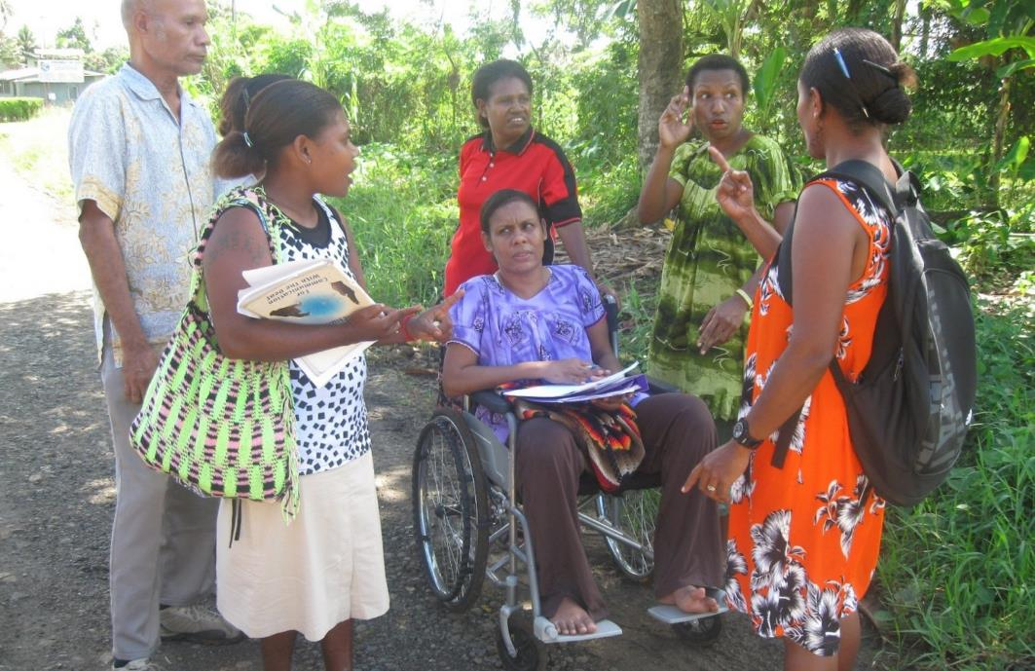

Photo caption: Data collectors in the Travelling Together project discuss road usage with local people with disabilities

Collecting stories about the histories, experiences and opinions of people with disabilities can also reveal important lessons on project successes and areas for improvement, as well as strengthening understanding of the lived reality of people with disabilities in the local context, from each person’s particular perspective. Stories can be empowering for the person telling the story because they allow the storyteller to use their own words, focus on elements that are important to them and analyse why and how events have taken place.

Stories can also be powerful methods for raising awareness and communicating the situations and experiences of marginalised people, as those hearing the stories are able to relate and connect to a personal journey. (See *Box 11* for an example of life story collection). The most significant change (MSC) method provides a structured way for stories to be analysed and selected by staff or project stakeholders, enabling reflection at different levels of project management or in the community itself on what changes have taken place and why they are valued.[18] Reflection can be grouped by storytellers with disabilities, other marginalised groups, duty bearers, and so on, to enable discussion and analysis of these groups’ differing experiences or situations.

As with interviews and focus discussions (see above), it is important to ensure that story collection processes are accessible by all participants and that appropriate communication methods are used.

Box 11: Hearing the stories of people with disabilities

In 2014, Plan International Cambodia recorded the stories of 20 adults and young people with disabilities who were participating in livelihood projects. In-depth interviews followed a life history approach, where people were asked to talk about significant events and times in their lives, with a particular focus on their experiences of having a disability. The stories were told in the first person and provided rich information that would not have been captured in typical monitoring or case study approaches. This included:

* How family or community members’ attitudes were enablers or barriers to disability inclusion
* How men, women, boys and girls all experience disability differently
* The cycle of disability, health and poverty
* How disability impacts spouses and family members
* The strengths and capacities of people with disabilities.

The stories were then used in reflection workshops with project staff and stakeholders, where they were effective at challenging some participants’ preconceptions about disability, highlighting and responding to specific gaps in Plan projects, and raising awareness about disability and inclusive practice.

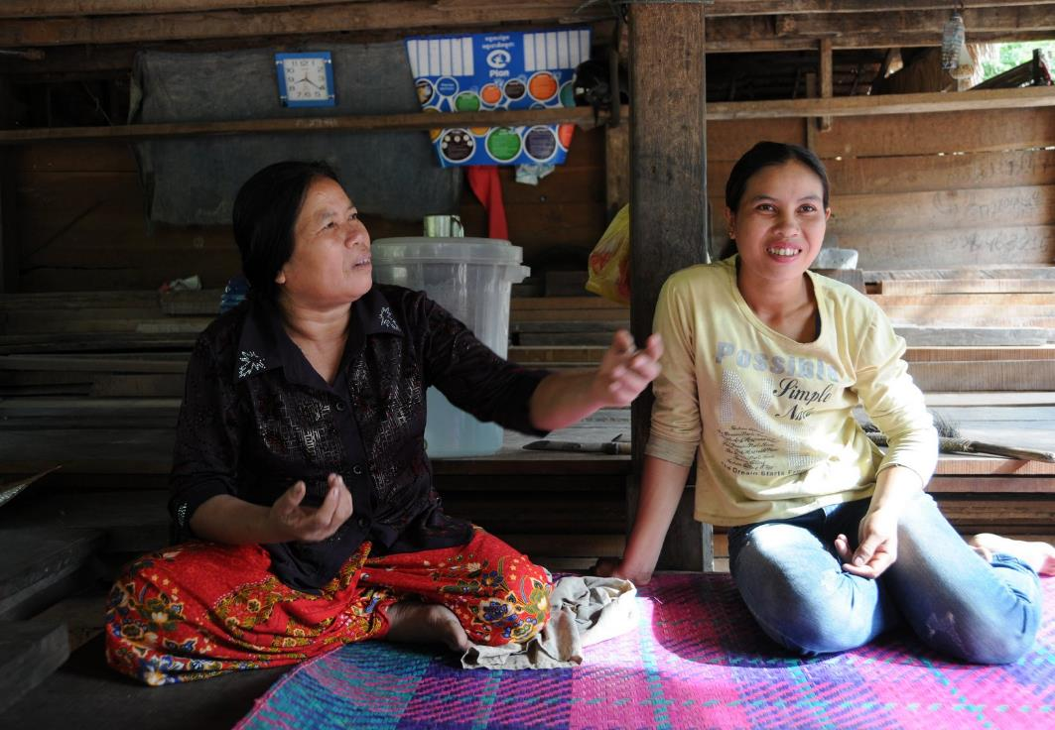

Photo caption: Pot and her daughter Phean telling their story of living with disability to Plan International Cambodia staff

## 4.4. Collecting data about children with disabilities

Identifying and collecting data about children with disabilities requires some consideration and planning. This is due to the fact that children are still developing, making it more difficult to identify impairments, as well as the particular vulnerability of children with disabilities. There are also limited data collection methods that have been specifically developed for children with disabilities at the project or program level, although some approaches are currently being developed and tested.

Methods have been developed for working with marginalised girls and boys to collect data about their situations and experiences, and ensure their participation in project decision-making. These approaches should provide a starting-point for projects, and can be adapted to make sure they are inclusive of children with disabilities and are sensitive to the local context. For example, existing child-friendly and child participation approaches often use drawing or visual techniques and practical/physical exercises – these would need to be adapted so that children of different abilities are able to participate in whatever format best suits them, such as by sharing information verbally for children who have difficulty seeing. It is also important that facilitators are able to sensitively respond to any issues that might arise, as girls and boys with disabilities might have experienced discrimination or abuse, and might not be accustomed to participating in project activities.

In seeking to identify children with disabilities and disaggregate data, it is important to note that the Washington Group Short Set of questions were intended primarily for the adult population, although they have been used for collecting data with children aged five and above. In 2016, UNICEF and the Washington Group jointly released a Module on Child Functioning and Disability, for use amongst children aged up to 17 years.[19] There are also plans to create a child version of the RAD tool (see *Box 9*) by adapting UNICEF’s childhood disability questions once they are developed.

When used with parents to identify children with disabilities, disability screening questions are sometimes phrased as “compared to other children his/her age” to prompt parents into thinking about their child’s level of functioning relative to other children in their age group.

Collecting data about children with disabilities also poses some specific challenges for projects to consider:

* Data is usually collected from parents or caregivers, rather than directly from children. This means that any questions about disability will be mediated by adults, and it might be more challenging to find out about issues of inequity within the household or children’s own opinions and experiences.
* As with identifying adults with disabilities, parents might not identify, or want to identify, their child as having a disability when asked direct questions about disability such as “do any family members have disabilities?” are asked. Instead, specific questions about a child’s development and functioning must be asked to learn about childhood disability.
* As children with disabilities are a particularly vulnerable group, there is a greater risk that being identified as having a disability could lead to discrimination or stigma in their schools or communities.
* Since children are constantly growing and developing, and each child develops at his or her own pace, it can be quite challenging for parents and project staff to identify impairments, particularly among younger children aged under 5.

Training for staff on how to ask questions about childhood disability sensitively, respectfully and appropriately to the local context can help mitigate some of these issues. Often, project staff can learn a large amount about potential disabilities or children’s experiences of exclusion or discrimination simply by asking children about their own feelings and perceptions, or asking their parents or carers about any concerns they might have about their child’s health or development.

It is important that project staff do not try to label children as having a disability; questions in surveys or other data collection processes should not be framed as being about ‘disability’. The questions about functioning discussed above can be used to identify children who may have a disability for project monitoring purposes, without actively labelling the child as having a disability during the interview or project activity.

See the *Further Resources* section for resources on conducting research with children with disabilities.

Table 3: Overview of methods and tools for collecting data to support disability inclusion

| Approach/method | | What is it? | Advantages | Limitations | When to use it? | |
| --- | --- | --- | --- | --- | --- | --- |
| Disaggregation | **Disaggregating data by disability** | A process of breaking down data into subgroups and comparing data from each of these subgroups (e.g. men, women, boys and girls with and without disabilities) to learn about their different situations and experiences across a range of indicators or domains. | * Can highlight issues that might otherwise remain invisible in general community level data, particularly for marginalised community members * Enables comparison and analysis of diverse experiences * Can point to issues for further investigation using other methods | * First requires identifying people with disabilities (see below) * Can be seen as a reporting or compliance issue * Needs follow-up data analysis focused on learning about and responding to the diversity of situations and experiences of different groups | Applies to all data collection processes, particularly those with large numbers of participants such as surveys or project monitoring tools. Should be complemented with more in-depth methods to hear various perspectives and learn about why different groups have different experiences. | |
| Identifying people with disability | **Using measures of ‘functioning’** | Various sets of questions that ask people about basic activities or major body functions, such as whether they have difficulty walking, seeing or communicating. These provide an approximate way to identify most people who *might* have a disability.  (Examples: Washington Group Short Set and Extended Set of Questions on Functioning) | * Provides a more sensitive and accurate way to collect data on disability prevalence than directly asking if someone has a disability * Avoids using language such as ‘disability’ or ‘handicap’ or other words which might be seen as stigmatising * Can be undertaken by staff or community members with a small amount of training | * Provides only an indication of disability, not a diagnosis * On its own, does not provide information about the barriers a person faces in their community * Requires training of data collectors and care to avoid focusing on a person’s limitations (particularly where staff are more familiar with medical approaches to disability) | To identify people who might have a disability in order to:   * disaggregate survey or other data; * follow up to learn more about their situation and priorities; * include people with disabilities in project or other development activities; * estimate disability prevalence within a community; and/or * refer people to specialist services. | |
| **Tool: Washington Group (WG) Short Set of Questions** | A set of 6 questions for identifying the most common types of functional difficulties and thereby providing an approximation of disability prevalence. It is the most widely used measure of functioning and is recommended by the UN for use in population-based surveys. | As above, plus:   * Has already been tested and translated into many languages * Provides a standardised and internationally comparable method for estimating disability * Shorter and simpler to use than other measures of functioning | As above, plus:   * Only identifies the most common types of functional difficulties (e.g. might miss mental health issues) * Has not been validated for use with children aged under 5; mainly designed for use with adults * Should be used exactly as developed to maintain validity | Can be incorporated into surveys, questionnaires, project registration sheets, monitoring tools, etc. to allow for disaggregating data or promoting individuals’ participation in a project. Particularly relevant where there is a rationale for collecting population and project data using internationally standardised measures. | |
| **Identifying childhood disability** | Sets of questions to be used with parents/carers to identify childhood disability are still under development (as of 2015) by the Washington Group and UNICEF. | As for measures of functioning, plus:   * Provides a standardised way of estimating disability at different stages of childhood development | As for measures of functioning, plus:   * Parents/carers might not recognise or want to disclose disability * Should be complemented with child-friendly/participatory methods | Particularly relevant for projects targeting vulnerable children, and/or which have a focus on learning and research on prevalence and experiences of childhood disability. | |
| **‘Snowballing’ and informal techniques** | A process of locating people with disabilities by talking to key informants (e.g. health workers, village leaders or volunteers) and having them refer project staff on to other people with disabilities they are aware of through various networks. | * Puts value on (and benefits from) local knowledge, participation and informal networks * Can locate people who might be hidden/missed by formal surveys * Can be easily used at any stage of a project | * Does not use a standard definition of disability * Care should be taken to avoid labelling people as ‘disabled’ or causing stigma or shame | Particularly useful for projects where people with disabilities are a target group and where generating standardised data is not a priority. Can also be used as part of project efforts to strengthen local networks and relationships. | |
| Methods for collecting data relating to disability | **Using existing data** | Involves using secondary local data from various sources, e.g. health provider or school records, census/ survey results, NGO reports/records, and the records of Disabled People’s Organisations (DPOs) or community-based rehabilitation (CBR) networks. | * Takes advantage of existing local data and knowledge on disability * Avoids duplicating surveys or other data collection activities * Can quickly and cheaply help provide an indicative snapshot of a local disability context | * May be incomplete, under-reported or partial (e.g. measuring only one type of disability or only adults) * Care should be taken to consider the data collection methods and understandings of disability underpinning each data source | Can provide a starting point for project design and planning – e.g. by identifying target locations and stakeholders – but will typically need to be complemented by more in-depth and localised data collection. |
| **Household and individual surveys** | Adding WG questions (or other measures of disability) to questionnaires enables surveys to: identify people who might have a disability; estimate disability prevalence; and disaggregate data across all survey questions. Specific questions on equity and inclusion should also be included. | * Provides a broad picture of disability and inclusion across various aspects of community life * Including questions on functioning (e.g. WG questions) enables identification of differences in experiences and outcomes between people with disabilities and other groups | * Can be time consuming for data collectors and survey respondents * Resource constraints may limit surveys to the household level and overlook intra-household inequities * Needs complementary data collection to better understand individuals’ perspectives and experiences | Questions to disaggregate data should be included in all surveys. At the planning stage, a baseline survey can inform situation analysis and identify barriers to inclusion which projects will need to address. End-of-project surveys can compare outcomes among different groups within a community. |
| **Tool: Rapid Assessment of Disability (RAD)** | A survey toolkit with questionnaires and guidelines designed to collect a baseline on disability and inform inclusive programming. It includes questions to identify individuals with disability and assess demographics, wellbeing and access/participation. | As above, plus:   * Provides a way of understanding and measuring how disability impacts upon wellbeing and access to services and rights * Identifies a wider set of functional limitations than the WG Short Set | As above, plus:   * Requires translation of the survey and training of data collectors | Can be used as a stand-alone disability-focused survey, or adapted into a comprehensive project baseline/endline by adding individual RAD components to other surveys or customising the RAD questionnaires. |
| **Key informant interviews and focus group discussions** | Interviews and discussion groups are important sources of data and should include people with disabilities, their carers and household members, DPO members, and disability NGO or service-provider staff. | * Can provide detailed qualitative information about the situations, experiences and views of people with and without disabilities, including the local context and understandings of disability | * Men, women, boys and girls with disabilities may feel uncomfortable participating in mixed groups * Processes/methods may need be adapted to ensure all people can access them and participate | At all stages of a project. Can help provide a snapshot of the disability context and the views of people with disabilities at planning stage, and help planners select appropriate further data collection approaches. |
| **Participatory Learning and Action (PLA) approaches** | A range of participatory methods and tools which can enable people to share knowledge and experiences, analyse local conditions, identify appropriate responses and reflect on projects in their community. | * Empowers participants and values local knowledge/experience * Uses accessible or easily adaptable techniques * Allows for diverse perspectives * Can raise awareness of disability and challenge attitudes/beliefs | * Does not use standardised approaches to disability * Care should be taken to avoid stigmatising people with disabilities or emphasising separateness * Some people might not feel comfortable in group activities | At all stages of a project, but especially at planning/start-up to inform localised, context-specific responses. Particularly relevant to projects focused on promoting social inclusion and working with marginalised community members. |
| **Tool: Accessibility audits** | A participatory process whereby people with disabilities attend a particular location or facility and assess any barriers or enablers to its accessibility. | * Empowers participants as data collectors and analysts * Can raise awareness among planners and decision-makers | * Might only reflect the perspectives of a limited number of participants * Might only identify physical barriers * Should be supplemented with specific design/building standards | Can be applied to facilities and venues being used, built or upgraded by a project, as well as to broader barriers to participation in a community or project. |

# Key messages

### 1. Disability inclusion and the need for data:

* **Global disability:** It is estimated that 15 percent of the world’s population is living with a disability; people with disabilities are likely to be present in any local community. Women, men, girls and boys with disabilities are often among the poorest and most marginalised in any community and historically have not been included in mainstream development initiatives on an equal basis to others.
* **Data to support ongoing learning and action:** Strengthening disability inclusion requires data in order to understand and respond to the experiences and situation of people with disabilities. This should be used to support an ongoing cycle of continual improvement involving data collection, learning, planning/adapting and taking action to improve processes and outcomes at the program and organisational level.
* **Data on disability:** Data on disability is often unavailable or incomplete at the local level, and existing data tends to underestimate the number of people with disabilities and ignore the diversity of experiences and situations of women, men, girls and boys with different types of impairments. Collecting data on disability can inform development programming that effectively includes and responds to the situations of *all* community members, including those with disabilities or from other marginalised groups, and is increasingly regarded as good development practice.
* **Rights-based approach:** Disability inclusive development practice should follow a rights-based approach, as encapsulated by the UN Convention on the Rights of Persons with Disabilities. This requires identifying and addressing the barriers in society which prevent people with disabilities from having full and equal access to all life opportunities, including those offered by development programs.
* **Participation and Disabled People’s Organisations:** People with disabilities have a right to participate in all decisions that affect them – including development project activities and all data collection processes. DPOs are representative organisations and provide a key way for ensuring the active participation of local women, men, girls and boys with disabilities.
* **Intersectionality:** People with disabilities are not a homogeneous group: they have different identities and impairments and come from a variety of backgrounds. An intersectional approach requires data collection and analysis which recognises this diversity, and helps development actors understand how the impact of converging identities in each particular context affect access to rights and opportunities for people with disabilities.

### 2. Making data collection more inclusive:

* **Raise awareness of program staff.** Addressing attitudes and assumptions about disability and raising awareness about disability inclusion and rights among staff is an important first step to building their capacity for disability inclusive practice. The ability of programs to collect data effectively and respectfully is dependent on staff having positive and sensitive attitudes and behaviours towards people with disabilities. Being involved in inclusive activities is the best way to challenge misconceptions, and the involvement of people with disabilities in the design and delivery of awareness/training activities is integral to this.
* **Involve people with disabilities** and their representative groups as active participants and decision-makers at every stage of the data collection process. Provide any support/training required to build the capacity of people with disabilities to be involved. Creating project consultative or advisory committees (or other similar mechanisms) with local people with disabilities and/or DPO representatives could be one mechanism to support this. Consider principles of universal accessibility and reasonable accommodation when organising team meetings.
* **Incorporate disability inclusion requirements into research designs or terms of reference.** This should include requirements for: the research/evaluation methodology and selected tools for data collection to be disability inclusive; consultation with people with disabilities on the design of research questions; development and implementation of survey tools (including engaging DPOs as key stakeholders in the research process where possible); collection and management of data disaggregated by disability; and use of appropriate ethical research protocols including confidentiality and consent mechanisms.
* **Develop/adapt data collection methods and tools** in collaboration with people with disabilities to fit the local context, and ensure that all methods include a focus on disability inclusion and gender equality. This should include considering physical accessibility of data collection venues or meeting places, and ensuring documents and information are available in accessible formats (e.g. Braille/large print, sign language interpreters). Procedures for child protection, informed consent and confidentiality, as well as staff awareness of implications in practice, are also vital to avoiding harm and avoiding stigmatising people with disabilities.

### 3. Using data to inform inclusive practice throughout the project cycle:

* **Situation analysis:** Collaborate with DPOs and other agencies to access existing information including health, welfare, and disability service provider records. Identify a reference group of stakeholders that include people with disabilities to inform the situation analysis and project design. Sharing data between organisations can be an efficient use of resources (subject to confidentiality requirements). Key informant interviews can help to identify disability stakeholders and determine key issues to be addressed during the design.
* **Project design:** Develop disability inclusion strategies and data collection approaches based on situation analyses, to be tested and developed (with further consultation with people with disabilities) through the rest of the project cycle. Ensure that disability-sensitive indicators and evaluation questions are embedded in program design and that plans are made to collect appropriate information/evidence to support them. Review project management tools and formats to ensure a focus on disability is included throughout.
* **Planning and start-up:** Ensure all staff carrying out data collection are aware of disability inclusion principles, including the use of functional screening questions, and know how to ask questions about disability respectfully and sensitively in the particular context. If possible, recruit people with disabilities themselves to participate as data collectors. Baseline data collection should include questions which allow disaggregation of data by disability, e.g. Washington Group questions. People with disabilities can be identified for inclusion without being ‘labelled’ or ‘diagnosed’ as having disabilities.
* **Implementation and monitoring:** Collect a mix of qualitative and quantitative data relating to the inclusion of people with disabilities in project activities, in development outcomes, and in their households and communities. Data should be disaggregated at a minimum by sex, age and disability to support learning around the diversity of people’s experiences of disability. Make sure data is used to inform improved practice, and not just for reporting purposes.
* **Reflection and adaptation:** Create regular opportunities for implementers to analyse and reflect on monitoring data collected on disability inclusion, and apply this information to strengthen practice. Staff need to be open to revising and improving project approaches during implementation to ensure any barriers for people with disabilities are addressed along the way.
* **Evaluation:** Make sure that terms of reference for evaluations recognise people with disabilities as a group which require specific focus, and emphasise engagement with key disability stakeholders such as DPOs. Evaluation methodologies should include qualitative and quantitative methods which examine the participation of people with disabilities in the project, their access to program outcomes, and inclusion within their community. All information should be disaggregated.

### 4. Data collection methods:

* **Informing inclusive practice:** Collect data that will inform and monitor inclusion at three levels: whether women, men, girls and boys with disabilities have meaningful participation in a project; whether they are equally benefiting from projects targeting them or their communities, compared to people without disabilities; and whether there are changes in their communities and households which support greater inclusion.
* **Mixed methods and diverse stakeholders:** Learning about disability inclusion will require the use of both qualitative and quantitative methods to collect data from people with disabilities themselves, their carers and household members, DPOs and other groups, disability service providers, local NGOs, community leaders, government representatives, and other community members.
* **Disaggregation:** Disaggregate all data at a minimum by sex, age and disability, to enable comparisons between different groups of people and better reflect people’s diverse experiences of disability.
* **Identifying people with disabilities:** Use questions on functioning – such as the Washington Group Questions – to identify people with disabilities for data disaggregation and inclusion in activities without stigmatising or labelling people as ‘disabled’.
* **Using existing data:** Existing data (e.g. from government statistical agencies, service providers, local DPOs and CBR networks) is an important first source of information. Be mindful that this data may be incomplete or informed by a particular approach to disability.
* **Household and individual surveys:** Disaggregate respondents by sex, age and disability (using questions on functioning) to enable the comparison of all survey questions across different groups of people. Include targeted questions relating to barriers to disability inclusion. Surveys should include a focus on differences within households and individual household members’ experiences of exclusion, by collecting individual responses or asking probing questions.
* **Interviews, discussions and participatory methods:** Use these methods to draw out more detailed qualitative information about the situations, experiences and views of people with and without disabilities, including the local context and understandings of disability and other barriers which people may face. Consider separate groups of women, men, girls and boys with and without disabilities as a way to ensure participants are comfortable and to draw out differing experiences.
* **Collecting data relating to children:** Use child-friendly and participatory data collection methods. The Washington Group Questions for identifying people with disabilities can be used for children aged five and over. As of 2015, specific tools for identifying children with disabilities are being developed and should be used once available. Bear in mind the challenges of identifying childhood disability and the risks of stigmatising or labelling children at a key developmental stage.

# Further resources

The list below includes a selection of further resources which may be useful for agencies and staff looking for guidance around disability inclusive development practice.

**Global reports on disability**

* World Health Organization, *World Report on Disability*: <http://www.who.int/disabilities/world_report/2011/en/>
* UNICEF, *State of the World’s Children 2013: Children with Disabilities*: <http://www.unicef.org/sowc2013/>
* Plan International, *Include Us! Report*:   
  <https://plan-international.org/publications/include-us>

**Government and UN resources**

* UN Convention on the Rights of Persons with Disabilities (UNCRPD):

<http://www.un.org/disabilities/convention/conventionfull.shtml>

* UN Enable – Rights and dignity of persons with disabilities:

<https://www.un.org/development/desa/disabilities/>

* Development for All 2015 – 2020: Strategy for strengthening disability-inclusive development in Australia’s aid program:

<http://dfat.gov.au/about-us/publications/Pages/development-for-all-2015-2020.aspx>

* Accessibility Design Guide: Universal Principles for Australia’s Aid Program*:*

<http://dfat.gov.au/about-us/publications/Documents/accessibility-design-guide.pdf>

**Guides and manuals to disability-inclusive development practice**

* CBM International, *Inclusion Made Easy*:   
  <http://www.cbm.org/Inclusion-Made-Easy-329091.php>
* Light for the World et al, *Count Me In*:  
  <http://www.lightfortheworld.nl/en/what-we-do/training-and-services/count-me-in>
* World Vision International, *Travelling Together* (training manual):  
  <http://www.wvi.org/disability-inclusion/publication/travelling-together>
* Inclusive practice for research with children with disability: a guide:  
  <http://www.voicesofchildrenwithdisability.com/resources/>
* Banteay Srei, CDPO, CBM Australia, IWDA and Monash University, *Challenging Discrimination Against Women with Disabilities: A Community Toolkit*: <https://www.iwda.org.au/resource/triple-jeopardy-community-toolkit-2/>

**Resource centres**

* Ask Source – International online resource centre on disability and inclusion:

<http://www.asksource.info>

* DID4All – Resources for disability inclusive development:

<http://www.did4all.com.au>

**Organisations**

* Australian Disability and Development Consortium:

<http://www.addc.org.au>

* International Disability and Development Consortium:

<http://www.iddcconsortium.net>

* Disability Rights Fund:

<http://www.disabilityrightsfund.org>

**International Disabled People’s Organisations (DPOs)**

* Disabled People’s International

<http://www.dpi.org>

* International Disability Alliance

<http://www.internationaldisabilityalliance.org>

**Locating Disabled People’s Organisations**

* The Australian Disability and Development Consortium includes a list of global, regional and national DPOs: <http://www.addc.org.au/content/links/dpos>
* The key DPO umbrella organisations working at international level are all listed and linked clearly on the website of the International Disability Alliance: <http://www.internationaldisabilityalliance.org/>
* Portal of Disabled People’s Organizations and Disability-Oriented Organizations:

<http://www.widernet.org/portals/index.php?PortalID=65&view=public>

1. Cockburn, L (2014) *Global perspectives on indicators for disability inclusive development: A literature review.* Unpublished: CBM.
2. Department of Foreign Affairs and Trade (2015) *Development for All 2015-2020: Strategy for strengthening disability-inclusive development in Australia’s aid program,* May 2015.
3. WHO and World Bank (2011), *World Report on Disability*, <http://www.who.int/disabilities/world_report/2011/en/>
4. CBM (2012), *Inclusion Made Easy*, <http://www.cbm.org/Inclusion-Made-Easy-329091.php>.
5. UN Enable. *Sustainable development goals and disability*. <http://www.un.org/disabilities/documents/sdgs/disability_inclusive_sdgs.pdf>.
6. UN Convention on the Rights of Persons with Disabilities, Article 1.
7. These principles were adapted from Plan International Australia’s *Disability Inclusion Framework*, and are also commonly referred to in other guides (see the *Further Resources* section).
8. See for example DFAT’s *Accessibility Design Guide: Universal Principles for Australia’s Aid Program,* <http://dfat.gov.au/about-us/publications/Documents/accessibility-design-guide.pdf>.
9. CBM (2011) *Inclusion Made Easy*. Geneva.
10. World Health Organisation (2010) *Mental health and development: targeting people with mental health conditions as a vulnerable group*. <http://www.who.int/mental_health/policy/mhtargeting/en/>
11. See, for example, Asbury, J & Walji, F (2013) *Triple Jeopardy: gender based violence and human rights violations experienced by women with disabilities in Cambodia*. AusAID. <https://www.iwda.org.au/resource/report-triple-jeopardy/>
12. The content in this section has been drawn from CBM Australia (2015) *Intersectionality working paper.* Unpublished draft.
13. Australian NGO Cooperation Program (ANCP) Research Project: *An analysis of ANCP partner organisations’ engagement on disability inclusion and recommendations for future progress*, November 2014, <http://www.addc.org.au/content/resources/australian-ngo-cooperation-program-ancp-research-project/1569/>.
14. Wissenbach (2015) *Pathways to Inclusive Development: How to make disability inclusive practice measurable?* Discussion Papers on Social Protection, GIZ, <http://www.addc.org.au/content/resources/pathways-to-inclusive-development-giz-2014/1496/>.
15. The extended set of questions can be found at <http://www.washingtongroup-disability.com/washington-group-question-sets/extended-set-of-disability-questions/>.
16. Washington Group on Disability Statistics: Short set of questions on disability, <http://www.washingtongroup-disability.com/washington-group-question-sets/short-set-of-disability-questions/>
17. International HIV/AIDS Alliance (2006) *Tools Together Now!* <http://www.aidsalliance.org/resources/275-tools-together-now>
18. For more info see Davies & Dart (2005), *The Most Significant Change   
    Technique*, <http://www.mande.co.uk/docs/MSCGuide.pdf>
19. For further information on the Module on Child Functioning and Disability, see <http://www.washingtongroup-disability.com/washington-group-question-sets/child-disability/>.