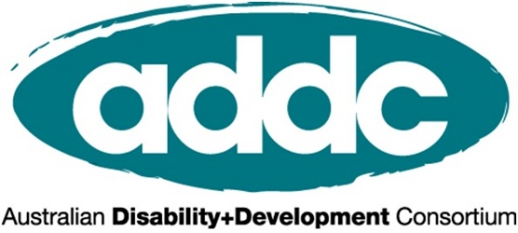

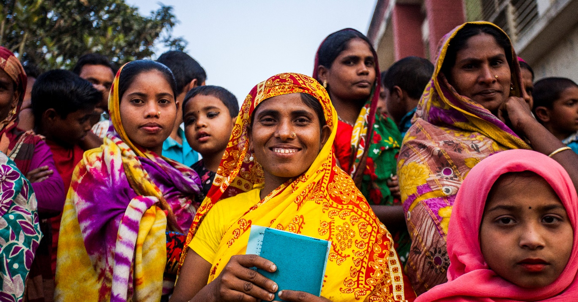

INTERNATIONAL DAY OF PEOPLE WITH DISABILITIES 2020

A better world for all:
What does an inclusive and equitable world look like?

ACTIVITY TOOLKIT
For the International Development Sector

Contents:
What is International Day of People with Disabilities? 2
What can your organisation do to mark IDPD? 2
IDPD Social Media Action 3
IDPD Event or Activity 4
Some tips for IDPD events and activities 6
Engaging a speaker with disabilities 7
Who is the Australian Disability and Development Consortium 9
Who is CBM Australia? 9

What is International Day of People with Disabilities?
International Day of People with Disabilities (IDPD) is a sanctioned United Nations day celebrated annually. This important day aims to raise awareness and promote action around the rights of people with disability and their full inclusion in society. This year it is on Thursday, 3 December.
IDPD poses a unique opportunity to work with your organisation to celebrate disability and raise awareness of disability inclusion issues. ADDC is keen to support disability inclusion champions within INGOs to use IDPD as an opportunity to celebrate disability and diversity, share the voices of people with disabilities, and raise awareness of the need for focused efforts and resourcing on disability inclusive development.

What can your organisation do to mark IDPD?
ADDC is encouraging our members and disability champions within INGOs to celebrate IDPD and to use this as an opportunity to raise awareness about disability inclusion within your organisation, by joining in our Social Media IDPD Action, and organising an IDPD Event or Activity within your workplace. We outline both of these below.

To support you with the above ADDC and CBM Australia are preparing a full IDPD Resource Pack including case studies, suggested social media that can be adapted for your org, social media banners and assets, and facts and statistics that you can draw upon in any of your chosen activities to mark IDPD. This Resource Pack will also link to CBM’s 2020 IDPD video, which features people with disabilities speaking about their vision for a more inclusive world.

IDPD Social Media Action
Advocating for real change starts with conversation and awareness. That’s why we need you to join the conversation. We would love you and others in your organisation to add your voice to the ‘call to action’ to showcase a #BetterWorldForAll on social media.
- Grab a piece of paper and draw a big circle, like the globe
- Write in the circle what you think is most needed to build an inclusive and equitable world for all
- Take a selfie of you holding the paper (see below)
- Spread the word by sharing your selfie on Facebook, Instagram and Twitter with the caption International Day of People with Disabilities: Building a #BetterWorldForAll #IDPD
By doing these steps you are helping us advocate for a #BetterWorldForAll. We will create a collage of everyone’s contributions
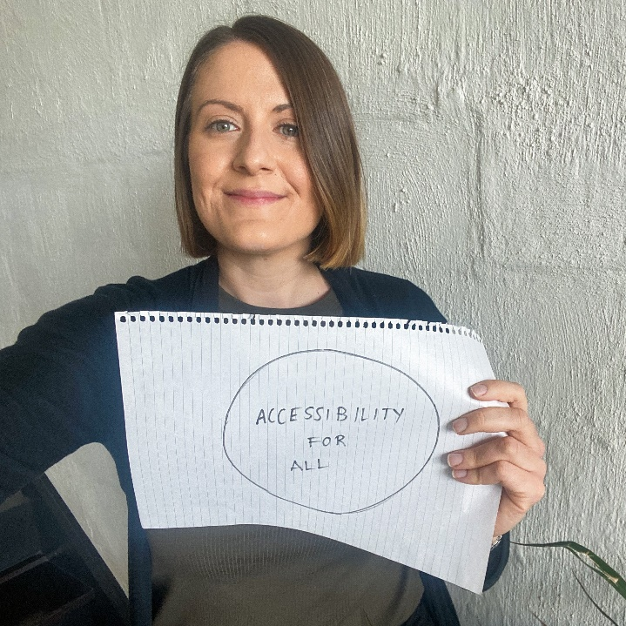
Need some inspiration? Here are a few ideas to get you started:
- Clean water FOR ALL
- Accessibility FOR ALL
- Gender Justice FOR ALL
- Jobs FOR ALL
- Education FOR ALL
ADDC and CBM Australia will be keeping track of everyone’s posts and share / collate these – follow or tag us to connect on the day!

IDPD Event or Activity
We are encouraging our members to organise an event or activity within their organisation to mark IDPD and promote awareness around disability. Our hope is that you will all do the IDPD Social Media Action as part of these activities and events also. Some ideas are as follows – these can be combined, so don’t limit yourselves!
IDPD Event or Activity | Feature resources | Who to involve
Organise a morning tea for your organisation (even a virtual one!) | - A speaker with disability (see further guidance on engaging speakers below)  - Keep your eyes out for the IDPD Resource Pack, featuring case studies, suggested social media, key facts and CBM’s 2020 IDPD video featuring people with disabilities talking about the world they want! This will be available in late November 2020.  - End the Cycle videos  - Do the IDPD Social Media Action as a group! | - Make sure you invite leadership to join, and if possible have someone from leadership speak (such as doing the introductions)  - Invite all staff or your team members, as appropriate  - In addition to the below, when you begin planning, ask any staff who identify as having disabilities if/how they would like to be involved and what they would like to do to mark the day
Raise awareness amongst your team or organisation by sharing resources via:  - email  - intranet article  - a team meeting | Share  - Draw upon the IDPD Resource Pack (see above).  - Do the IDPD Social Media Action as a group. | - Leadership – ask them to be involved. For example they could send out an all staff email. You can offer to help write this for them  - Your team or all staff members, as appropriate
Ask your organisation to share a post regarding disability and IDPD on your website, communications and social media  Use your organisation’s voice to raise awareness about disability and poverty issues this IDPD! | - If your organisation has any projects focusing on people with disabilities, or case studies of how people with disabilities have accessed their work, IDPD is a great opportunity to show case them  - If you don’t have access to a social story like this, your organisation can still share some key facts about disability and poverty through social media. The Resource Pack will provide plenty of material for you here  - Share photos of your team doing the IDPD Social Media Action through your org’s digital channels! | - Ask the Digital Communications team on board to share the content.  - International Programs or Policy teams may have a case study to share  - Ask your CEO or leadership to engage in the Social Media Call to Action (and sharing this through relevant digital channels!)
Launch a new disability inclusion initiative within your organisation | - IDPD is a great opportunity to launch any disability initiative that your organisation may have been considering for some time. For example a Disability Action Plan or a Disability Working Group.  - It could aim to have a final product ready to be shared on IDPD, or if you are at the start of your journey you can use IDPD to launch this initiative, or call for any interested staff to get involved.  - A public or shared announcement of intention on something like this can be a powerful means of accountability. | - Leadership endorsement  - Any other disability ‘champions’ or people interesting in promoting disability rights in your org

Some tips for IDPD events and activities
Organisng an event or activity to mark IDPD is a wonderful first step, and there are a few things to be aware of to make sure this is effective and sensitive. Below are some
Include the voice of people with disabilities: Firstly, the catch cry of the disability movement is ‘nothing about us without us’. This means it is imperative that any event or activity features the voices of people with disabilities.
- A powerful way of doing this is by inviting a speaker with disability to talk – there are some guidelines on this below.
- If you are aware of any people within your organisation who openly identify as living with a disability, talk to them about the possibility of your organisation doing something for IDPD, ask whether they want to be involved and/or if they have any particular ideas or messages they want to share. Remember, this is their day.
- Share a video or case study of a person with disability sharing their story in their own words. There is a huge range of End the Cycle videos from a broad range of low and middle income countries that do just this!
Get leadership involved: Many years of experience has told us that a key factor of increasing organisation’s commitment to disability inclusion is having leadership come to recognise its importance. As such, IDPD provides a key opportunity to help raise awareness amongst your organisation’s leadership, as part of a journey to getting them understanding and investing in improved disability inclusion practices.
- Identify key leaders within your organisation to target: whether they be those holding particularly influential positions, or perhaps those with a particular interest in disability or inclusion.
- Invite them to have some role in the event or activity: perhaps saying the welcome, introducing a speaker, being the one to send out a staff email or intranet article that you can help author, or even by getting them to do the IDPD Social Media Action and sharing this via your org’s digital media channels!
- Now is a good time to help leadership showcase any work they or the organisation are doing in disability inclusion: whether that be a strong international program, a Disability Action Plan, or improved reporting/data disaggregation.
Ensure your event is accessible to any people with disabilities who may attend (even if it’s just a virtual event!)
Your communications publicising the event or activity can directly ask people to let you know if they have any accessibility requirements, which should always be provided free of cost to them in accordance to their rights. Please refer further to these resources on how to make your organisation and communications more inclusive, and this event accessibility checklist.

Engaging a speaker with disabilities

Like everyone, people with disabilities have a lot of competing priorities for their time and what they can give themselves to. While your IDPD will definitely be enriched by a speaker with disabilities, it is important to recognise that doing so requires time and effort on their part, and arranging for them to speak should be approached thoughtfully.
- Be clear about what will be involved in speaking: length of time, format (e.g. presentation or interview), purpose or focus of the event. This will help the invited speaker to gauge whether it’s an activity they can commit to. Make sure that your event actually allocates enough time for them to speak, including allowing some extra time if they are using interpreters, and that they are invited to stay for the whole event (such as a morning tea).
- Ask what the speaker’s speaking fee is, and do not expect them to participate for free. Like all of us, their time is valuable! If the event is in-person, the fee should cover their travel costs and any reasonable accommodation requirements such as Sign Language interpreters or captioning if required. If the speaker’s fee is out of your range, politely explain this and that you won’t be able to engage them this time - do not ask or expect them to reduce their fee for you.
- Before approaching the speaker, get clear on what you want them to talk about. It might help to think up a specific title for your event, such as “Why inclusion matters in your organisation’s work”?, ‘A look at disability-inclusive WASH programming in Indonesia’, or “What does a disability inclusive organisation look like?” Providing this clarity is important for a few reasons:
  - Approaching speakers without a clear purpose or topic in mind can often create the impression that their involvement is tokenistic, rather than because you specifically want to learn from them on a particular issue.
  - A clear topic allows you to make sure that they have appropriate expertise or knowledge on this area. If you are unsure of their expertise, you can have a discussion about this by proposing the general theme of your activity and asking if/ what they feel they could best speak to within this.
  - You can also ask them if there are any particular messages or themes that they would like to raise within this theme. Ideally their speaking will be a mutually beneficial activity for both your organisation and the speaker.
- When you confirm the booking with the speaker, ask how they would like to be introduced. Include this wording clearly in the event notes / speaking notes for whoever will introduce them.
- Remember people with disabilities have diverse backgrounds and identities! Not all their expertise are the same, and it is important to engage speakers from broad range of backgrounds including gender, age, type of disability, location, and Indigenous and LGBTI people.
- Remember that in order for your IDPD event and involvement of a speaker with disabilities to not feel tokenistic, this activity needs to be made alongside work to improve disability inclusive policies and practices within your organisation, both before and after the event.

Finding a speaker
If your organisation is at the start of their disability inclusion journey, it can take a little time to find a speaker with a disability. You could consider reaching out to:
- People within your organisation who identify as having a disability should have already been invited to be involved with the activity planning when you first started this. If any have indicated they do want to be involved, you can ask if they want to speak themselves, or if not, if they can help introduce you to appropriate speakers.
- A local organisation that provides information about disability – such as a local Disabled Person’s Organisation or representative group – and ask to book a presenter with a disability. Be aware they are well placed to speak about disability in general, rather than necessarily in a development context.
- There are various people with disabilities on social media who are also available to be booked to speak.
- If your organisation partners with any disability groups overseas, it may be an option for them to speak online too. Be mindful of cross-cultural communication and power dynamics that may exist if your organisation funds them, and any need for local spoken and/or Sign language interpreters.
If you have any questions arising from this toolkit, please contact Lucy Daniel, ADDC Executive Officer, on ldaniel@addc.org.au

Who is the Australian Disability and Development Consortium?

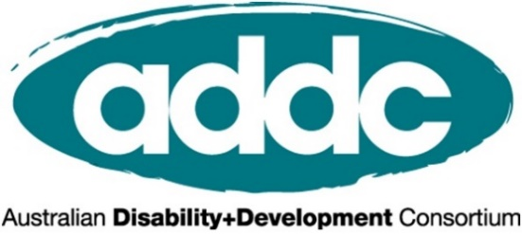
ADDC is an Australian, international network focusing attention, expertise and action on disability issues in developing countries; building on a human rights platform for disability advocacy. We focus on providing networking and learning opportunities, sharing resources and lobbying activities, to improve and promote the practice of disability inclusive development throughout Australia’s international development sector.
To join ADDC (membership is free) or find out more, please visit www.addc.org.au

ADDC is grateful for CBM Australia’s support on this toolkit

Who is CBM Australia?
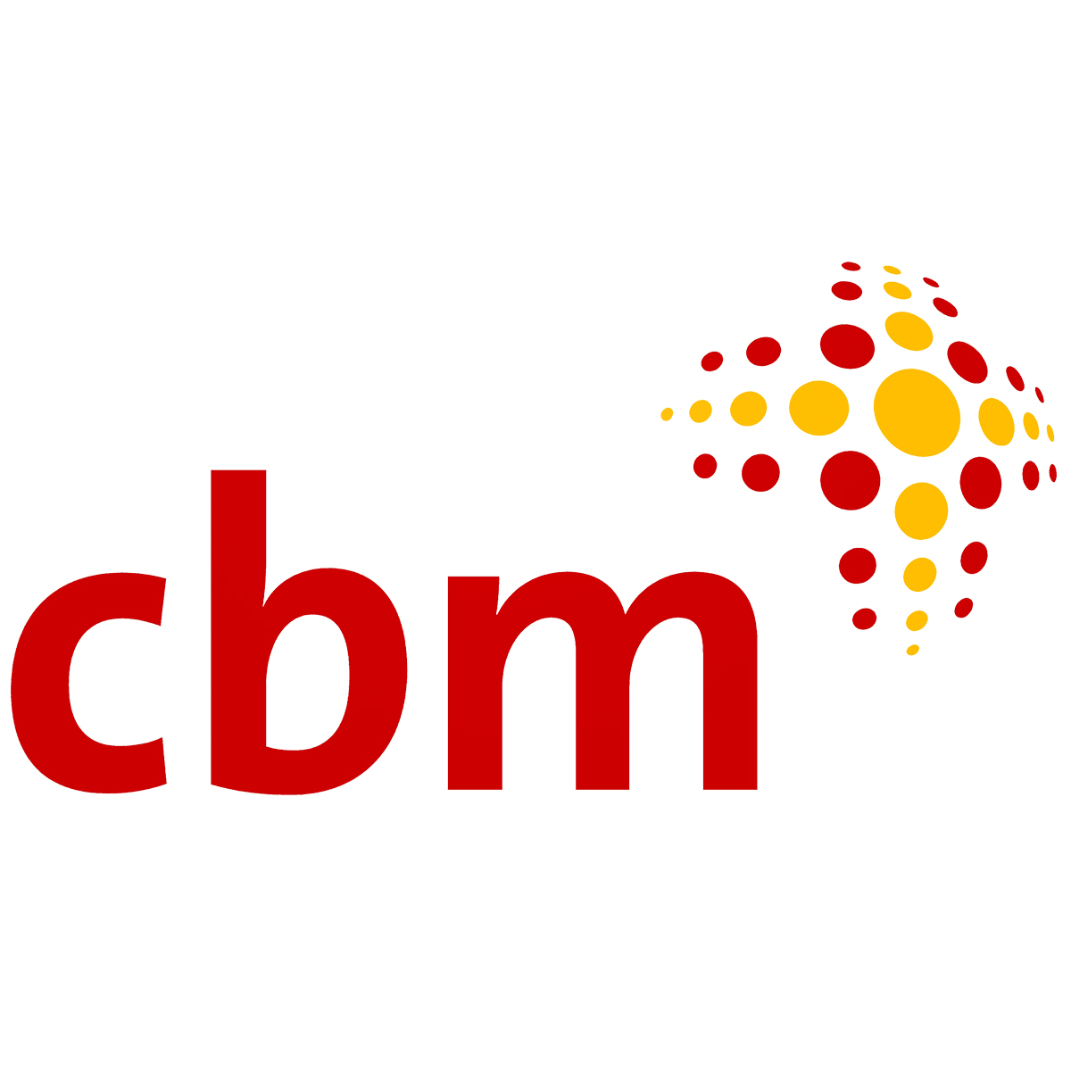CBM Australia is an international Christian development organisation committed to improving the quality of life of people with disabilities in poor communities around the world.
Addressing poverty alleviation through development efforts that include people with disabilities, and prevent disability for those at risk; CBM Australia is helping to end the cycle of poverty and disability.
CBM Australia works in partnership with people with disabilities, non-government organisations, government and international agencies to empower people with disabilities to achieve their human rights and participate fully in society.
CBM is fully accredited with Australia’s Department of Foreign Affairs and Trade, receives Australian NGO Cooperation Program funding, and is a full member of the Australia Council for International Development.

