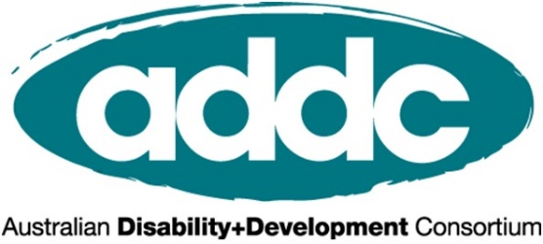

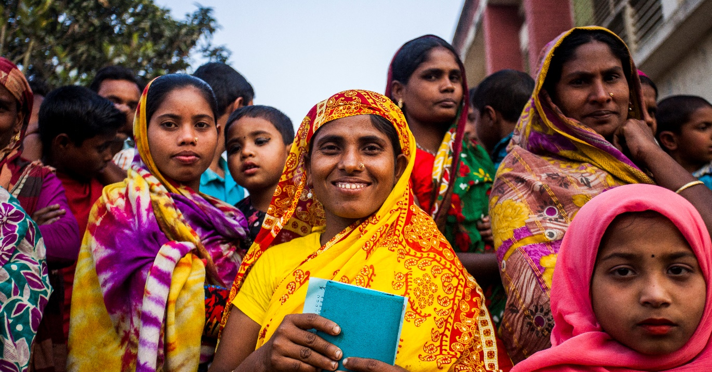

INTERNATIONAL DAY OF PEOPLE WITH DISABILITIES 2020

A better world for all:
what does an inclusive and equitable world look like?

RESOURCE KIT
for the International Development Sector

Welcome to ADDC’s IDPD Resource Kit!

This has been designed to help the international development sector to mark International Day of People with Disabilities across online and social media platforms. As you can see in the outline below, we have a range of content to guide and inspire your communications. You can pick and choose from these and adapt them, however works best for your specific audiences. We hope it proves useful! Remember you can also refer to our IDPD Activity Toolkit for ideas on how to mark the day – these communications could be incorporated or complement any events as well.
If you have any feedback please feel free to reach out to Lucy at ldaniel@addc.org.au.

Contents
CBM IDPD Video: #BetterWorldForAll 2
End the Cycle videos, case studies and fact sheets 2
Official Call To Action: 2
Suggested Social Media Posts 3
Assets for your organisation to use across communication channels 5
Disabilities and Global Development – facts and statistics 5
Case Studies 6

CBM IDPD Video: #BetterWorldForAll
In CBM’s 2020 IDPD video we hear from people with disabilities around the world and their vision of a more inclusive world. A world where every person is able to live their life fully and equal - free from stigma and discrimination. In this world everyone is able to participate and enjoy their human rights. We aspire to build this world, a #BetterWorldForAll. The video can be accessed here and is under embargo until 9am AEST December 3. Please do not share or post on social media accounts until December 3.

End the Cycle videos, case studies and fact sheets
End the Cycle promotes tools and resources to help international development practitioners raise awareness of and practice disability-inclusive development. The resources feature people with disabilities in low and middle income countries telling their own stories in their own words. They personally approve the stories and photographs that represent them, meaning these resources can help bring the lived experience of people with disabilities into your activities. End the Cycle is an initiative of CBM Australia, and the resources can be browsed here.

Official Call To Action:
- Show your support for IDPD on the day by getting involved through our Social Media Call to Action– and get your colleagues to join in too!

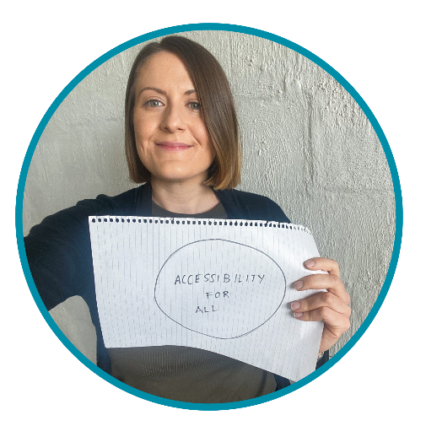
- Join the conversation by telling us what makes for a #BetterWorldForAll:
  - Grab a piece of paper and draw a big circle, like the globe
  - In the circle tell us what is most needed to build an inclusive #BetterWorldForAll
  - Post a selfie to Facebook and/or Instagram of you holding your sign with the hashtags #IDPD #BetterWorldForAll

Suggested Social Media Posts
Please choose and adapt the content that best suits your needs. There are also some further facts and statistics and case studies below.

Official hashtags: #BetterWorldForAll #IDPD
Share content: from Monday, 30 November to Thursday, 3 December.

Video:
BetterWorldForAll Video (The video is also available in audio description here)

- People with disabilities have a clear vision for their future and for a world that includes them. A world where every person is able to live their life fully and equal - free from stigma and discrimination. But don’t take our word for it, listen to the 14 people with disabilities who shared their vision for a #BetterWorldForAll in CBM Australia’s brand new video.
- Our friends [or partners if in partnership with CBM] at CBM Australia have created a short video which shares the voices of people with disabilities and their vision of a more inclusive world. A world where every person is able to live their life fully and equal - free from stigma and discrimination. In this world everyone is able to participate and enjoy their human rights. #IDPD #BetterWorldForAll
- “As a person with disability, a #BetterWorldForAll means everyone has the same opportunities to study, work, travel and can enjoy life without any barriers in terms of awareness, public buildings, and transportation.” Fiona is one of 14 people with disabilities in CBM Australia’s soon to be launched #IDPD video advocating for a more inclusive #BetterWorldForAll

LinkedIn:

- Today is International Day of People with Disabilities. The global pandemic of 2020 has had catastrophic impacts on the lives and well-being of the world’s one billion people with disabilities, who have faced:
    - higher rates of unemployment,
    - increased food insecurity
    - challenges to protect themselves from the virus disproportionately more than people without disabilities
As we to look to the future there is an opportunity to build back a #BetterWorldForAll, and address inequalities and injustices inherent in our current systems. We all have a role to play in building a society that listens and acts on the ideas, priorities and perspectives of people with disabilities. This International Day of People with Disabilities join us as we campaign for a world where all people feel valued and heard; and can access their human rights. #BetterWorldForAll #IDPD

General suggestions - Facebook:

- Join [Insert Organisation Name] as we mark International Day of People with Disabilities at our [Insert Event] #IDPD #BetterWorldForAll
- International Day of People with Disabilities is an important day to raise awareness of the many barriers people with disabilities face around the world. At [Insert Org] we are working to build a more inclusive world by [insert program or activity] #BetterWorldForAll #IDPD
- During the COVID-19 pandemic, issues related to mental health have been on the rise. Tearfund and their partners in India have been working to support people with psychosocial disabilities and ensure them and their families have access to the medicine they need and essential food items. Programs such as this pave the way for a more inclusive future, where all people are included. #BetterWorldForAll #IDPD
- In 2020, mask-wearing has become the norm to help stop the spread of COVID-19 across the world. For deaf people, this has restricted communicating via lip reading. CBM’s partners in the Philippines have found an innovative solution, by designing and manufacturing an inclusive mask. #BetterWorldForAll #IDPD

General suggestions - Twitter:

- Take a look at the video @CBMAustralia created to mark International Day of People with Disabilities which shares the voices of people with disabilities calling for a #BetterWorldForAll #IDPD
- We want to live in a world where every person is able to live their life fully and equal - free from stigma and discrimination. In this world everyone is able to participate and enjoy their human rights. #BetterWorldForAll #IDPD

General suggestions - Infographic:

- Right across the world millions of people with disabilities do not have access to their human rights, essential services and still face daily exclusion in their communities. COVID-19 has made things worse. This International Day of People with Disabilities, we’re taking a moment to envision a more inclusive #BetterWorldForAll #IDPD

Assets for your organisation to use across communication channels

SOCIAL MEDIA TILES Click here

BANNERS Click here

ADAPTABLE MEDIA RELEASE Click here

Disabilities and Global Development – facts and statistics
The following may be of use as you prepare communications to share

General statistics and facts:
- Globally, 15 per cent / one in seven people / one billion people in the world have a disability.
- 22 per cent of the world’s poorest people have a disability.
- Disability and poverty are often linked as people living in poverty have a higher chance of acquiring a disability due to lack of medical care, poor nutrition, violence, unsafe housing, and getting injured at work.
- People with disabilities are more likely to live in poverty. People with disabilities report multiple barriers to accessing health services.
- People with disabilities are also less likely to attend school, are more likely to be unemployed and generally earn less when employed.

COVID and disability
In Indonesia, people with disabilities have reported considerable barriers to accessing information, particularly for people who were blind, while Deaf people noted challenges in communication due to difficulties lip reading while others were wearing masks.
An Indonesian survey found that 46% of people with disabilities found COVID-19 information difficult to understand.

In Indonesia, a survey noted that 41% of respondents with disabilities had experienced a reduction in necessary assistance from others for daily activities.
A global survey of women and non-binary people with disabilities found that one in three respondents had lost access to needed disability-related support services, including personal assistance, wheelchair replacement and repair, and accessibility services such as Sign Language interpreters.

Reports from sexual and reproductive health service providers around the world indicate that client numbers are declining during the pandemic due to inaccessibility, reduced community engagement, or fears of infection.. Women and girls with disabilities are experiencing targeted exclusion as telehealth substitutes are insufficiently accessible.

In Vietnam, 30% of survey respondents with disabilities reported losing their jobs in the 1st month of COVID-19 restrictions, and of those still working, 59% reported cuts to their pay. This resulted in people with disabilities reporting a 28% reduction in income in the first month of lockdowns, leading many households to fall into poverty for the 1st time.

In Indonesia, 67% of men and 71% of women with disabilities reporting that they were no longer working compared to 55% of men and women without disabilities. 80% of those who lost income due to the COVID-19 lockdown faced difficulties covering their basic needs and 43% were unable to pay their monthly utility bills.

Globally, women and girls with disabilities are two to three times more likely to experience physical or sexual violence than women without disabilities. Women with disabilities have reported particular fear of violence based on stigma or superstition relating to their disability and COVID-19.

Women and girls with disabilities
- In many low and middle income countries, women and girls with disabilities face triple discrimination: being female, having a disability and being among the poorest of the poor.
- Women and girls with disabilities are often hidden away by families, excluded from decision making – even about their own bodies and lives – and are less likely to attend school than girls without disabilities.
- Women with disabilities are two to three times more likely to be physically or sexually abused than women without disabilities.
- It has been estimated that 90 per cent of children with disabilities in low and middle income countries do not go to school.
- Furthermore, children with disabilities who do go to school have much lower rates of staying and succeeding in school.
- In low and middle income countries just 32.9 per cent of girls with disabilities complete primary school.
- People with disabilities who do not attend school as a child are more likely to live in poverty as an adult.
- People with disabilities are also less likely to be in employment than people without disabilities.
- In low and middle income countries 58.6 per cent of men with disabilities are in employment compared to just 20 per cent of women with disabilities.

Case Studies
from across the sector featuring people with disabilities and disability-inclusive initiatives

Tearfund Case Study
Partner Organisation: SHIFA Mental Health and Disability Project – India

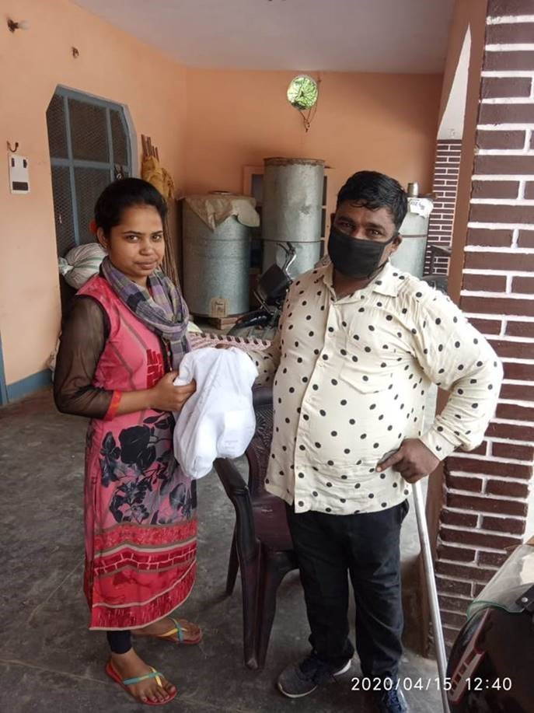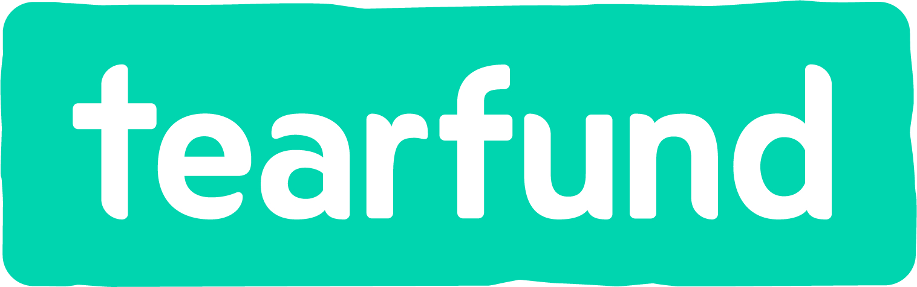The unprecedented spread of COVID-19 pandemic has led to a stressful situation all over the world, making it an issue of global health concern. The impact of this pandemic, however, is not limited to physical health. Many issues related to mental health are on the rise, and people with existing psychosocial conditions are often left without access to the support they require. In Saharanpur, a district of Uttar Pradesh, India, TEAR’s partner organisation Emmanuel Hospital Association runs the project SHIFA Mental Health and Disability which works to improve the mental health of people with psychosocial disabilities and their families.

"I am a person with a disability and I have felt sad during the pandemic. But the help I’ve received means I can now support my family and I am very happy about that. Someone is standing beside the poor.” – Anita

Many people in this region are reliant on livelihoods in agriculture, horticulture and trade. Severe lockdowns were imposed on the community when the pandemic began and people suddenly found themselves out of work, unable to support themselves and their families. People with psychosocial disabilities struggled to access psychological support and their medications, and some even experienced depressive episodes and suicidal thoughts. The government established a free rations program so communities could access daily necessities, but the local health service weren’t able to provide adequate support for those with mental health issues. People within the community felt fearful and stressed.

During the pandemic SHIFA Mental Health Project partnered with several local organisations, including an OPD (Organisation of People with Disabilities) and faith based groups, to ensure individuals and families got the information and support they needed. One initiative provided vital psychiatric services and medicine to those that needed it - many from the local community came forward for support and care. A brochure was also developed to promote health messaging in the communities on “How to stay mentally healthy during covid-19 lockdown”. The brochure was available in five local language dialects and shared through a number of channels to ensure the information was accessible. Further, hygiene kits including face masks and sanitizer were distributed to a number of families, along with public health messaging about how to protect yourself from COVID-19. This included education on hand washing and how to safely use a mask.

"We are delighted. Our daily life has improved! During lockdown the project has made medicines available to our family and we are incredibly grateful" said Rishipal.

It is programs like these that pave the way for a more inclusive future, where all people are included. We are working towards that future where everyone, especially people with disabilities and psychosocial disabilities, is valued and respected as part of the family and community; a future where everyone will be able to reach their full potential. With small steps, change is possible.

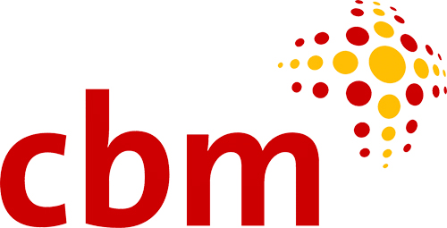
CBM Australia Case Study
Partner Organisation: CBM Philippines Country Office

When COVID-19 first reached the Philippines, widespread lockdowns and mandatory mask-wearing were introduced across the country to slow the spread of the virus. For deaf people, this meant that they were cut off from communicating via lip reading, as traditional masks hide people’s faces.

Michi, from CBM’s Country Office in the Philippines, explains that “the situation for people with disabilities is difficult. That’s why we have joined forces with local partners and organisations of persons with disabilities (OPDs) to ensure response efforts are inclusive and protect the safety of all people.”

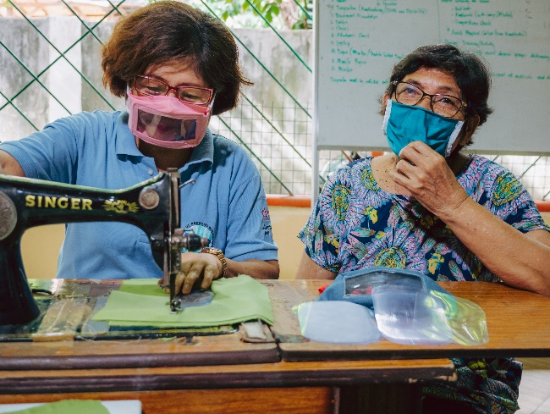
One initiative that has come out of the collaboration is an inclusive mask. The team designed a mask featuring a clear plastic panel to allow for lip reading and it has since been manufactured by OPDs. The mask was successfully trialled in the community with many welcoming the initiative. The success of the masks has meant they are now being produced at scale and rolled out to even more communities.

“The inclusive face mask has helped me and the Deaf community to communicate with people and understand them through lip reading. Thank you for making us feel that we are one.” said Floyd, a member of the Deaf community and vice president of the Inclusive Disaster Risk Reduction (IDRR) Motivators.

Michi continues, “We’ve also been able to have influence with the local government’s disaster preparedness committee who have tweaked their wider community response to include people with disabilities.”

“The Local Government appreciates the initiative so much they are giving us a space in the market to display the face masks. There is growing support for inclusive face masks from nearby provinces and private institutions. We have even received orders from a medical school.” said Mae, a project manager of Edmund Rice Ministries.

Alongside the inclusive mask initiative, the team have been distributing food and hygiene packs to several communities in need. The packs were specifically designed with people with disabilities in mind and include Personal Protective Equipment (PPE), disinfectant, emergency food supplies and materials that raise awareness about how to protect yourself from COVID-19.

“If we want to create a world which is inclusive, we must design our products for disability.” said Michi. A crisis can also be an opportunity, and in the case of COVID-19 we can reimagine the world as it could be where all people, especially people with disabilities, are valued and respected.

Plan Indonesia Water For Women Case Study
The COVID-19 pandemic that swept the globe this year has changed the world as we know it, bringing with it significant economic, health and social challenges to the Asia Pacific region where Yayasan Plan International Indonesia (YPII) runs a large project entitled ‘WASH and Beyond: Transforming Lives in Eastern Indonesia’, with support from Plan International Australia and the Australia Government’s Water for Women (WfW) Fund.

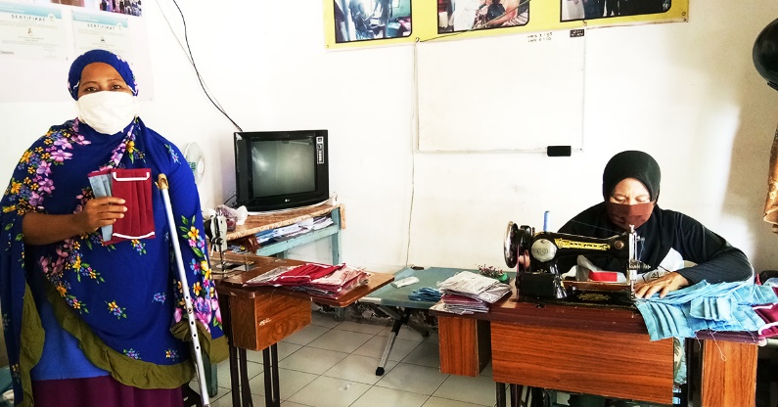
With the pause of several industries in Indonesia, including manufacturing, tourism, transportation, trade, and construction, many people have been let go from their employment and countless businesses have closed or are struggling to stay afloat. YPII’s WfW project, including the DPOs the project supports, have seen first-hand how badly COVID-19 is impacting the livelihoods of people with disabilities:

"Since the COVID-19 pandemic, the massage business which employs groups of people with disabilities has been completely closed. We do not have any source of income, because no one dares to come for a massage for fear of contracting the virus" said Baiq Hadijah (Head of Samawa Disability Persons Organisation).

Despite a very challenging year, people with disabilities are not letting themselves be discouraged by the current conditions. Many are in fact responding in remarkable ways during a time of adversity. Despite the closure of their massage business, they have adapted quickly to become mask-making entrepreneurs. YPII has been supporting the group in this new business venture:

"There are several people with disabilities who have the ability to sew, have tried to pioneer the business of making masks. Initially for our own needs, but including many requests from outsiders. The most orders are currently coming from Yayasan Plan International Indonesia, which ordered 1,440 masks with 3 layers of cotton fabric according to the Ministry of Health's recommendation" said Baiq Hadijah.

This has proved mutually beneficial for both the people with disabilities involved in the project and YPII. The masks ensure YPII staff can continue to undertake their frontline COVID-19 response (which had previously been challenging due to mass shortages in PPE) and the people with disabilities involved are now earning an income. This partnership is helping many stay employed and stay protected during an uncertain time.

Throughout the crisis the project has also been working with people with disabilities and supporting them to understand and advocate their rights. This has included training in water and sanitation, gender equality and social inclusion. YPII’s disability-inclusive response has ensured people with disabilities are included and able to enjoy their human rights during the COVID-19 crisis, paving the way for a more inclusive future.

Author: Jatmoko who works as Yayasan Plan International Indonesia WfW project’s Provincial Project Coordinator in NTB province. (Story edited from Water for Women website)

Department of Economic and Social Affairs. (2007). 2004 Demographic yearbook- fifty-sixth issue. New York: United Nations. Cited in World Health Organization & World Bank. (2011). World Report on Disability (p. 28). Geneva: World Health Organization.
World Health Survey. (2002-2004). Geneva: World Health Organization. Retrieved from http://who.int/healthinfo/survey/en
Groce, N. (2004). HIV/AIDS & Disability: Capturing Hidden Voices. Global Survey on HIV/AIDS and Disability. Connecticut: The World Bank/Yale University. Retrieved from: http://siteresources.worldbank.org/DISABILITY/Resources/Health-and-Wellness/HIVAIDS.pdf
VanLeit, B., Rithy, P. & Channa, S. (2007). Secondary Prevention of Disabilities in the Cambodian Provinces of Siem Reap and Takeo: Perceptions of and use of the health system to address health conditions associated with disability in children. Report prepared for Handicap International Brussels. Retrieved from http://siteresources.worldbank.org/DISABILITY/Resources/News---Events/BBLs/070517HIrptCambodia.pdf
Burchardt, T. (2005). The education and employment of disabled young people: frustrated ambition. Bristol: Policy Press. Cited in World Health Organization & World Bank. (2011). World Report on Disability (p. 10).
YAKKUM Emergency Unit. Cited in CBM Australia and Nossal Institute for Global Health (2020) Experiences of people with disabilities in COVID-19: A summary of current evidence. URL: https://www.did4all.com.au/Resources/Full%20report_Evidence%20Summary%20Disability%20COVID_%20July20.pdf.
ASB Disability Cluster. Cited in CBM Australia and Nossal Institute for Global Health (2020).
ASB Disability Cluster.
Women Enabled International. p. 13.
Church, K., Gassner, J. and Elliott, M. (2020). ‘Reproductive Health under COVID-19 – Challenges of Responding in a Global Crisis’, Sexual and Reproductive Health Matters 28 (1):1–3. URL: https://doi.org/10.1080/26410397.2020.1773163.
Women Enabled International. p. 7.
UNDP Viet Nam (2020) Rapid Assessment of the Socio-economic impact of COVID-19 on persons with disabilities in Viet Nam. Ha Noi: UNDP. p. 7.
Rema H, O. B. (2020). Current Results of Online Survey on Economic Impact of COVID-19- results for people with disabilities. Cited in CBM Australia and Nossal Institute for Global Health (2020).
DPO Network in Indonesia. Cited in CBM Australia and Nossal Institute for Global Health (2020).
CBM Australia, 2018. Leave No One Behind: Gender Equality, Disability Inclusion and Leadership for Sustainable Development. URL: https://www.cbm.org.au/wp-content/uploads/2017/03/CBM-011-WhitePaper-v1.4-WEB.pdf.
Women Enabled International. p. 17.
Promoting Gender Equality. (2005). New York: United Nations Population Fund. Retrieved from http://www.unfpa.org/gender/
CBM International. (2016). The 3 P’s for Inclusion for Women with Disabilities: The Personal, The Political, The Policy. (p.2). Retrieved from http://www.cbm.org/article/downloads/54741/The_Personal__The_Political__The_Policy.pdf
Department for International Development [DFID]. (2000). Disability, Poverty and Development. Retrieved from http://handicap-international.fr/bibliographie-handicap/4PolitiqueHandicap/hand_pauvrete/DFID_disability.pdf
Global Partnership for Education. 2017. Children with Disabilities. Retrieved from: http://www.globalpartnership.org/focus-areas/children-with-disabilities
World Health Organisation &World Bank. (2011). World Report on Disability (p. 225). Retrieved from http://www.who.int/disabilities/world_report/2011/en/index.html
World Health Organisation & World Bank. (2011). World Report on Disability (p. 225). Retrieved from http://www.who.int/disabilities/world_report/2011/en/index.html
Filmer, D. (2008). Disability, poverty and schooling in developing countries: results from 14 household surveys. The World Bank Economic Review. Washington: World Bank. Cited in World Health Organization & World Bank. (2011). World Report on Disability (p. 205).
World Health Organisation &World Bank. (2011). World Report on Disability (p. 225). Retrieved from http://www.who.int/disabilities/world_report/2011/en/index.html

