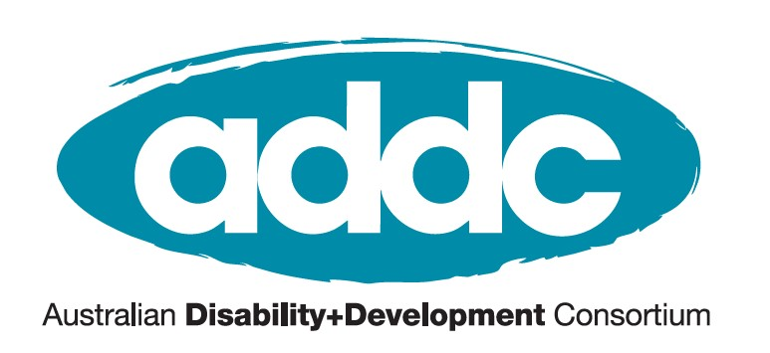
ADDC Executive Committee Nomination Form 2021
Nominations close on Wednesday 13 October at 5pm AEST.
Email completed forms to lmunoz@addc.org.au.
We, the undersigned, wish to nominate the following person:

Name: _____________________________________

Nomination category (Select one):
Australian Aid and Development organization
Organisation Name: ___________________________
General position for organization
Organisation Name: ___________________________
General position for individual ADDC member
Nominator/Seconder:
________________________________________ ________________________________________
Member proposer name Member proposer signature (digital accepted)
________________________________________ _________________________________________
Member seconder name Member seconder signature (digital accepted)

I am willing to be nominated:
________________________________________ _________________________________________
Nominee name Nominee signature (digital accepted)

For nominees representing an organisation -
Manager Statement: This position requires the member to participate in at least:  - One teleconference meeting per month  - One face to face meeting per year  - Up to one hour of work per week  Your signature assures you agree to this commitment. | Manager name  Manager signature (digital accepted)
All nominations must be Australian-based members of ADDC. If you want to confirm your membership, contact Linda Munoz on lmunoz@addc.org.au.

Nominee Statement
This statement will be included in the ballot paper for all voting members to read. Include biography, background and why you are interested in this role with a max of 500 words.
Enter your Nominating Statement here.

Nominations for the 2021 election of the
ADDC Executive Committee closes on 13 October on 5pm AEST.

Send completed nomination forms to Linda Munoz via lmunoz@addc.org.au.

For more information visit the ADDC Election page or
contact Kerryn Clarke, ADDC Executive Officer via kclarke@addc.org.au.

