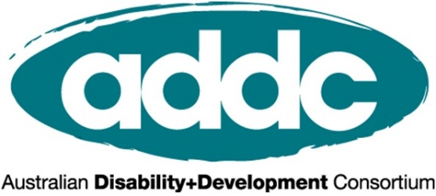

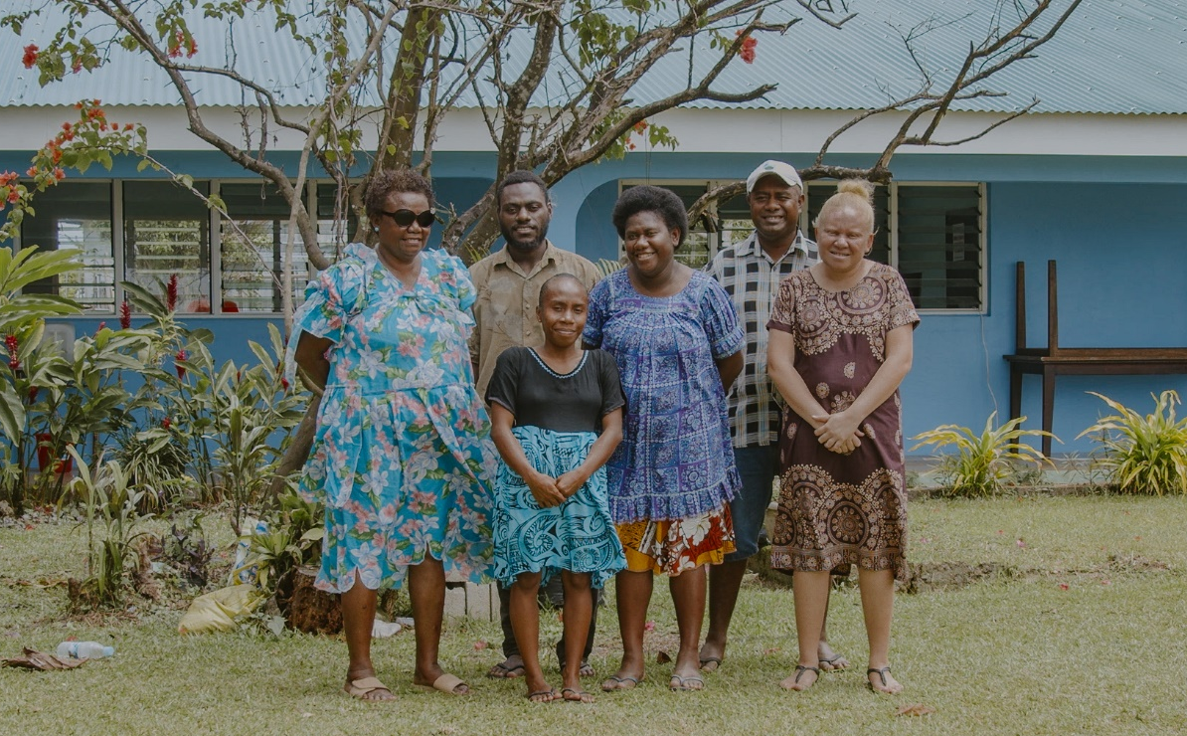

INTERNATIONAL DAY OF PEOPLE WITH DISABILITIES 2021

Build a Better World for All
The time is now!

ACTIVITY TOOLKIT
For the International Development Sector

Contents:
What is International Day of People with Disabilities? 2
What can your organisation do to mark IDPD? 2
Tips for IDPD events and activities 6
Make your event accessible 7
Engaging a speaker with disabilities 7
Who is the Australian Disability and Development Consortium? 10
ADDC is grateful for CBM Australia’s support on this toolkit 10
Who is CBM Australia? 10

What is International Day of People with Disabilities?
International Day of People with Disabilities (IDPD) is a sanctioned United Nations day celebrated annually. This important day aims to raise awareness and promote action around the rights of people with disability and their full inclusion in society. This year it is on Friday 3rd December.
IDPD poses a unique opportunity to work with your organisation to celebrate disability and raise awareness of disability inclusion issues. ADDC is keen to support disability inclusion champions within INGOs to use IDPD as an opportunity to celebrate disability and diversity, share the voices of people with disabilities, and raise awareness of the need for focussed efforts and resourcing on disability inclusive development.

What can your organisation do to mark IDPD?
ADDC is encouraging our members and disability champions within INGOs to celebrate IDPD and to use this as an opportunity to raise awareness about disability inclusion within your organisation, by joining in our Social Media IDPD Action, and organising an IDPD Event or Activity within your workplace. We outline both below.

IDPD Resource Kit
To support you with the above ADDC and CBM Australia are preparing a full IDPD Resource Kit including case studies, suggested social media that can be adapted for your organisation, social media banners and assets, and facts and statistics that you can draw upon in any of your chosen activities to mark IDPD.
All ADDC members will receive the IDPD Resource Kit in mid-November.

IDPD Social Media Action – Share the video marking IDPD
Advocating for real change starts with a conversation with those at the centre of disability inclusive development: people with disabilities themselves. We are asking you to advocate with people with disabilities by participating in two actions in the lead up to and on IDPD;
- Share the 2021 IDPD video produced by CBM Australia that features people with disabilities from across our region talking about what building a better world for all during and after the COVID-19 pandemic means to them.
- Share how your organisation is working alongside people with disabilities to build a more inclusive world during and after the COVID-19 pandemic.
The IDPD Resource Pack to be released in mid-November will include a link to the 2021 IDPD video. Become a member of ADDC (for free) to receive the Kit as soon as released.
To take action:
- Share the IDPD Day video on your organisational (and personal if you like!) social pages such as Facebook, Instagram, Linkedin and Twitter with the caption International Day of People with Disabilities: Build a #BetterWorldForAll #IDPD
- Share in the week of IDPD (Monday 29 November – Friday 3 December) a photo and/or short story of how your organisation is working with people with disabilities to build a more inclusive world during and after the COVID-19 pandemic. Include caption International Day of People with Disabilities: Build a #BetterWorldForAll #IDPD. For example, launch a new disability inclusion initiative within your organisation or an example of how your organisation is including people with disabilities in a development project.
By doing these steps you are helping us advocate for a #BetterWorldForAll.
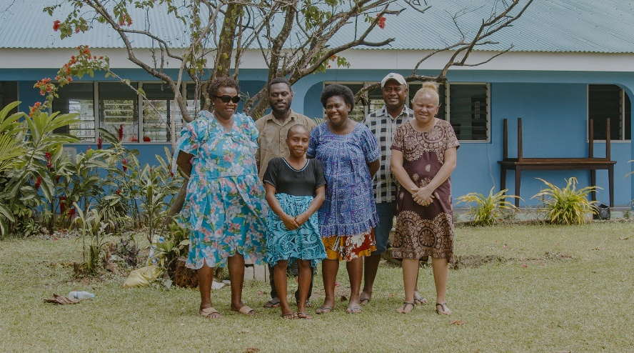

Cover photo: Members of the Vanuatu Disability Promotion &
Advocacy Association (VDPA) stand side by side.
Copyright: CBM Australia
IDPD Event or Activity
We invite you to organise an event or activity within your organisation to mark IDPD and promote awareness around disability. Our hope is that you will all do the IDPD Social Media Actions as part of these activities and events also. Some ideas are as follows – these can be combined and or added to.
IDPD Event or Activity: Organise an in-person or virtual morning tea for your organisation
Resources:
- A speaker with disability (see further guidance on engaging speakers below) – remember your speaker can join virtually!
- Keep your eyes out for the IDPD Resource Kit, featuring case studies, suggested social media, key facts and CBM’s 2021 IDPD video featuring people with disabilities talking about the world they want! This will be emailed to all ADDC members in late November 2021 and will feature on the ADDC website.
- End the Cycle videos.
Who to involve:
- Encourage all staff to share the IDPD video organisational short story at the morning tea.
- See below for guides on hosting an inclusion online event or meeting. Make sure you invite leadership to join, and if possible have someone from leadership speak (such as doing the introductions).
- Invite all staff, or your team members as appropriate.
- In addition to the below, when you begin planning, ask any staff who identify as having disabilities if/how they would like to be involved and what they would like to do to mark the day.
IDPD Event or Activity: Raise awareness amongst your team or organisation by sharing resources via:
- email
- intranet article
- a team meeting
Resources:
- Draw upon the IDPD Resource Kit, available late November on the ADDC website.
- Do one or both of the IDPD Social Media Actions as a group (see above).
Who to involve:

- Leadership – ask them to be involved. For example, they could send out an all staff email. You can offer to help write this for them.
- Your team or all staff members, as appropriate
IDPD Event or Activity:
Ask your organisation to share a post regarding disability and IDPD on your website, communications and social media
Use your organisation’s voice to raise awareness about disability and poverty issues this IDPD!
Resources:
- If your organisation has any projects focusing on people with disabilities, or case studies of how people with disabilities have accessed their work, IDPD is a great opportunity to show case them
- If you don’t have access to a social story like this, your organisation can still share some key facts about disability and poverty through social media. The IDPD Resource Kit will provide plenty of material to choose from.
- Share photos of your team doing the IDPD Social Media Actions through your organisation’s digital channels.
Who to involve:
- Ask the Digital Communications team on board to share the content.
- International Programs or Policy teams may have a case study to share.
- Ask your CEO or leadership to engage in the Social Media Call to Action (and sharing this through relevant digital channels!).
IDPD Event or Activity: Launch a new disability inclusion initiative within your organisation
Resources:
- IDPD is a great opportunity to launch any disability initiative that your organisation may have been considering for some time. For example, a Disability Action Plan or a Disability Working Group.
- It could aim to have a final product ready to be shared on IDPD, or if you are at the start of your journey, you can use IDPD to launch this initiative or call for any interested staff to get involved.
- A public or shared announcement of intention on something like this can be a powerful means of accountability.
Who to involve:
- Leadership endorsement.
- Any other disability ‘champions’ or people interesting in promoting disability rights in your organisation.
IDPD Event or Activity: Play a virtual disability inclusion game or activity with your team
Resources:
- Get your team together or a small group of people from your organisation. See here for several suggested games or activities to be done virtually in 20 to 40 minutes.
- Follow the activity with a conversation about disability rights and what people learnt.
- Encourage people to have a hot drink or lunch to eat while playing in a relaxed learning environment.
- See below for guides on hosting an inclusion online event or meeting.

Who to involve:
- Invite your team to undertake an activity together.
- Alternatively, target several people who you work with across your organisation to raise the need for increased disability inclusive practises.
- If there are people with disabilities working or volunteering with your organisation, recommend reaching out to them to see whether they would like to help facilitate the session or discussion, or participate in anyway.

Tips for IDPD events and activities
Organising an event or activity to mark IDPD is a great first step and there are a few things to be aware of to make sure this is effective and sensitive.
Include the voice of people with disabilities: Firstly, the core value of the disability movement is ‘nothing about us without us’. This means it is imperative that any events or activities are amplifying the voices of people with disabilities.
- A powerful way of doing this is by inviting a speaker with disability to talk – there are some guidelines on this below.
- If you are aware of any people within your organisation who openly identify as living with a disability, talk to them about the possibility of your organisation doing something for IDPD, and ask whether they want to be involved and/or if they have any particular ideas or messages they want to share. Remember, this is their day.
- Share a video or case study of a person with disability sharing their story in their own words. There is a huge range of End the Cycle videos from a broad range of low and middle income countries that do just this. Or reach out to a person with disabilities involved in one of your organisation’s programs to share their story virtually.
Get leadership involved: Many years of experience has told us that a key factor of increasing organisation’s commitment to disability inclusion is having leadership come to recognise its importance. IDPD provides a key opportunity to help raise awareness amongst your organisation’s leadership, as part of a journey to getting them understanding and investing in improved disability inclusion practices.
- Identify key leaders within your organisation to target: whether they be those holding particularly influential positions, or perhaps those with a particular interest in disability or inclusion.
- Invite them to have some role in the event or activity: perhaps saying the welcome, introducing a speaker, being the one to send out a staff email or intranet article that you can help author, or even by getting them to do the IDPD Social Media Action and sharing this via your organisation’s digital media channels!
- Now is a good time to help leadership showcase any work they or the organisation are doing in disability inclusion: whether that be a strong international program, a Disability Action Plan, or improved reporting/data disaggregation.

Make your event accessible
Ensure your event is accessible to all, both in person and virtually.

It is important to live out the principle of inclusion with any invite to mark IDPD. Resources on how to make your event inclusive are readily available on the ADDC website; including an in-person event accessibility checklist and a virtual event accessibility guide or an accessibility checklist.
Your communications team publicising the event or activity can directly ask people to let you know if they have any accessibility requirements, which should always be provided free of cost to them in accordance with their rights.

Engaging a speaker with disabilities

Like everyone, people with disabilities have a lot of competing priorities for their time and what they can give themselves to. While your IDPD event will definitely be enriched by a speaker with disabilities, it is important to recognise that doing so requires time and effort on their part, and arranging for them to speak should be approached thoughtfully.
- Be clear about what will be involved in speaking: length of time, format (e.g. presentation or interview), purpose or focus of the event. This will help the invited speaker to gauge whether it’s an activity they can commit to. Make sure that your event actually allocates enough time for them to speak, including allowing some extra time if they are using interpreters, and that they are invited to stay for the whole event (such as a morning tea). Remember you might need to engage an interpreter or captioner for your virtual event too.
- Consider inviting a representative of an Organisation of People with Disabilities that your organisation partners with to the event. Remember whether you are meeting in-person or virtually a speaker can present online from anywhere in the world (time zones permitting), so think broadly and consider inviting a speaker from a partner organisation in one of the countries your organisation works in. However, make sure to consider all the other tips listed here in that context too as they are all relevant.
- Ask what the speaker’s speaking fee is and do not expect them to participate for free. Like all of us, their time is valuable! If the event is in-person, the fee should cover their travel costs and any reasonable accommodation requirements such as sign language interpreters or captioning if required. If the speaker’s fee is out of your range, politely explain this and that you won’t be able to engage them this time - do not ask or expect them to reduce their fee for you.
- Before approaching the speaker, get clear on what you want them to talk about. It might help to think up a specific title for your event, such as “Why inclusion matters in your organisation’s work?”, “A look at disability-inclusive WASH programming in Indonesia”, or “What does a disability inclusive organisation look like?” Providing this clarity is important for a few reasons:
  - Approaching speakers without a clear purpose or topic in mind can often create the impression that their involvement is tokenistic, rather than because you specifically want to learn from them on a particular issue.
  - A clear topic allows you to make sure that they have appropriate expertise or knowledge on this area. If you are unsure of their expertise, you can discuss this by proposing the general theme of your activity and asking if/ what they feel they could best speak to within this.
  - You can also ask them if there are any particular messages or themes that they would like to raise within this theme. Ideally their speaking will be a mutually beneficial activity for both your organisation and the speaker.
- When you confirm the booking with the speaker, ask how they would like to be introduced. Include this wording clearly in the event notes / speaking notes for whoever will introduce them.
- Remember people with disabilities have diverse backgrounds and identities! Not all their areas of expertise are the same, and it is important to engage speakers from broad range of backgrounds including gender, age, type of disability, location, and Indigenous and LGBTI people.
- Remember that in order for your IDPD event and involvement of a speaker with disabilities to not feel tokenistic, this activity needs to be made alongside work to improve disability inclusive policies and practices within your organisation, both before and after the event.

Finding a speaker
If your organisation is at the start of their disability inclusion journey, it can take a little time to find a speaker with a disability. You could consider reaching out to:
- People within your organisation who identify as having a disability – ideally they should have already been invited to be involved with the activity planning when you first started. If any have indicated they do want to be involved, you can ask if they want to speak themselves, or if not, if they can help introduce you to appropriate speakers.
- A local organisation that provides information about disability – such as a local Organisations of People with Disabilities or representative group – and ask to book a presenter with a disability. Be aware they are well placed to speak about disability in general, rather than necessarily in a development context.
- There are various people with disabilities on social media who are also available to be booked to speak.
- If your organisation partners with any disability groups overseas, it may be an option for them to speak online too. Be mindful of cross-cultural communication and power dynamics that may exist if your organisation funds them, and any need for local spoken and/or sign language interpreters.
Contact us
We would love to hear from you and your plans to mark IDPD! Email Kerryn Clarke, ADDC Executive Officer, on kclarke@addc.org.au sharing your plans.
If you have any questions arising from this toolkit, also contact Kerryn (who works Monday, Tuesday and Thursdays).
We look forward to marking IDPD with you and advancing conversations about disability inclusion and rights!

Who is the Australian Disability and Development Consortium?

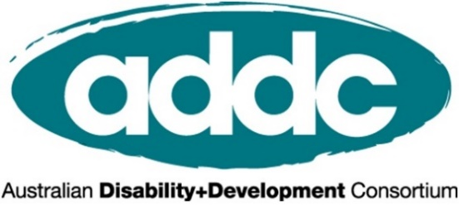
ADDC is an Australian, international network focusing attention, expertise and action on disability issues in developing countries; building on a human rights platform for disability advocacy. We focus on providing networking and learning opportunities, sharing resources and lobbying activities, to improve and promote the practice of disability inclusive development throughout Australia’s international development sector.
To join ADDC (membership is free) or find out more, please visit www.addc.org.au

ADDC is grateful for CBM Australia’s support on this toolkit

Who is CBM Australia?
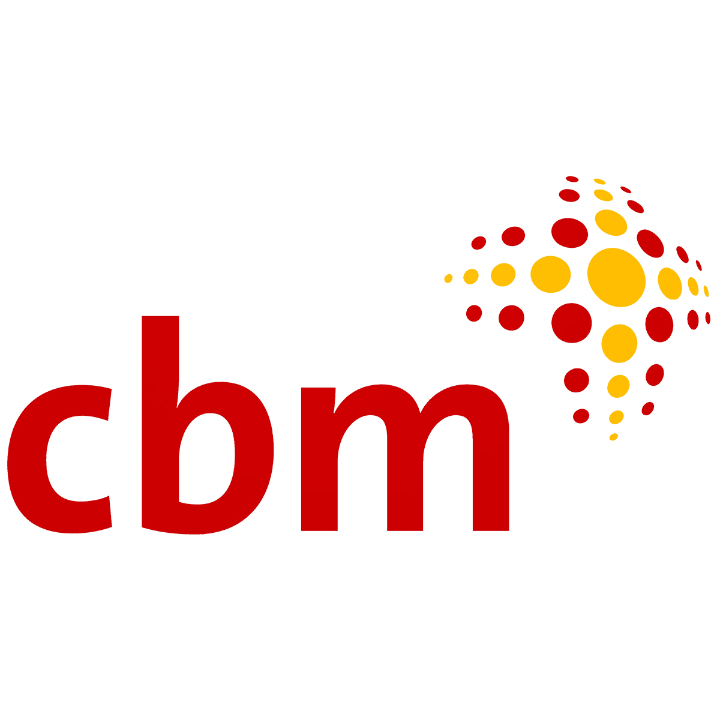CBM Australia is an international Christian development organisation committed to improving the quality of life of people with disabilities in poor communities around the world.
Addressing poverty alleviation through development efforts that include people with disabilities, and prevent disability for those at risk; CBM Australia is helping to end the cycle of poverty and disability.
CBM Australia works in partnership with people with disabilities, non-government organisations, government and international agencies to empower people with disabilities to achieve their human rights and participate fully in society.
CBM is fully accredited with Australia’s Department of Foreign Affairs and Trade, receives Australian NGO Cooperation Program funding, and is a full member of the Australia Council for International Development.

