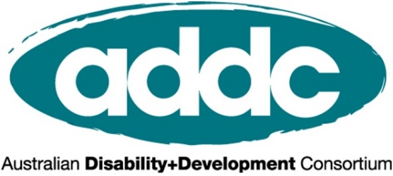

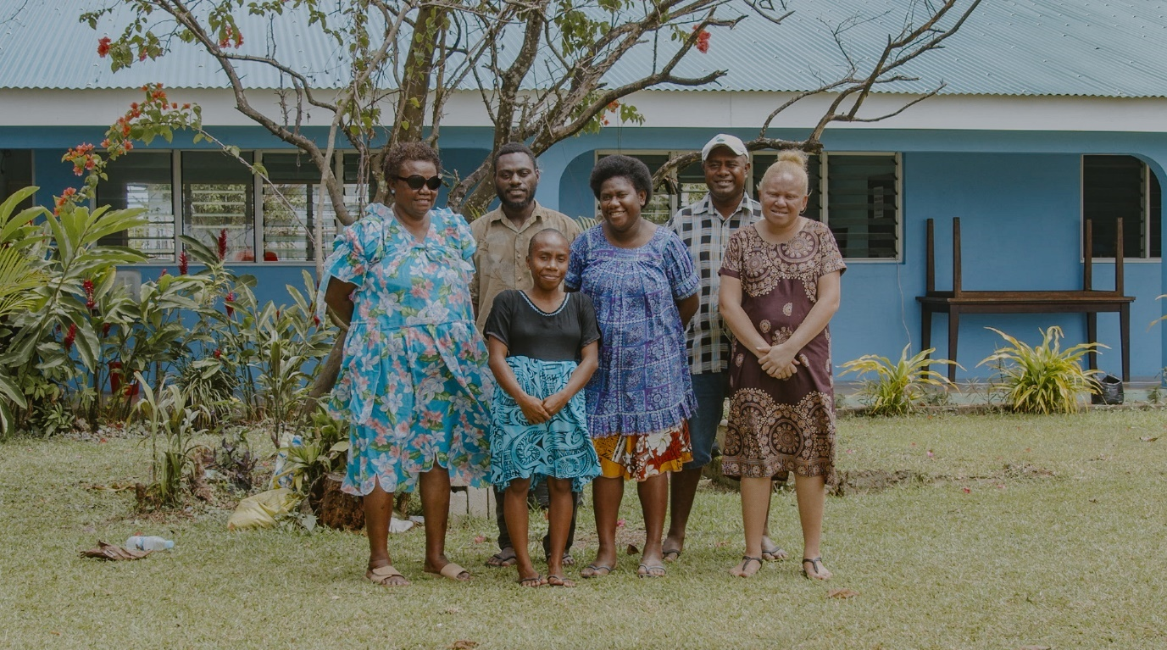

INTERNATIONAL DAY OF PEOPLE WITH DISABILITIES 2021

Build a Better World for All
The Time is Now!

RESOURCE KIT

For the International Development Sector

Welcome to ADDC’s IDPD Resource Kit!

This kit has been designed to help the international development sector in Australia to mark International Day of People with Disabilities across online and social media platforms. People with disabilities have been disproportionately impacted by the COVID-19 pandemic, so it is important than ever to join the call of people with disabilities to build a better world. We have a range of content to guide and inspire your online communications to mark the day. You can pick and choose from these and adapt them to appeal to your specific audiences. We hope it proves useful!
You can also refer to our IDPD Activity Toolkit for ideas on how to mark the day with your organisation and partners. The following communications resources can be incorporated into and complement your event.
Any questions, reach out to Kerryn at kclarke@addc.org.au.

Contents
Welcome to ADDC’s IDPD Resource Kit! 2
What is International Day of People with Disabilities? 2
What can your organisation do to mark IDPD? 3
CBM IDPD Video: Build Back A #BetterWorldForAll 3
End the Cycle videos, case studies and fact sheets 3
Official Call to Action: 3
Suggested Social Media Posts 4
Assets for your organisation to use across communication channels 6
Disabilities and Global Development – facts and statistics 6
Case Studies 8

What is International Day of People with Disabilities?
International Day of People with Disabilities (IDPD) is a sanctioned United Nations’ Day celebrated annually. This important day aims to raise awareness and promote action around the rights of people with disability and their full inclusion in society. This year it is on Friday 3rd December.
IDPD poses a unique opportunity to work with your organisation to celebrate disability and raise awareness of disability inclusion issues. ADDC is keen to support disability inclusion champions within INGOs to use IDPD as an opportunity to celebrate disability and diversity, share the voices of people with disabilities, and raise awareness of the need for focussed efforts and resourcing on disability inclusive development.

What can your organisation do to mark IDPD?
ADDC is encouraging our members and disability champions within INGOs to celebrate IDPD and to use this as an opportunity to raise awareness about disability inclusion within your organisation, by joining in our Social Media IDPD Actions, and organising an IDPD Event or Activity within your workplace. Online communication tools for the day are below. For ideas on an event or activity your organisation can host, see our IDPD Activity Toolkit here.

CBM IDPD Video: Build Back A #BetterWorldForAll
CBM’s 2021 IDPD video shares the voices of people with disabilities and the challenges they’ve faced during the COVID-19 pandemic. It also explores their hopes and ideas for a more inclusive world post-COVID and how recovery efforts can include them.

This IDPD join the call of people with disabilities to build back a #BetterWorldForAll. Together, we are demanding that governments address the injustice experienced by people with disabilities and are pursuing an inclusive recovery that ensures their health, safety and livelihoods.

The time is now to build back a #BetterWorldForAll. The video can be accessed here. There will also be an audio described version which can be accessed here. The video is under embargo until 9am AEST December 3. Please do not share or post on social media accounts until December 3.

End the Cycle videos, case studies and fact sheets
End the Cycle promotes tools and resources to help international development practitioners raise awareness of and practice disability-inclusive development. The resources feature people with disabilities in low- and middle-income countries telling their own stories in their own words. They personally approve the stories and photographs that represent them, meaning these resources can help bring the lived experience of people with disabilities into your activities. End the Cycle is an initiative of CBM Australia, and the resources can be browsed here.

Official Call to Action:
- Show your support and share the voices of people with disabilities in the 2021 IDPD video produced by CBM Australia that features people with disabilities from across our region talking about what building a better world for all during and after the COVID-19 pandemic means to them.
- Add to the conversation and share in the week of IDPD how your organisation is working alongside people with disabilities to build a more inclusive world during and after the COVID-19 pandemic. For example, featuring a new disability inclusion initiative within your organisation from this year or an example of how your organisation is including people with disabilities in a development project. Include the caption International Day of People with Disabilities: Build a #BetterWorldForAll #IDPD.

Suggested Social Media Posts
Please choose and adapt the content that best suits your needs. There are also some further facts and statistics and case studies below.

Official hashtags: #BetterWorldForAll #IDPD
Share content: from Monday, 29 November to Friday, 3 December.

Video:
Build Back a #BetterWorldForAll Video (The video is also available in audio description)

- “We know that we (people with disabilities) are the most at-risk in any disaster. We need to make sure that communication is inclusive, and information reaches everybody.” Nelly is from Vanuatu and one of 11 people with disabilities featured in CBM Australia’s #IDPD video advocating to build a more inclusive #BetterWorldForAll following the COVID-19 pandemic.
- COVID-19 has had a catastrophic impact on people with disabilities. They have experienced less access to vaccines and critical health information, been cut off from their vital aides and supports, suffered greater job losses and more food insecurity than people without disabilities. But don’t take our word for it, listen to the 11 people with disabilities who share their experiences of the pandemic in CBM Australia’s brand new video. Join their call to build a world where people with disabilities are fully included:
✔️ in all response and recovery efforts
✔️ in all decision making
- Our friends [or partners if in partnership with CBM] at CBM Australia have created a short video in which people with disabilities from across our region share the challenges they’ve faced during the COVID-19 pandemic. Their message is clear - it’s time to build back a world where people with disabilities are fully included:
✔️ in all response and recovery efforts
✔️ in all decision making
- Over the past two years, the global COVID-19 pandemic has devastated the lives of people with disabilities around the world. Hear firsthand their experiences from across our region in CBM Australia’s compelling new International Day video. Their message is clear - it’s time to build a world where people with disabilities are fully included, in all response and recovery efforts and decision making. It’s time to build back a #BetterWorldForAll.
- “A better world for all would meet the diverse needs of persons with disabilities in all development efforts.” Ross is from Papua New Guinea and one of 11 people with disabilities featured in CBM Australia’s #IDPD video advocating to build a more inclusive #BetterWorldForAll following the COVID-19 pandemic.
LinkedIn:

- Today is International Day of People with Disabilities. The global COVID-19 pandemic has had catastrophic impacts on the lives and well-being of the world’s one billion people with disabilities, who have faced:
    - higher rates of death from COVID-19
    - higher rates of unemployment,
    - increased food insecurity
    - increased barriers to protect themselves from the virus disproportionately more than people without disabilities
As we to look to the future there is an opportunity to build a #BetterWorldForAll, and address inequalities and injustices inherent in our current systems. We all have a role to play in building a society that listens and acts on the ideas, priorities and perspectives of people with disabilities.

This International Day of People with Disabilities join us as we campaign for a world where all people are included in response and recovery efforts #BetterWorldForAll #IDPD

General suggestions - Facebook:

- Join [Insert Organisation Name] as we mark International Day of People with Disabilities at our [Insert Event] #IDPD #BetterWorldForAll
- International Day of People with Disabilities is an important day to raise awareness of the many barriers people with disabilities face around the world. At [Insert Org] we are working to build a more inclusive world by [insert program or activity] #BetterWorldForAll #IDPD
- During the COVID-19 pandemic, people with disabilities have been left out of response and recovery measures and struggled to access critical health information. [insert Organisation Name]and their partners in [insert country] have been working with organisations of people with disabilities to ensure response and recovery efforts include and are informed by people with disabilities. Initiatives such as this pave the way for a more inclusive world #BetterWorldForAll #IDPD
- To build a better world following the COVID-19 pandemic it is [insert org]’s priority to ensure all people with disabilities in [countries/region] have access to vaccines, public health services and economic recovery. They are working to achieve this through partnering with local organisations of people with disabilities (OPDs) and [donor if relevant] #BetterWorldForAll #IDPD

General suggestions - Twitter:

- “A better world for all would meet the diverse needs of persons with #disabilities in all development efforts.” Ross from PNG, is featured in CBM Australia’s #IDPD video advocating to build a more inclusive #BetterWorldForAll during & following the COVID-19 pandemic.
- Take a look at the video @CBMAustralia created to mark International Day of People with Disabilities which shares the voices of people with disabilities calling to build a #BetterWorldForAll #IDPD
- We want to live in a world where every person is included in response and recovery efforts following crises such as COVID-19. In this world everyone is able to participate and enjoy their human rights. #BetterWorldForAll #IDPD

General suggestions - Infographic:

- Right across the world millions of people with disabilities do not have access to their human rights, essential services and still face daily exclusion in their communities. COVID-19 has made things worse. This International Day of People with Disabilities, we’re echoing the voices of people with disabilities calling to build a #BetterWorldForAll following the COVID-19 pandemic #IDPD
- Global and national surveys conducted during the COVID-19 pandemic have highlighted that people with disabilities have been disproportionally affected by COVID-19 and are more likely to die from the virus, making up more than 50% of all deaths. On International Day of People with Disabilities, echo the voices of people with disabilities calling on governments to build a #BetterWorldForAll following the COVID-19 pandemic. The time is now! #IDPD
- Accessing critical public health information about COVID-19; and regular health care and medicines, has been a great challenge for people with disabilities during the COVID-19 pandemic. We want to live in a world where every person can access life-saving information and medical treatment during crises such as COVID-19. This International Day of People with Disabilities, join the call to build a #BetterWorldForAll. The time is now! #IDPD

Assets for your organisation to use across communication channels

SOCIAL MEDIA TILES Click here

BANNERS Click here

ADAPTABLE MEDIA RELEASE Click here
BUILD BACK A #BETTERWORLDFORALL VIDEO Click here [The video is under embargo until 9am AEST December 3]

Disabilities and Global Development – facts and statistics
The following may be of use as you prepare communications to share.

General statistics and facts:
- Globally, 15 per cent / one in seven people / one billion people in the world have a disability.
- 22 per cent of the world’s poorest people have a disability.
- Disability and poverty are often linked as people living in poverty have a higher chance of acquiring a disability due to lack of medical care, poor nutrition, violence, unsafe housing, and getting injured at work.
- People with disabilities are more likely to live in poverty. People with disabilities report multiple barriers to accessing health services.
- People with disabilities are also less likely to attend school, are more likely to be unemployed and generally earn less when employed.

COVID and disability
The COVID-19 pandemic is deepening pre-existing inequalities. Nowhere is this more evident than for people with disabilities.

For people with disabilities the COVID-19 pandemic has;
- Increased barriers they already face on multiple fronts.
- Resulted in poorer health outcomes, less access to education, reduced services and support, and increased violence and abuse compared to people without disabilities.
- As seen with large and complex emergencies, their needs have been overlooked and they have not been able to access vital health, economic and social support in response efforts.
- Resulted in Organisations of People with Disabilities (OPDs) having to address urgent service shortfalls, stepping into the role government and humanitarian systems should be playing.

The World Health Organisation has identified people with disabilities as one of the most vulnerable populations in public health emergencies and disproportionately affected by the health, social and economic impacts of COVID-19.
- People with disabilities are at much greater risk of dying from COVID-19 than people without disabilities.
- Women with disabilities and other under-represented groups of people with disabilities are experiencing greater social and economic exclusion during the pandemic.
- Globally, violence against women with disabilities has increased during the pandemic.
- More than 85% of people with disabilities surveyed in Vietnam, Indonesia and the Philippines affected by COVID-19 lockdowns were yet to receive financial assistance.
- In Indonesia, people with disabilities have reported considerable barriers to accessing information, particularly for people who were blind and vision impaired, while deaf and hearing impaired people noted challenges in communication due to difficulties lip reading while others were wearing masks.
- A global survey of women and non-binary people with disabilities found that one in three respondents had lost access to needed disability-related support services, including personal assistance, wheelchair replacement and repair, and accessibility services such as Sign Language interpreters.
- Reports from sexual and reproductive health service providers around the world indicate that client numbers are declining during the pandemic due to inaccessibility, reduced community engagement, or fears of infection..
- In Vietnam, 30% of survey respondents with disabilities reported losing their jobs in the 1st month of COVID-19 restrictions, and of those still working, 59% reported cuts to their pay. This resulted in people with disabilities reporting a 28% reduction in income in the first month of lockdowns, leading many households to fall into poverty for the 1st time.
- In Indonesia, 67% of men and 71% of women with disabilities reported that they were no longer working compared to 55% of men and women without disabilities. 80% of those who lost income due to the COVID-19 lockdown faced difficulties covering their basic needs and 43% were unable to pay their monthly utility bills.

For more information see the two following briefs:
- Leave No One Behind – Disability inclusion in Australia’s COVID-19 response, available here. Link will be live on November 26. This report is under embargo until 9am AEST December 3
- Evidence summary: Experiences of people with disabilities during COVID-19 in Asia and the Pacific, available here.

Case Studies
from across the sector featuring people with disabilities and disability-inclusive initiatives

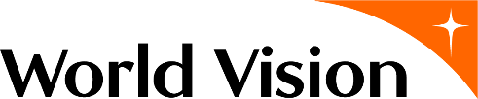
WorldVision Case Study
In 2020 Vanuatu faced one of its most challenging humanitarian crises to date: a global pandemic.

While Vanuatu recorded very few cases of COVID-19 early in the pandemic, people with disabilities were greatly impacted, due to barriers accessing prevention measures, such as water for handwashing, and limited information on how to protect themselves from the virus. People with disabilities also experienced significant job and income losses due to lockdowns.

Despite the high vulnerability to COVID-19 and other humanitarian emergencies, people with disabilities rarely participate in the development of action or response plans, especially those in rural areas. World Vision Vanuatu recognised that to reach the most vulnerable during disasters, people with disabilities must be included in all preparedness initiatives and response. As such they have been working with local organisations of people with disabilities (OPDs) to do just that.

World Vision together with the Vanuatu Disability Promotion and Advocacy Association (VDPA), the Vanuatu Society for People with Disability and other AHP Disaster READY partners rolled out life-saving information and awareness raising of the impacts of COVID-19 to ensure the health and safety of communities in Sanma Province. As a team they connected directly with communities, providing COVID-19 information and additional handwashing facilities; handwashing being one of the most effective ways to prevent the spread of the virus.

Further, World Vision Vanuatu with support of the Australian Government’s Water for Women Fund facilitated a two-day Inclusive COVID-19 Action Plan forum bringing together people with disabilities, organisations of people with disabilities and key civil society actors to ensure that the needs of people with disabilities are addressed and considered in national and provincial plans.

As a male participant with disability explained, “My opinion nor presence has never been asked of in such high-profile forums such as this. Usually, they always happen in the capital city. Thank you so much for allowing us to come from our rural communities and contribute on how people such as myself can be guided on maintaining safety measures against COVID-19."

The forum was designed to provide an opportunity for participants to not only contribute to strategies to protect themselves against COVID-19, but to also ask questions about what community transmission would mean for them if it were to occur in Vanuatu.

Relvie Poilapa, World Vision Vanuatu’s Inclusive WASH Portfolio Manager explained, “the forum provided an opportunity for people with disabilities to think about how national and provincial plans impact them, what do those plans really mean for me as an individual? How do I prepare if we go into lockdown?”

The forum also provided an opportunity to discuss awareness raising activities delivered at a national and community level. The discussions explored the limitations of communication mediums used to disseminate COVID-19 awareness, especially for people with different impairments.

Ms Poilapa said “The forum was so important to raise visibility of the need for and to deliver accessible information. A lack of accessible information for people with disabilities compounds their vulnerability to COVID-19. Many people with disabilities who attended the forum weren’t aware that Vanuatu has different alert levels which correspond to different levels of risk and restrictions.”

Participants at the forum discussed how the frequent use of radio, television and videos to disseminate key information was ineffective and failed to reach people with hearing impairments. Further, most communications did not include captioning or sign language.

For World Vision, building a better world for all means partnering with local OPDs to ensure people with disabilities are prioritised during national emergencies and that all health and emergency information is accessible for diverse impairments.
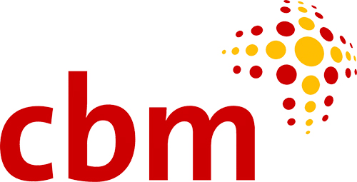

CBM Australia Case Study
Partner Organisation: Pacific Disability Forum

After their huge success in remaining almost COVID-19 free throughout 2020, several Pacific Island nations and neighbouring Timor-Leste faced a sharp increase in cases in 2021.

In the Pacific and Timor-Leste, limited COVID-19 testing, slow vaccine rollouts and poor healthcare systems has compounded things for vulnerable populations and people with disabilities. Which is why CBM has been working alongside the disability movement throughout the pandemic to support the Government to prioritise people with disabilities in all COVID-19 response and recovery.

Earlier this year Papua New Guinea saw COVID-19 surge in the community. Within weeks, cases climbed into the thousands. People with disabilities reported a lack of accessible health information, extreme economic hardship, and a lack of government support. We spoke to Adrian, a disability advocate with a physical disability living in Port Moresby, who told us “a lot of persons with disability are really missing out on a lot of those opportunities to even access what the government is providing.” He was also concerned about access for people with different types of disability: “Accessible for me is not just about physical infrastructure. It is about how do we communicate with the people who are vision impaired, how do we make information available for the hearing impaired?”

In May, after a year of almost no community transmission in Fiji, the extremely infectious Delta strain of COVID-19 arrived in the country. This saw a rapid increase in community cases and most of the Fiji population thrown into lockdown, lasting for months. CBM’s Fiji-based partner Pacific Disability Forum (PDF) is a regional umbrella organisation that supports up to 71 organisations of people with disabilities across 22 Pacific Island countries and territories. PDF has been working to roll out inclusive health messaging and advice as well as mobilise response teams to support Organisations of People with Disabilities in seven regions of concern. CBM has provided support to PDF during this time. As we near the end of the year it is promising to see Fiji has vaccinated more than 80% of its population with a strong vaccine campaign and boosted vaccine supply. Lifting vaccination rates among the remaining Pacific nations is critical as this will provide further protection for people with disabilities.

Timor-Leste started to see a rise in cases in February across their border with Indonesia. The virus eventually reached the capital Dili seeing the country impose its first lockdown, which continued for months. Despite the lockdown the number of cases continued to rise into the thousands. The Government of Timor-Leste tried to reduce numbers by removing people from their homes and placing them in a quarantine facility when positive. But the facilities were not always accessible or inclusive. That’s why CBM has been supporting the Australian Government’s Partnership for Human Development to ensure the approach is more inclusive. More recently CBM has been working to ensure free and equal access to vaccines for all people.

Not only does our research indicate people with disabilities are more likely to die from COVID-19, they also face greater loss of income than people without disabilities, inaccessible critical health information and reduced access to services and supports.

To build back a better world following the COVID-19 pandemic it is CBM’s priority to ensure all people with disabilities in the Pacific and Timor-Leste have access to the vaccine, public health services and economic recovery. We are working to achieve this through partnering with local organisations of people with disabilities (OPDs) and the Australian Government.

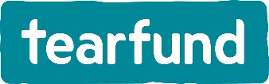
Tearfund Case Study
Partner Organisation: SHIFA Mental Health and Disability Project – India

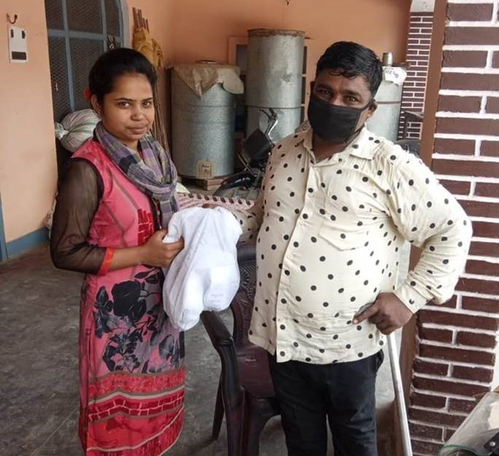
The unprecedented spread of COVID-19 pandemic has led to a stressful situation all over the world, making it an issue of global health concern. The impact of this pandemic, however, is not limited to physical health. Many issues related to mental health are on the rise, and people with existing psychosocial conditions are often left without access to the support they require. In Saharanpur, a district of Uttar Pradesh, India, TEAR’s partner organisation Emmanuel Hospital Association runs the project SHIFA Mental Health and Disability which works to improve the mental health of people with psychosocial disabilities and their families.

"I am a person with a disability and I have felt sad during the pandemic. But the help I’ve received means I can now support my family and I am very happy about that. Someone is standing beside the poor.” – Anita

Many people in this region are reliant on livelihoods in agriculture, horticulture and trade. Severe lockdowns were imposed on the community when the pandemic began and people suddenly found themselves out of work, unable to support themselves and their families. People with psychosocial disabilities struggled to access psychological support and their medications, and some even experienced depressive episodes and suicidal thoughts. The government established a free rations program so communities could access daily necessities, but the local health service weren’t able to provide adequate support for those with mental health issues. People within the community felt fearful and stressed.

During the pandemic SHIFA Mental Health Project partnered with several local organisations, including an OPD (Organisation of People with Disabilities) and faith based groups, to ensure individuals and families got the information and support they needed. One initiative provided vital psychiatric services and medicine to those that needed it - many from the local community came forward for support and care. A brochure was also developed to promote health messaging in the communities on “How to stay mentally healthy during covid-19 lockdown”. The brochure was available in five local language dialects and shared through a number of channels to ensure the information was accessible. Further, hygiene kits including face masks and sanitizer were distributed to a number of families, along with public health messaging about how to protect yourself from COVID-19. This included education on hand washing and how to safely use a mask.

"We are delighted. Our daily life has improved! During lockdown the project has made medicines available to our family and we are incredibly grateful" said Rishipal.

It is programs like these that pave the way for a more inclusive future, where all people are included. We are working towards that future where everyone, especially people with disabilities and psychosocial disabilities, is valued and respected as part of the family and community; a future where everyone will be able to reach their full potential. With small steps, change is possible.

Who is the Australian Disability and Development Consortium?

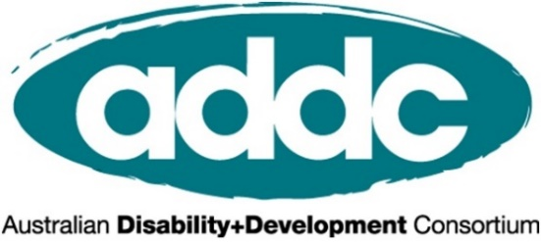
ADDC is an Australian, international network focusing attention, expertise and action on disability issues in developing countries; building on a human rights platform for disability advocacy. We focus on providing networking and learning opportunities, sharing resources and lobbying activities, to improve and promote the practice of disability inclusive development throughout Australia’s international development sector.
To join ADDC (membership is free) or find out more, please visit www.addc.org.au

ADDC is grateful for CBM Australia’s support on this toolkit

Who is CBM Australia?
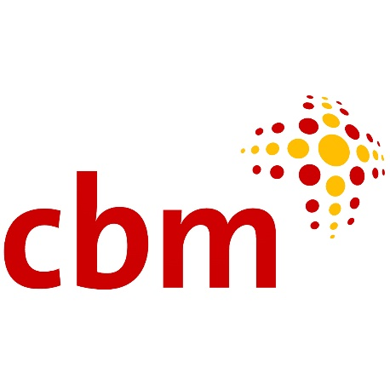
CBM Australia is an international Christian development organisation committed to improving the quality of life of people with disabilities in poor communities around the world.
Addressing poverty alleviation through development efforts that include people with disabilities, and prevent disability for those at risk; CBM Australia is helping to end the cycle of poverty and disability.
CBM Australia works in partnership with people with disabilities, non-government organisations, government and international agencies to empower people with disabilities to achieve their human rights and participate fully in society.
CBM is fully accredited with Australia’s Department of Foreign Affairs and Trade, receives Australian NGO Cooperation Program funding, and is a full member of the Australia Council for International Development.

Office for National Statistics. 2021. Updated estimates of coronavirus (COVID-19) related deaths by disability status
NDF-N, 2020. Impact of COVID-19 Pandemic and Lockdown on Persons with Disabilities
UN. (2020). Policy Brief: Disability-Inclusive Response to COVID-19. Retrieved here: https://www.un.org/en/coronavirus/disability-inclusion
Handicap International. (2015). Disability in Humanitarian Context - Views from affected people and field organisations.
Previously referred to as Disabled Peoples Organisations (DPOs)
Inclusive Futures. (2021). Consequences of Exclusion: A Situation Report on Organisations of People with Disabilities and COVID-19 in Bangladesh, Nigeria, and Zimbabwe.
WHO and UNICEF. (2021). Disability considerations for COVID-19 vaccination: WHO and UNICEF policy brief, 19 April 2021 Retrieved from: https://www.who.int/publications/i/item/who-2019-ncov-vaccination-and-disability-policy-brief-2021.1
UK Office of National Statistics. (2021). Updated estimates of coronavirus (COVID-19) related deaths by disability status, England: 24 January to 20 November 2020. Retrieved from: https://www.ons.gov.uk/peoplepopulationandcommunity/birthsdeathsandmarriages/deaths/articles/coronaviruscovid19relateddeathsbydisabilitystatusenglandandwales/24januaryto20november2020
Inclusive Futures. (2021).
Ibid; Inclusive Futures. (2021).
UNDP Viet Nam. (2020). Rapid Assessment of the Socio-economic impact of COVID-19 on persons with disabilities in Vietnam
Department of Economic and Social Affairs. (2007). 2004 Demographic yearbook- fifty-sixth issue. New York: United Nations. Cited in World Health Organization & World Bank. (2011). World Report on Disability (p. 28). Geneva: World Health Organization.
World Health Survey. (2002-2004). Geneva: World Health Organization. Retrieved from http://who.int/healthinfo/survey/en
Groce, N. (2004). HIV/AIDS & Disability: Capturing Hidden Voices. Global Survey on HIV/AIDS and Disability. Connecticut: The World Bank/Yale University. Retrieved from: http://siteresources.worldbank.org/DISABILITY/Resources/Health-and-Wellness/HIVAIDS.pdf
VanLeit, B., Rithy, P. & Channa, S. (2007). Secondary Prevention of Disabilities in the Cambodian Provinces of Siem Reap and Takeo: Perceptions of and use of the health system to address health conditions associated with disability in children. Report prepared for Handicap International Brussels. Retrieved from http://siteresources.worldbank.org/DISABILITY/Resources/News---Events/BBLs/070517HIrptCambodia.pdf
Burchardt, T. (2005). The education and employment of disabled young people: frustrated ambition. Bristol: Policy Press. Cited in World Health Organization & World Bank. (2011). World Report on Disability (p. 10).
YAKKUM Emergency Unit. Cited in CBM Australia and Nossal Institute for Global Health (2020) Experiences of people with disabilities in COVID-19: A summary of current evidence. URL: https://www.did4all.com.au/Resources/Full%20report_Evidence%20Summary%20Disability%20COVID_%20July20.pdf.
Women Enabled International. p. 13.
Church, K., Gassner, J. and Elliott, M. (2020). ‘Reproductive Health under COVID-19 – Challenges of Responding in a Global Crisis’, Sexual and Reproductive Health Matters 28 (1):1–3. URL: https://doi.org/10.1080/26410397.2020.1773163.
UNDP Viet Nam (2020) Rapid Assessment of the Socio-economic impact of COVID-19 on persons with disabilities in Viet Nam. Ha Noi: UNDP. p. 7.
Rema H, O. B. (2020). Current Results of Online Survey on Economic Impact of COVID-19- results for people with disabilities. Cited in CBM Australia and Nossal Institute for Global Health (2020).
DPO Network in Indonesia. Cited in CBM Australia and Nossal Institute for Global Health (2020).

