**ADDC Strategic Plan for 2023-2026**

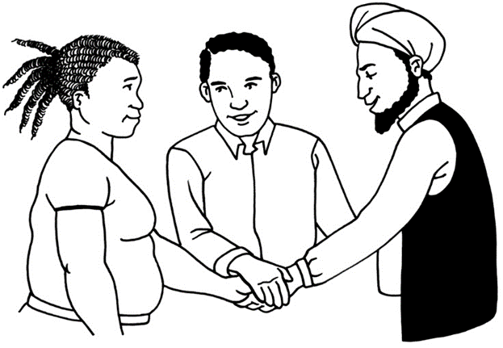

**Easy Read**

**Email:** [info@addc.org.au](mailto:info@addc.org.au)

**Website:** www.addc.org.au

**What is in this document?**

**Page**

Before you start 3

What is this book about? 4

ADDC’s purpose 5

ADDC’s vision 6

ADDC’s mission 7

ADDC’s values 8

ADDC’s strategic outcomes 12

List of hard words 14

**Before you start**

There may be words in this book

* **A stick figure with question marks over their head.** that are new to you
* you may notknow what they mean

**or**

* you may be unsure what they mean.

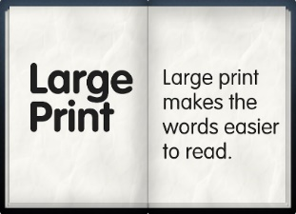 We will make them blue and in large print the first time we use them.

If you want to know what these words mean you can go to the **List of hard words** in this book on page 8.

**What is this book about?**

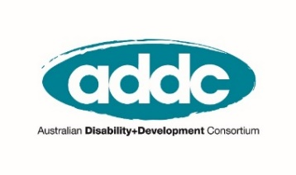

The word **ADDC** stands for the Australian Disability and Development Consortium.

ADDC is a group of people in Australia who have ways of working to make sure people with disabilities in poverty in other countries get their human rights.

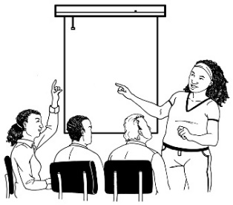

This book is a strategic plan written by the ADDC Executive Committee.

**ADDC’s purpose**

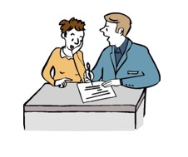 A **purpose** is the reason why someone does their work.



**ADDC’s purpose** is to:

* Bring people in Australia together to work in ways

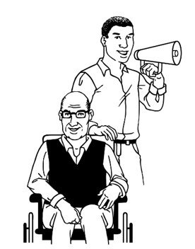

* To speak up for people with disability in poverty in other countries

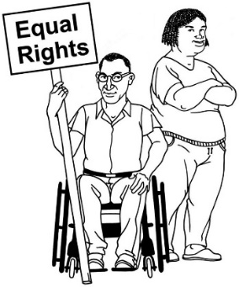

* To get their human rights

**ADDC’s vision**

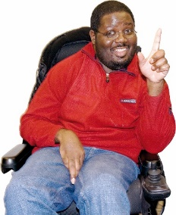

A **vision** is thinking about how something could be in the future.

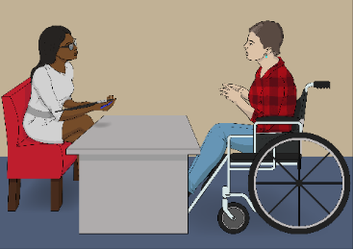 **ADDC’s vision** is that:

* People with disabilities should have a say in all plans made in Australia to make a better world for all.



* People with disabilities should get their human rights.



**ADDC’s mission**

A **mission** is thinking about how people can work together to get work done.

 **ADDC’s mission** is to:

* Bring people together
* To lift up others
* Who work on plans to make a better world for people with disabilities in poverty.

**ADDC’s values**

**Values** are about what someone thinks is important.

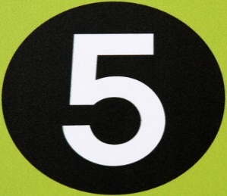

ADDC has **five values**.



The first value is **rights**.

All people have Human Rights.

A scale has people sitting on one side balanced with people with disability and an assistance dog on the other.
 People with disabilities in poverty in other countries do not all have their human rights met.

The Convention on the Rights of Persons with Disabilities is an agreement made by governments to make sure people with disabilities get their human rights.

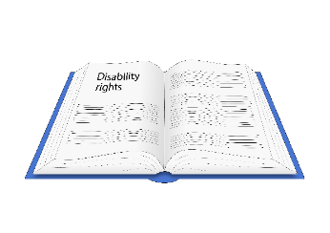

You can get a copy of the [Easy Read version of the Convention here](https://assets.publishing.service.gov.uk/government/uploads/system/uploads/attachment_data/file/345108/easy-read-un-convention.pdf).



ADDC supports the Convention and other agreements that want people with disabilities to get their human rights.

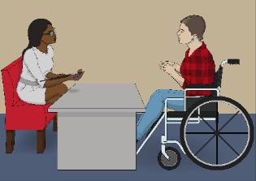 The second value is **participation**.

ADDC thinks that all people including people with disabilities should have a say in things that affect their lives.

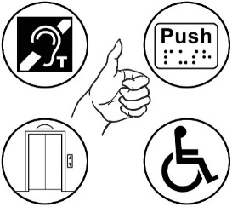 Everyone has something important to give to those around them.

The third value is **accessibility**.

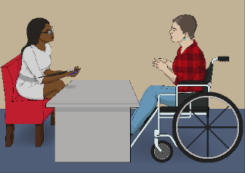 Accessibility is making sure everyone can use all information and places, such as enter all buildings or be involved in a conversation.

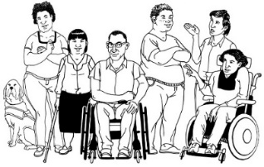 The fourth value is **inclusion**.

ADDC thinks that everyone belongs in the world and should be valued exactly as they are. For example, people with different genders and cultural backgrounds should feel like they belong and are valued as they are.

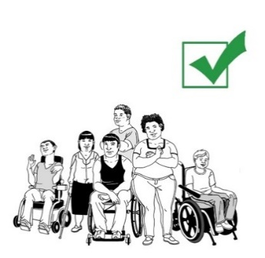

The fifth value is **collaboration**.

ADDC thinks that it can do a better job if it works with a large group of people who share their own ideas.

**ADDC’s strategic outcomes**

 **ADDC’s strategic outcomes** are the main things ADDC will try to achieve in the next three years.

ADDC has **four strategic outcomes**.

The first outcome is **knowledge and skills**.

This means that people who work with those in poverty learn ways to include people with disabilities in their work.

The second outcome is **policy and practice**.

This means that the Australian Government agrees to include people with disabilities in their work in other countries to reduce poverty.



The third outcome is **accountability**.

This means that the work that ADDC does includes people with disabilities and their ideas.



The fourth outcome is **collective voice**.

This means that ADDC tries to increase the number of people we work with in Australia and in other countries.

**List of hard words**

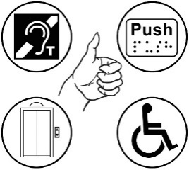 **Accessibility**

Being able to use something, like:

* buildings
* transport.

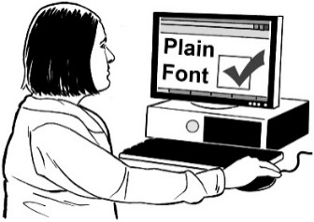 Accessibility also means:

* being able to get the information you need
* getting information in a way you can understand.

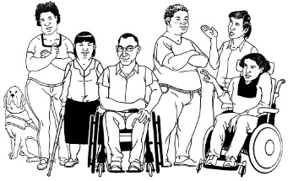

**The Convention**

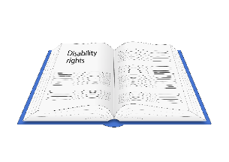The UN has made an agreement called theConvention **on the Rights of Persons with Disabilities**.

In this book we will call it the **Convention**.

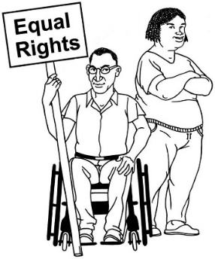 The Convention is about human rights for persons with disabilities.

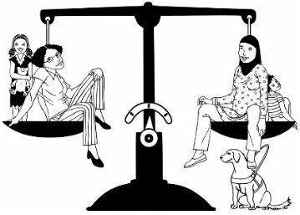

The Convention says persons with disabilities:

* have the same rights as persons who do not have disabilities
* should get their rights.

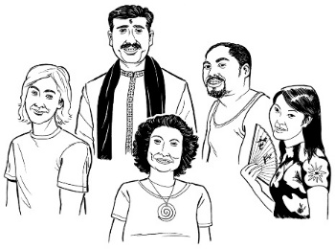 **Cultural background**

Your cultural background can mean:

* where you have come from
* the way you celebrate special days

 **ADDC Executive Committee**

The Executive Committee is a group of people who were put in charge of the work of ADDC by our members.

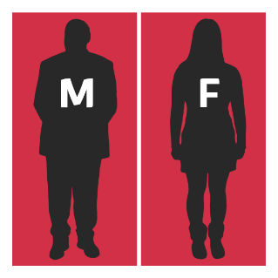 **Gender**

How a person feels about whether they are:

* male
* 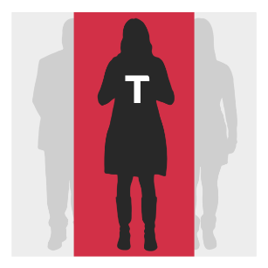female
* a mix of male and female
* not male or female.

 **Government**

A group of people in charge of running a country.

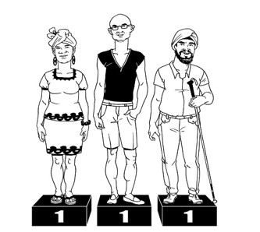 **Human Rights**

All people have Human Rights.

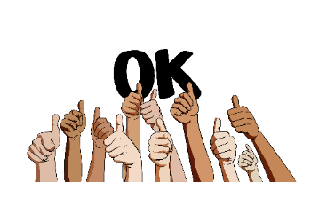 Governments need to make sure that people can get their rights all the time.

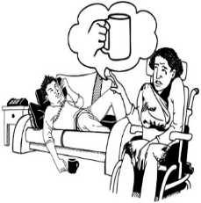 Human rights are things like:

* the right to food and water
* the right to housing
* the right to be safe from abuse

**Poverty**



A person living in poverty cannot access goods and services to meet their basic needs.

Basic needs include:

* Food



* Water
* Shelter
* Education
* 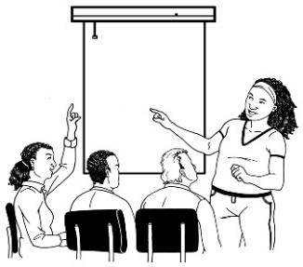Health care

**Strategic plan**

In this book, this means when ADDC is thinking about:

* what work they need to do
* how they will do the work they need to do