ADDC Bulletin: IDPD 2025 edition
ADDC news
In the news
New resources
Webinar recordings
Your input is needed
Upcoming events
Opportunities

Welcome to our last edition of the Bulletin for this year.
Today we celebrate the International Day of People with Disabilities (IDPD) and acknowledge the vital contributions people with disabilities make to their communities. This year, we mark IDPD with CBM Australia’s “Access Means I Can” campaign, highlighting the barriers to accessibility and inclusion people with disabilities face in their daily lives.
Told through compelling person-centred stories, we hear from people with disabilities in Indonesia and Papua New Guinea about the inequities they experience in accessing information, public transport, education, healthcare and employment. Watch the film below here.
You can help to amplify the voices and priorities of people with disabilities by sharing this video with your own networks.
The ADDC Executive Committee met in person on 29 October, and it was a terrific opportunity to get together for a full day of reviewing 2025 and planning for the coming year as you will read below. In other ADDC news we are excited to announce that ADDC Executive Committee member Tim Harte has been nominated as one of four finalists for the 2026 Victorian Young Australian of the Year.
Wishing you all a very merry festive season for those who celebrate, a lovely break over the New Year and look forward to championing disability equity with you in 2026.
In solidarity,
Kathryn Bloom
ADDC Executive Officer

ADDC NEWS

ADDC Executive Committee meeting
The annual in person ADDC Executive Committee meeting, held in Melbourne in October, was an important opportunity to meet in person, regroup and reflect on the year's activity, and start planning for the year to come.
Our Executive Committee includes representatives from Australian peak disability organisations, Australian INGOs, research institutes and individual experts who are based all over the country. Gathering such a group in one place for an extended period led to stimulating discussion and generation of rich ideas and content for our work plan and advocacy campaigns for the upcoming year. The ADDC Executive Committee looks forward to working together with ADDC members to advance disability equity, inclusion and rights across all facets of decision-making and policy in the international development area. Find out more about the members of ADDC’s Executive Committee here.
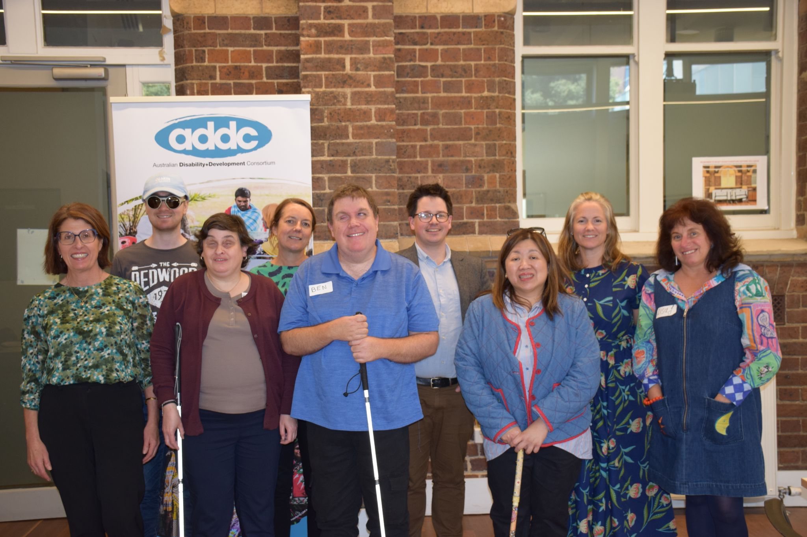

ACFID 2025: Elevating Disability Voices Across the Region
Kathryn Bloom, representing ADDC joined colleagues Jane Edge and Kerryn Clarke from CBM Australia for the ACFID 2025 National Conference, where they had the privilege of spending time with Maulani Rotinsulu, Secretary General of the ASEAN Disability Forum (ADF) and co-founder of the Indonesia Association of Women with Disabilities (HWDI).
Maulani is one of the region’s leading disability rights advocates, and contributed to two events at the conference. She reminded attendees of the critical importance of elevating the voices of people with disabilities and demonstrated the transformative impact that partnerships between the Australian Government, INGOs, and Organisations of People with Disabilities in the ASEAN region can achieve.
Her words called on all of us to keep building a region that is inclusive, resilient, and just—where those most affected by inequality lead the way.
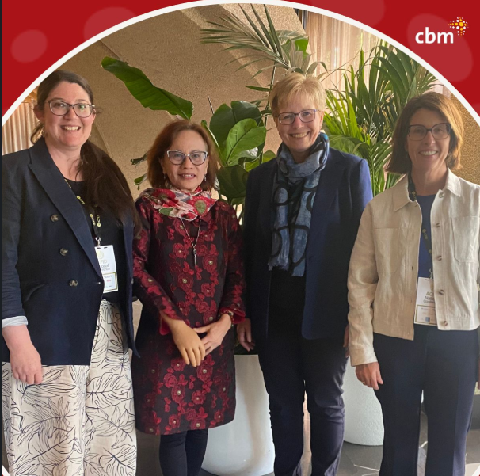

Congratulations to Tim Harte
ADDC Executive Committee member Tim Harte has been nominated as one of four finalists for the 2026 Victorian Young Australian of the Year. His work spans sustainable energy research at Deakin University and CSIRO, and years of dedicated service across disability, youth, and environmental sectors. Through leadership roles in organisations like the Australian federation of Disability Organisations (AFDO), Youth Affairs Council Victoria (YACVic), Physical Disability Australia (PDA), and the Global Network of Young Persons with Disabilities, Tim continues to champion inclusion, sustainability, and community empowerment. Congratulations to Tim on this outstanding achievement and recognition of his leadership and impact!
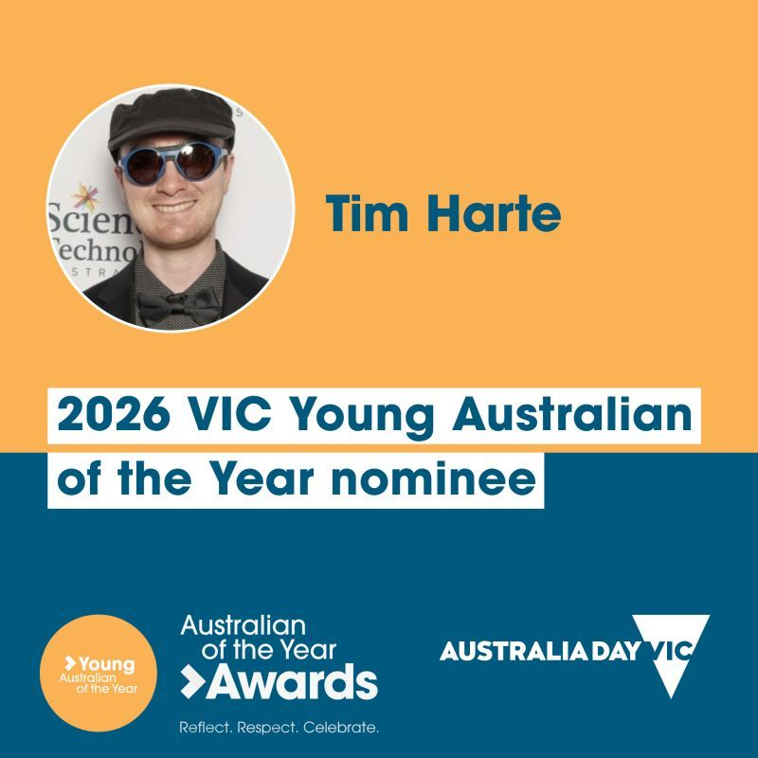

Vale Alice Wong
ADDC joins the disability community in mourning the passing of Alice Wong. An established Asian American disability activist, Alice had a pivotal role in creating twenty-first century disability culture including founding the Disability Visibility Project in 2014 to provide a platform to share the work and stories of hundreds of disability stories and politics online.
Peter Torres Fremlin of the Disability Debrief writes a compelling memorial to Alice in a recent issue. Read it here.

IN THE NEWS

CBM Australia’s IDPD campaign: ‘Access Means I Can’
CBM Australia is marking International Day of People with Disabilities (IDPD) with this year’s theme: “Access Means I Can.” The campaign, running until IDPD on 3 December, highlights the barriers that prevent people with disabilities from fully participating in society—whether in the physical environment, transport, healthcare, or communication.
Through powerful stories and videos, CBM Australia are amplifying the voices of people with disabilities from Papua New Guinea and Kupang, Indonesia, sharing how access transforms lives. From Erik, who regained independence through access to medicine, to Yani, who moves freely thanks to accessible transport, and Rafael, whose surgery opened the door to education and dreams of becoming a pilot—these stories show that accessibility means opportunity.
Watch the film here. Read more about CBM’s campaign here.
Together, let’s create a world where everyone has access and help spread the message that #AccessMeansICan participate, contribute, and thrive.

COP30: Advancing Disability-Inclusive Climate Action
COP30 (Conference of the Parties), the United Nations’ annual climate summit where countries come together to negotiate global climate action, was held this year in Belém, Brazil from 10–21 November 2025. This year’s conference represented a critical turning point—not only for global climate negotiations, but also for the long-overdue integration of the disability movement into climate policy and decision-making.
CBM Global played an active role at COP30, building on four years of engagement in climate spaces. The organisation worked closely with its partners—Organisations of Persons with Disabilities (OPDs)—to strengthen advocacy efforts and amplify the voices of persons with disabilities. CBM Global also contributed to the growing Disability Caucus, which continues to gain recognition as a key stakeholder group in climate negotiations.
Several important initiatives were launched during the summit. On 13 November, CBM Global introduced the Photo Voice Project, which showcased research on the impact of climate change on women with disabilities in Nepal through powerful videos and an exhibition. On 19 November, the organisation presented findings from “One in Five Is Not Enough”, highlighting the slow progress toward disability-inclusive climate action. In addition, CBM Global hosted an exhibition booth featuring examples of disability-inclusive climate initiatives from OPDs and civil society organisations.
Throughout COP30, CBM Global advocated for stronger commitments to disability inclusion and pushed for formal recognition of the Disability Caucus. They supported the calls to action on the Disability Caucus policy briefing note, found here. The team also awaited the announcement of COP31’s host country, with hopes that Australia would be selected.

Inclusive Climate Action in the Pacific: Global Disability Fund Partnership Launched at COP30
On 19 November at the Australian Pavilion, the Global Disability Fund and the International Disability Alliance (IDA) hosted a COP30 side event spotlighting inclusive climate action in the Pacific.
The session marked the launch of the Global Disability Fund – Australian Department of Foreign Affairs and Trade partnership, a multi-year collaboration supported by #Australia to embed disability inclusion across:
- Adaptation planning
- Resilient infrastructure
- Climate-smart systems
A Global Call for Innovative Solutions was also announced, connecting OPD-led ideas with financing and technical support.
As one of the regions most affected by climate change, the Pacific demonstrated how OPD leadership strengthens accountability, drives innovation, and delivers effective climate responses.

QualityRights: Enabling human rights-based services and supports in the Asia-Pacific
QualityRights hosted an in-person training event, part of a CBM Australia funded initiative to build human rights-based mental health services across the Asia-Pacific. This event brought together participants from government ministries, human rights commissions, Organisations of People with Disabilities (OPDs), universities, and NGOs from Indonesia, the Philippines, Fiji, and beyond, including Red Cross Red Crescent MHPSS Hubs. Over three days, attendees built skills, confidence, and connections, all while learning how to implement the CRPD for people with psychosocial disabilities.
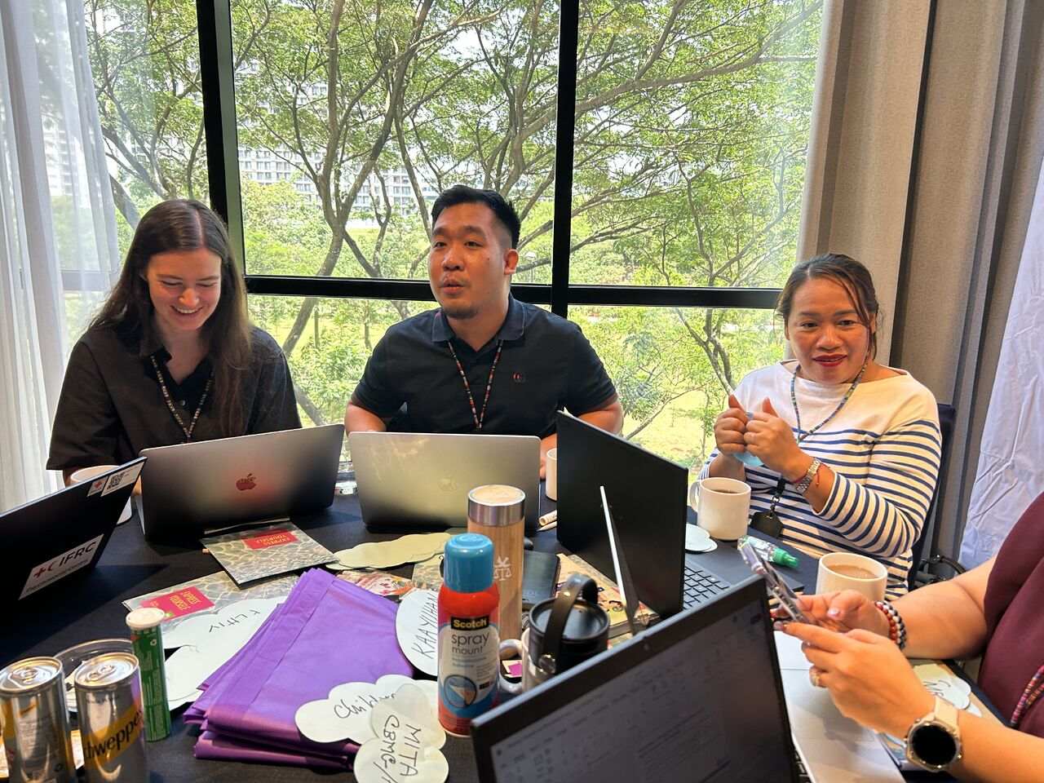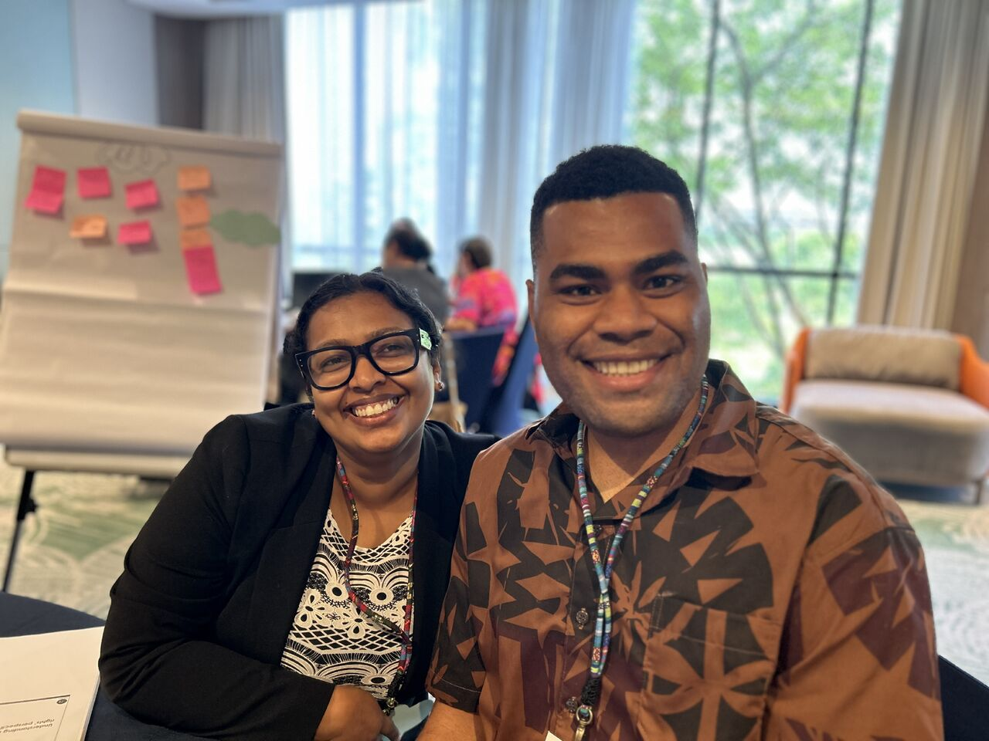
For more, visit this LinkedIn post.

Spotlight on Inclusive Finance and Health at Financial Inclusion Week
Financial Inclusion Week 2025, held in early October, brought together over 350 global experts for four days of discussion under the theme “Building Resilience & Well-being During Rising Uncertainties.” Opportunity International Australia contributed through two sessions exploring gender lens investing and amplifying women’s voices in redefining health, highlighting the critical role inclusive finance plays in empowering marginalised communities.
In the first session, Fifi Rashando, GEDSI (Gender Equality, Disability and Social Inclusion) & Safeguarding Manager (Inclusive Finance & Innovation) at Opportunity International Australia and ADDC Executive Committee member joined a virtual panel exploring how gender lens investing can support financial inclusion for women and people with disability in Indonesia. Watch this session here.
Additionally, the Opportunity International Network convened a Spotlight webinar showcasing practical strategies for embedding disability inclusion into financial services. The session drew on lessons from their work in Uganda and Indonesia, offering valuable insights into how inclusive finance can be implemented effectively across diverse contexts. View this session here.

Read the full blog here.

PDF regional workshop on Social Protection
The Pacific Disability Forum partnered with Partnerships for Social Protection (P4SP) and the Australian Government Department of Foreign Affairs and Trade to host a two-day workshop bringing together Organisations of People with Disabilities (OPDs) from across the Pacific. Insights from this event will shape a new guidance note to help governments design and deliver more effective, disability-inclusive social benefits.
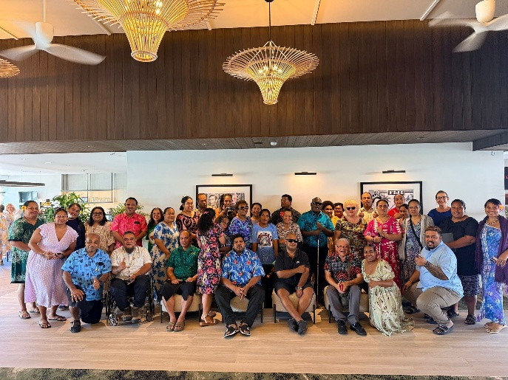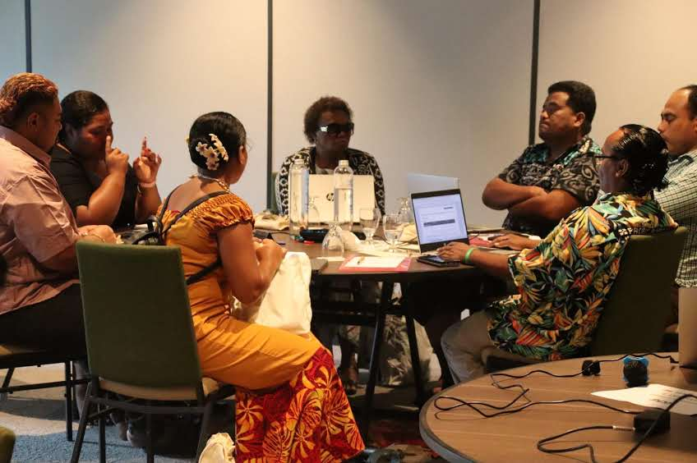
Read more via this Facebook post here.

WHO Disability Health Equity Network
The International Disability Development Consortium, along with 152 members comprising Member States, intergovernmental organisations, CSOs and OPDs, academics and the private sector gathered in Geneva last week for the Inaugural Meeting of the WHO Disability Health Equity Network. This new initiative aims to close avoidable health gaps between people with disabilities and the broader population. Over two days the group focused on a shared vision for the Initiative’s impact, strategic approach and priorities in advancing health equity for all people with disabilities.
Find out more about this exciting new cohort via LinkedIn post here.

NEW RESOURCES
New research: Understanding Barriers and Enablers to Community Participation for People with Psychosocial Disabilities in Fiji
CBM Australia’s latest research, produced in partnership with Psychiatric Survivors Association of Fiji, “They Don’t See Us: Voices from Fiji on Exclusion and the Power of Inclusion,” explores the lived experiences of people with psychosocial disabilities in Fiji. Despite Fiji’s ratification of the UNCRPD, systemic exclusion persists due to stigma, discriminatory attitudes, and outdated laws.
The study highlights that inclusion is transformative, improving mental health and fostering belonging, and provides actionable insights for policymakers, service providers, community organisations on rights-based approaches, inclusive service design and the central role of lived experience in shaping effective supports.
CBM Australia is joined by partners at this week’s Australasian Aid Conference in a panel discussion exploring the different facets of deinstitutionalisation.
Access the summary of the report here.

New guide: Advancing disability inclusive climate action: A resource guide for global practitioner
A new report released by CBM Global’s Inclusion Advisory Group and the Global Disability Innovation Hub provides global practitioners working in urban climate action with practical strategies to embed disability inclusion across climate programs, policies and investments. As climate change continues to deepen inequalities that disproportionately affects people with disabilities, this resource provides actionable entry points for strategy and implementation and ensures work is inclusive, rights-based and responsive to the lived experiences of people with disabilities.
Access this guide here.

New resource: Climate Change Through our Lens: Stories of Climate Exclusion and Resilience from Women with Disabilities in Nepal
A new study on women with disabilities and climate change, released at COP30 UN Climate Conference last month, showcases the voices and stories of twelve women with disabilities in Nepal as they navigate the realities of climate change. Women with disabilities, particularly relating to climate change, remain overlooked, under-documented and undervalued. These stories are necessary in exposing these prevailing inequities, and offer stories of unwavering strength, resilience and the power of community.
Watch here.

Disability Inclusion in Climate Policy: IDA Briefing Paper for COP30
Despite being among the most affected by climate change, the 1.3 billion persons with disabilities worldwide are rarely included in climate policy, planning, and finance.
In this briefing paper by the Disability Caucus, International Disability Alliance (IDA) for COP30, key recommendations and calls to action across five priority areas are made reminding global leaders that the path to a sustainable future must be built by and for persons with disabilities.
Access the paper here.

Kevin Akike & Sarah Goulding (2025) Disability and climate change – inclusive futures
This practice note explores how climate change responses can be strengthened by centring the lived experience and leadership of persons with disabilities in the Pacific. Kevin Akike – a disability rights advocate from Papua New Guinea – and Sarah Goulding highlight the urgent need for disability-inclusive climate action, particularly in frontline communities facing severe environmental challenges. Through inclusive Tok Stori dialogues, they reflect on the exclusion of people with disabilities from climate policy and programming. The article outlines practical, community-led approaches such as inclusive communication, accessible community mapping, and the leadership of local Organisations of Persons with Disabilities (OPDs) and calls for reform in global climate finance institutions to embed disability inclusion in policy and practice. It offers valuable insights for development practitioners seeking to advance equity, accessibility and resilience in climate action.
Access this paper here.

Opportunity Rolls Out Inclusive Finance and Accessibility Tools
Opportunity International Australia has been a pioneer in inclusive finance for nearly 50 years, empowering people in poverty, especially marginalised groups, to transform their lives. Inclusion is not just a value, but a daily practice embedded across their programs. For the latest tools designed to support financial service providers in becoming more inclusive and accessible, read the blog here.

UPCOMING EVENTS

Australasian AID Conference, 3-5 December 2025
The annual Australasian AID Conference (AAC) will be held at the Crawford School of Public Health at ANU from 3-5 December. The aim of the conference is to bring together researchers from across Australia, the Pacific, Asia, and beyond who are working on aid and international development policy to share insights and help develop the research community. Tickets can be purchased here.

OPPORTUNITIES

DFAT Australia Awards Fellowships: Round 21 now open
DFAT Australia Awards Fellowships aim to build networks of influence and leadership by strengthening partnerships between Australian organisations and partner organisations in the region. Fellowships target senior and mid-career officials and professionals who are in a position to advance development outcomes in priority areas and increase the institutional capacity of partner countries through their leadership.
Through Australia Awards Fellowships, Australian organisations can apply for funding to host and support a range of professional development activities including work attachment; supervised research; a management or leadership course; a study tour; program meetings and visits or a combination of these. Fellowships can vary in length, ranging from 2 weeks to 52 weeks.
Applications close 16 January 2026. Find out more here.

Expression of Interest: Opportunity for Assistive Technology User Experts in the Pacific
ATScale in partnership with the International Disability Association (IDA) are seeking assistive technology (AT) users from Pacific Island nations to join the ATScale Advisory Technical Group to provide technical and strategic input into ATScale’s programs. Selected consultants will advise on accessibility and inclusion and contribute to knowledge products. Applications close on 17 December 2025.
For more information, visit the IDA website, under “consultancies” here.

Executive Assistant, International Women’s Development Agency
More information here

ABOUT US
ADDC is an Australian, international network focusing attention, expertise and action on disability issues in developing countries; building on a human rights platform for disability advocacy. To join ADDC (membership is free) or find out more, please visit our website.
This bulletin aims to provide information on Disability Inclusive Development across organizations working to improve the quality of life for people with disabilities both here in Australia and across the world. Generic disability and domestic information will be included in our Bulletins when possible as part of our commitment to disability advocacy and strengthening partnerships; however, our focus remains on disability and development issues.
Acknowledgment of Country: ADDC recognizes the Australian Aboriginal and Torres Strait Islander people as the first inhabitants of the nation and the traditional custodians of the lands where we live, learn and work. We acknowledge their resilience, contributions and connection to land, culture and water. We pay our respects to their Elders, past, present and future. 45 percent of Aboriginal Australians live with a disability or a long-term, restricting health condition. They are 2.1 times more likely to be persons with disabilities than non-Aboriginal Australians, and 5 times more likely to experience a mental health condition. Aboriginal people with disabilities participate in cultural activities at the same rates as those without disabilities. We pay our respects to their enduring spirit and inclusivity.

Disclaimer: This bulletin is a compilation of other organizations’ articles and material. While every effort made is to validate content, ADDC does not endorse all opinions and views contacted within the Bulletin.

