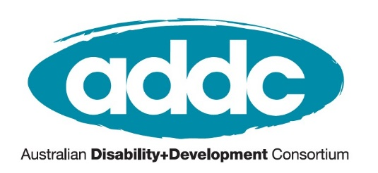
ADDC Executive Committee Nomination Form 2026
Nominations close on Friday 3 July at 5pm AEST
Email completed forms to mgabuya@addc.org.au
I, the undersigned, wish to nominate the following person:

Name: _____________________________________

Nomination category (Select one):
Australian international development organization
Organisation Name: ___________________________
General position for organization
Organisation Name: ___________________________
General position for individual ADDC member
Nominator:
________________________________________
Member proposer name

I am willing to be nominated:
________________________________________
Nominee name

For nominees representing an organisation -
Manager Statement: This position requires the member to participate in at least:  - One teleconference meeting per month  - One face to face meeting per year  - Up to one hour of work per week  Your signature assures you agree to this commitment. | Manager name

All nominations and nominators must be Australian-based members of ADDC. If you want to confirm your membership, contact Melinda Gabuya on mgabuya@addc.org.au.

Nominee Statement
This statement will be included in the ballot paper for all voting members to read. Include biography, background and why you are interested in this role with a max of 500 words.
Enter your Nominating Statement here.

Nominations for the 2026 election of the
ADDC Executive Committee closes on Friday 3 July at 5pm AEST.

Send completed nomination forms to Melinda Gabuya via
mgabuya@addc.org.au

For more information visit the ADDC Election page or
Contact Bloom, ADDC Executive Officer via kbloom@addc.org.au.

